|  |  |
| --- | --- |
| **Logo_FPT_University_doc** | **MINISTRY OF EDUCATION AND TRAINING** |

|  |
| --- |
| **FPT UNIVERSITY** |
| Capstone Project Document |
| Fast Food Delivery System |
|  |
| |  |  | | --- | --- | | **Group 12** | | | **Group Members** | Huynh Thanh Tam – Team leader – 60253  Pham Viet Phu – Team member – 60274  Nguyen Van Long – Team member – 60281  Huyen Ton Nu Uyen Thu – Team member – 60305 | | **Supervisor** | Mr. Kieu Trong Khanh | | **Ext Supervisor** | N/A | | **Capstone Project code** | FFDS | |
|  |

|  |
| --- |
| - Ho Chi Minh City, 9/2012- |

# Acknowledgements

The first one we really want to give our special thanks is Mr. Kieu Trong Khanh, our instructor – who helped us to finish this project. Maybe, sometime he made us felt so stress but at last, we recognized that all the things he did for us, he was with us and gave many useful advices from the beginning to the day we finished the work. One more time, thank you for all helping and dedication you gave us. Teacher!

Next, we would like to give faithful thanks to all teachers, who guided us from the first day we were here. We also would like to thank Ms. Le Hong Phuong and the Training department staff of FPT University, who gave us many supports to finish our project.

Finally, we want to dedicate this work to our parents. Thank them for bearing us and for their caring over the years. Without them, we would not have been who we are today.

FFDS Team.

# List of abbreviations and acronyms

|  |  |  |
| --- | --- | --- |
| **No.** | **Abbreviation& Acronym** | **Definition** |
| 1 | FFDS | Fast Food Delivery System |
| 2 | Admin | Administrator |
| 3 | PM | Project Manager |
| 4 | PTL | Project Technical Leader |
| 5 | TL | Team Leader |
| 6 | QA | Quality Assurance Officer |
| 7 | CC | Infrastructure Configuration Controller |
| 8 | DV | Developer |
| 9 | URD | User Requirement Document |
| 10 | SRS | Software Requirement Specification |
| 11 | ADD | Architecture Design Document |
| 12 | DDD | Detail Design Document |
| 13 | TP | Test Plan |
| 14 | TC | Test Case |
| 15 | SC | Source Code |

Table 1: Abbreviation& AcronymList

Table of Contents

[Acknowledgements 2](#_Toc342935182)

[List of abbreviations and acronyms 3](#_Toc342935183)

[Table 1: Abbreviation& AcronymList 3](#_Toc342935184)

[Table of Contents 3](#_Toc342935185)

[A. Introduction Software 17](#_Toc342935186)

[Table 2: Introduction 20](#_Toc342935187)

[B. Project management Plan 20](#_Toc342935188)

[I. Problem Definition 20](#_Toc342935189)

[1. Name of this Capstone Project 20](#_Toc342935190)

[2. Problem Abstract 20](#_Toc342935191)

[3. Project Overview 20](#_Toc342935192)

[3.1. The Current System 20](#_Toc342935194)

[3.2. The Proposed System 21](#_Toc342935195)

[3.3. Boundaries of the System 21](#_Toc342935196)

[3.4. Development Environment 21](#_Toc342935197)

[3.4.1. Hardware requirements: 21](#_Toc342935198)

[3.4.2. Software requirements: 21](#_Toc342935199)

[4. Project organization 21](#_Toc342935200)

[4.1. Software Process Model 21](#_Toc342935202)

[Figure 1: Waterfall Model 22](#_Toc342935203)

[4.2. Roles and Responsibilities 22](#_Toc342935204)

[Table 3: Roles and Responsibilities 23](#_Toc342935205)

[4.3. Tools and Techniques 23](#_Toc342935206)

[5. Project management Plan 24](#_Toc342935207)

[5.1. Tasks 24](#_Toc342935209)

[Table 4: Task 26](#_Toc342935210)

[5.2. Task Sheet: Assignment and Timetable 27](#_Toc342935211)

[5.3. All Meeting Minutes 27](#_Toc342935212)

[6. Coding Convention 27](#_Toc342935213)

[C. Software Requirements Specifications 27](#_Toc342935214)

[I. User Requirement Specification 27](#_Toc342935215)

[1. Customer Requirements 27](#_Toc342935216)

[2. Receipt Requirements 27](#_Toc342935217)

[3. Store Manager Requirements 27](#_Toc342935218)

[4. Delivery man Requirements 27](#_Toc342935219)

[5. Admin Requirements 28](#_Toc342935220)

[II. System Requirement Specification 28](#_Toc342935221)

[1. External Interface Requirements 28](#_Toc342935222)

[1.1. User Interface 28](#_Toc342935223)

[1.2. Hardware Interface 28](#_Toc342935224)

[1.3. Software Interface 28](#_Toc342935225)

[Table 5: Software List 29](#_Toc342935226)

[1.4. Communication Protocols 29](#_Toc342935227)

[2. System Figures 29](#_Toc342935228)

[Figure 2- General Use Case Diagram 29](#_Toc342935229)

[Figure 3- Customer Sequence Diagram 32](#_Toc342935230)

[2.1. <User> Log in 32](#_Toc342935234)

[2.2. <User> Log out 32](#_Toc342935235)

[2.3. <Customer> Register 32](#_Toc342935236)

[2.4. < Customer > View and Edit Personal Information 32](#_Toc342935237)

[2.5. < Customer >View and Edit Account Information 32](#_Toc342935238)

[2.6. <Customer, Visitor, Receipt >Create Order 32](#_Toc342935239)

[Figure 4- Create Order use case diagram 32](#_Toc342935240)

[Figure 5- Add products into shopping cart screen 36](#_Toc342935241)

[Figure 6- Shopping Cart screen 37](#_Toc342935242)

[2.7. <Customer, Visitor> Check Out Order 38](#_Toc342935243)

[Figure 7- Check Out Order use case diagram 38](#_Toc342935244)

[Figure 8- Check Out Order screen 43](#_Toc342935245)

[Figure 9- Checking Information Process screen 44](#_Toc342935246)

[Figure 10- Finish Order screen 45](#_Toc342935247)

[2.8. < Customer >Customer Cancel Order 45](#_Toc342935248)

[Figure 11- Customer Cancel Order use case diagram 45](#_Toc342935249)

[Figure 12- Customer Cancel Order screen 48](#_Toc342935250)

[Figure 13- Order Detail screen 49](#_Toc342935251)

[2.9. < Receipt > Check Out Order 49](#_Toc342935252)

[Figure 14- Check Out Order use case diagram 49](#_Toc342935253)

[Figure 15- Check Out Order screen 54](#_Toc342935254)

[Table 17: Check Out Order screen’s Control 54](#_Toc342935255)

[2.10. < Receipt > View Order List 55](#_Toc342935256)

[2.11. < Receipt > View Order Detail 55](#_Toc342935257)

[2.12. < Receipt > Receipt Cancel Order 55](#_Toc342935258)

[Figure 16- Receipt Cancel Order use case diagram 55](#_Toc342935259)

[Table 18: Customer Cancel Order Use Case Specification 57](#_Toc342935260)

[2.13. < Store Manager > View Order List 57](#_Toc342935261)

[2.14. < Store Manager > View Order Detail 57](#_Toc342935262)

[2.15. <Store Manager>Receive Order 58](#_Toc342935263)

[2.16. <Store Manager>Confirm Order 58](#_Toc342935264)

[Figure 17- Confirm Order use case diagram 58](#_Toc342935265)

[2.17. <Store Manager>Cancel Order 58](#_Toc342935266)

[Figure 18- Cancel Order use case diagram 58](#_Toc342935267)

[2.18. <Store Manager>Cancel Order For Customer 58](#_Toc342935268)

[Figure 19- Cancel Order For Customer use case diagram 58](#_Toc342935269)

[2.19. <Delivery Man >Receive Order 59](#_Toc342935270)

[2.20. <Delivery Man >Confirm Order 59](#_Toc342935271)

[Figure 20- Confirm order use case diagram 59](#_Toc342935272)

[2.21. <Delivery Man>Finish Order 59](#_Toc342935273)

[Figure 21- Receive delivery’s order use case diagram 59](#_Toc342935274)

[2.22. <System>Draw routes in map 59](#_Toc342935275)

[Figure 22- Draw routes in map use case diagram 59](#_Toc342935276)

[Table 19: Draw routes in map use case diagram 61](#_Toc342935277)

[2.23. <System> Check order of customer 61](#_Toc342935278)

[Figure 23- Check order of customer 61](#_Toc342935279)

[Table 20: Draw routes in map use case diagram 63](#_Toc342935280)

[2.24. <Admin> Manage Employee 64](#_Toc342935281)

[2.24.1. Create New Employee 64](#_Toc342935284)

[2.24.2. Edit Employee Information 64](#_Toc342935285)

[2.24.3. Inactive Employee 64](#_Toc342935286)

[2.25. < Admin > Manage Customer 64](#_Toc342935287)

[2.25.1. Create New Customer 64](#_Toc342935290)

[2.25.2. Edit Customer Information 64](#_Toc342935291)

[2.25.3. Inactive Customer 64](#_Toc342935292)

[2.26. < Admin > Manage Product 64](#_Toc342935293)

[2.26.1. Create New Product 64](#_Toc342935294)

[2.26.2. Edit Product Information 64](#_Toc342935295)

[2.26.3. Inactive Product 64](#_Toc342935296)

[2.27. < Admin > Manage Delivery Man 64](#_Toc342935297)

[2.27.1. View Delivery Man Location 64](#_Toc342935298)

[2.28. < Admin >Manage Store 64](#_Toc342935299)

[2.28.1. Create New Store 64](#_Toc342935300)

[2.28.2. Update Store Information 64](#_Toc342935301)

[2.28.3. Inactive Store 65](#_Toc342935302)

[2.28.4. View Store Location 65](#_Toc342935303)

[2.28.5. View Order Location 65](#_Toc342935304)

[2.29. <Admin>Report 65](#_Toc342935305)

[2.29.1. Sales Income Report 65](#_Toc342935306)

[2.29.2. Sales Product Quantity Report 65](#_Toc342935307)

[2.30. <Admin>Configuration 65](#_Toc342935308)

[3. Software System Attributes 65](#_Toc342935309)

[3.1. Usability 65](#_Toc342935312)

[3.1.1. Graphic User Interface 65](#_Toc342935313)

[3.1.2. Usability for end-users 65](#_Toc342935314)

[3.1.3. Usability for admin and staff 65](#_Toc342935315)

[3.1.4. Installation 66](#_Toc342935316)

[3.2. Reliability 66](#_Toc342935317)

[3.3. Availability 66](#_Toc342935318)

[3.4. Security 66](#_Toc342935319)

[3.5. Maintainability 66](#_Toc342935320)

[3.5.1. Portability 66](#_Toc342935321)

[Hardware: 66](#_Toc342935327)

[Network: 66](#_Toc342935328)

[Environment: 66](#_Toc342935329)

[Browser: 66](#_Toc342935330)

[3.5.2. Performance 66](#_Toc342935331)

[Load time 66](#_Toc342935332)

[Capacity 66](#_Toc342935334)

[4. Entity Relationship Diagram 67](#_Toc342935335)

[Figure 24- Entity Relationship Diagram 67](#_Toc342935336)

[D. Software Design Description 67](#_Toc342935337)

[I. Design Overview 67](#_Toc342935338)

[II. System Architectural Design 68](#_Toc342935339)

[Figure 25: System Architectural Design 68](#_Toc342935340)

[III. Component Diagram 68](#_Toc342935341)

[Figure 26: Component Diagram 69](#_Toc342935342)

[IV. Presentation Layer’s Components 69](#_Toc342935343)

[Figure 27: Presentation Layer's Components 69](#_Toc342935344)

[1. Business Logic Layer’s Components 69](#_Toc342935345)

[Figure 28: Business Layer's Components 70](#_Toc342935346)

[2. Data Access Layer’s Components 70](#_Toc342935347)

[Figure 29: Data Access Layer's Components 70](#_Toc342935348)

[3. Common Component 70](#_Toc342935349)

[Figure 30: Common Components 70](#_Toc342935350)

[I. Detailed Design Description of Components 71](#_Toc342935351)

[Figure 31: General Class Diagram 71](#_Toc342935352)

[1. <User> Log in 71](#_Toc342935353)

[2. <User> Log out 71](#_Toc342935354)

[3. <Customer> Register 71](#_Toc342935355)

[4. < Customer > View and Edit Personal Information 71](#_Toc342935356)

[5. < Customer >View and Edit Account Information 71](#_Toc342935357)

[6. <Customer, Receipt, Visitor>Create Order 72](#_Toc342935358)

[6.1. Class Diagram 72](#_Toc342935362)

[Figure 32: Create Order Class Diagram 72](#_Toc342935363)

[6.2. Class Explanation 72](#_Toc342935364)

[6.2.1. Customer 72](#_Toc342935365)

[**Attributes:** 72](#_Toc342935366)

[Table 21: Customer Attributes 73](#_Toc342935367)

[**Methods:** 73](#_Toc342935368)

[Table 22: getCustomerByUserName’s Parameters 73](#_Toc342935369)

[**Methods:** 73](#_Toc342935370)

[Table 23: getCustomerByUserName’s Parameters 73](#_Toc342935371)

[**Methods:** 73](#_Toc342935372)

[Table 24: updateCustomerPoint’s Parameters 73](#_Toc342935373)

[6.2.2. Order 73](#_Toc342935374)

[**Attributes:** 73](#_Toc342935375)

[Table 25: Order Attributes 74](#_Toc342935376)

[**Methods:** 74](#_Toc342935377)

[Table 26: insertOrderCustomer’s Parameters 74](#_Toc342935378)

[**Methods:** 74](#_Toc342935379)

[Table 27: getOrderItemsByOrder’s Parameters 74](#_Toc342935380)

[**Methods:** 74](#_Toc342935381)

[Table 28: checkValidOrderCustomer’s Parameters 74](#_Toc342935382)

[6.2.3. Store 74](#_Toc342935383)

[**Attributes:** 74](#_Toc342935384)

[Table 29: Store Attributes 75](#_Toc342935385)

[**Methods:** N/A 75](#_Toc342935386)

[1.1.1. Sequence Diagram 76](#_Toc342935387)

[Figure 33: Create Order Sequence Diagram 78](#_Toc342935388)

[7. < Customer > Customer Cancel Order 78](#_Toc342935389)

[8. < Receipt > View Order List 78](#_Toc342935390)

[9. < Receipt > View Order Detail 78](#_Toc342935391)

[10. < Receipt > View Customer List 78](#_Toc342935392)

[11. < Store Manager > View Order List 78](#_Toc342935393)

[12. < Store Manager > View Order Detail 78](#_Toc342935394)

[13. <Store Manager>Receive Order 78](#_Toc342935395)

[14. <Store Manager>Confirm Order 78](#_Toc342935396)

[15. <Store Manager>Cancel Order 79](#_Toc342935397)

[15.1. Class Diagram 79](#_Toc342935412)

[Figure 34: Create Order Class Diagram 79](#_Toc342935413)

[15.2. Class Explanation 79](#_Toc342935414)

[15.2.1. Order 79](#_Toc342935415)

[**Attributes:** 79](#_Toc342935416)

[Table 30: Order Attributes 80](#_Toc342935417)

[**Methods:** 80](#_Toc342935418)

[Table 31: insertOrderCustomer’s Parameters 80](#_Toc342935419)

[**Methods:** 80](#_Toc342935420)

[Table 32: searchNewOrdersByStore’s Parameters 80](#_Toc342935421)

[**Methods:** 80](#_Toc342935422)

[Table 33: getOrderItemsByOrder’s Parameters 80](#_Toc342935423)

[15.2.2. Store 80](#_Toc342935424)

[**Attributes:** 80](#_Toc342935425)

[Table 34: Store Attributes 81](#_Toc342935426)

[**Methods:** 81](#_Toc342935427)

[Table 35: getStoreByStoreID’s Parameters 81](#_Toc342935428)

[**Methods:** 81](#_Toc342935429)

[Table 36: searchNewOrdersByStore’s Parameters 81](#_Toc342935430)

[**Methods:** 81](#_Toc342935431)

[Table 37: searchNewOrdersByStore’s Parameters 81](#_Toc342935432)

[15.3. Sequence Diagram 82](#_Toc342935433)

[Figure 35: Store Reject Order Sequence Diagram 82](#_Toc342935434)

[16. <Store Manager>Cancel Order for Customer 82](#_Toc342935435)

[17. <Delivery Man >Receive Order 82](#_Toc342935436)

[18. <Delivery Man >Confirm Order 82](#_Toc342935437)

[19. <Delivery Man >Finish Order 82](#_Toc342935438)

[20. < Delivery Man >Does not confirm order 82](#_Toc342935439)

[20.1. Class Diagram 82](#_Toc342935450)

[20.2. Class Explaination 82](#_Toc342935451)

[20.3. Sequence Diagram 83](#_Toc342935452)

[Figure 36: Delivery Man Does Not Confirm Order Sequence Diagram 83](#_Toc342935453)

[21. <System>Draw routes in map 83](#_Toc342935454)

[22. <System> Check order of customer 83](#_Toc342935455)

[23. <Admin> Manage Employee 83](#_Toc342935456)

[23.1. Create New Employee 83](#_Toc342935463)

[23.2. Edit Employee Information 83](#_Toc342935464)

[23.3. Inactive Employee 83](#_Toc342935465)

[24. < Admin > Manage Customer 83](#_Toc342935466)

[24.1. Create New Customer 83](#_Toc342935470)

[24.2. Edit Customer Information 84](#_Toc342935471)

[24.3. Inactive Customer 84](#_Toc342935472)

[25. < Admin > Manage Product 84](#_Toc342935473)

[25.1. Create New Product 84](#_Toc342935477)

[25.2. Edit Product Information 84](#_Toc342935478)

[25.3. Inactive Product 84](#_Toc342935479)

[26. < Admin > Manage Delivery Man 84](#_Toc342935480)

[26.1. View Delivery Man Location 84](#_Toc342935484)

[27. < Admin >Manage Store 84](#_Toc342935485)

[27.1. Create New Store 84](#_Toc342935489)

[27.2. Update Store Information 84](#_Toc342935490)

[27.3. Inactive Store 84](#_Toc342935491)

[27.4. View Store Location 84](#_Toc342935492)

[27.5. View Order Location 84](#_Toc342935493)

[28. <Admin>Report 84](#_Toc342935494)

[28.1. Sales Income Report 84](#_Toc342935498)

[28.2. Sales Product Quantity Report 84](#_Toc342935499)

[V. Algorithm 85](#_Toc342935500)

[1. Create Order 85](#_Toc342935501)

[Figure 37: Create Order Algorithm 86](#_Toc342935502)

[2. Assign Order To Store 87](#_Toc342935503)

[Figure 38: Assign Order To Store Algorithm 87](#_Toc342935504)

[3. Store Manager Cancel Order 88](#_Toc342935505)

[Figure 39: Store Manager Cancel Order Algorithm 88](#_Toc342935506)

[4. Suggest Address To Customer 89](#_Toc342935507)

[Figure 40: Suggest Address To Customer Algorithm 89](#_Toc342935508)

[VI. Database Design 90](#_Toc342935509)

[1. Entity Relation Diagram 90](#_Toc342935510)

[Figure 41: Entity Relation Diagram 90](#_Toc342935511)

[2. Tables 91](#_Toc342935512)

[Figure 42: Database Diagram 91](#_Toc342935513)

[Table 38: Tables List 92](#_Toc342935514)

[3. Table Dictionary 92](#_Toc342935515)

[3.1. Tbl\_role 92](#_Toc342935519)

[Table 39: tbl\_role table dictionary 92](#_Toc342935520)

[3.2. Tbl\_sex 92](#_Toc342935521)

[Table 40: tbl\_sex table dictionary 92](#_Toc342935522)

[3.3. Tbl\_user 92](#_Toc342935523)

[Table 41: tbl\_user table dictionary 92](#_Toc342935524)

[3.4. Tbl\_employee 92](#_Toc342935525)

[Table 42: tbl\_user table dictionary 93](#_Toc342935526)

[3.5. Tbl\_customer 93](#_Toc342935527)

[Table 43: tbl\_customer Table Dictionary 94](#_Toc342935528)

[3.6. Tbl\_delivery\_man\_status 94](#_Toc342935529)

[Table 44: tbl\_delivery\_man Table Dictionary 94](#_Toc342935530)

[3.7. Tbl\_delivery\_man 94](#_Toc342935531)

[Table 45: tbl\_delivery\_man Table Dictionary 95](#_Toc342935532)

[3.8. Tbl\_order\_items 95](#_Toc342935533)

[Table 46: tbl\_order\_items Table Dictionary 95](#_Toc342935534)

[3.9. Tbl\_order 95](#_Toc342935535)

[Table 47: tbl\_order Table Dictionary 96](#_Toc342935536)

[3.10. Tbl\_product 96](#_Toc342935537)

[Table 48: tbl\_product Table Dictionary 97](#_Toc342935538)

[3.11. Tbl\_order\_status 97](#_Toc342935539)

[Table 49: tbl\_order\_status Table Dictionary 97](#_Toc342935540)

[3.12. Tbl\_store 97](#_Toc342935541)

[Table 50: tbl\_store Table Dictionary 97](#_Toc342935542)

[3.13. Tbl\_price 97](#_Toc342935543)

[Table 51: tbl\_price Table Dictionary 98](#_Toc342935544)

[3.14. Tbl\_order\_items\_area\_over 98](#_Toc342935545)

[Table 52: tbl\_order\_items\_cancel Table Dictionary 98](#_Toc342935546)

[3.15. Tbl\_category 98](#_Toc342935547)

[Table 53: tbl\_category Table Dictionary 98](#_Toc342935548)

[3.16. Tbl\_order\_area\_over 98](#_Toc342935549)

[Table 54: tbl\_order \_cancel Table Dictionary 99](#_Toc342935550)

[3.17. Tbl\_product\_type 99](#_Toc342935551)

[Table 55: tbl\_product\_type Table Dictionary 100](#_Toc342935552)

[VII. References 100](#_Toc342935553)

[E. Software Test Documentation 100](#_Toc342935554)

[I. Introduction 100](#_Toc342935555)

[1. System Overview 100](#_Toc342935556)

[2. Test Approach 100](#_Toc342935557)

[II. Test Plan 101](#_Toc342935558)

[1. Features to be tested 101](#_Toc342935559)

[1.1. <Customer, Visitor, Receipt>Add Product into Shopping Cart 101](#_Toc342935560)

[1.2. <Customer, Visitor, Receipt>Check out Delivery Information 101](#_Toc342935561)

[1.3. <Customer, Visitor, Receipt>Export Order Detail to PDF 101](#_Toc342935562)

[1.4. <Customer>Cancel Order 101](#_Toc342935563)

[1.5. <Store Manager>Confirm Order 101](#_Toc342935564)

[1.6. <Store Manager>Cancel Order 101](#_Toc342935565)

[1.7. <Store Manager>Confirm Order for Customer 101](#_Toc342935566)

[1.8. <Store Manager>Assign Order to Delivery Man 101](#_Toc342935567)

[1.9. <Admin>Keep track on location of Delivery Man 101](#_Toc342935568)

[1.10. <Admin>Keep track on location of Store 101](#_Toc342935569)

[1.11. <Admin>Keep track on location of Order 102](#_Toc342935570)

[1.12. <Admin>View Statistics Report 102](#_Toc342935571)

[2. Features not to be tested 102](#_Toc342935572)

[2.1. <Customer> View and Edit Personal Information 102](#_Toc342935574)

[2.2. <Customer>View and Edit Account Information 102](#_Toc342935575)

[2.3. <Store Manager> Receive Order 102](#_Toc342935576)

[2.4. <Admin> View, add, edit and active (inactive) Employee 102](#_Toc342935577)

[2.5. <Admin> View, add, edit and active (inactive) Customer 102](#_Toc342935578)

[2.6. <Admin> View, add, edit and active (inactive) Product 102](#_Toc342935579)

[2.7. <Admin> View, add, edit and active (inactive) Store 103](#_Toc342935580)

[III. Test Cases 104](#_Toc342935581)

[1. <Visitor>Register (R) 104](#_Toc342935582)

[2. <Customer, Visitor>Create Order (CO) 104](#_Toc342935583)

[2.1. Customer (Visitor) add product to shopping cart (AP) 104](#_Toc342935587)

[Table 56: Create Order Test Case 105](#_Toc342935588)

[2.2. Customer (Visitor) input check-out information at “THÔNG TIN MUA HÀNG” popup (COI) 105](#_Toc342935589)

[Table 57: Check Out Order Test Case 109](#_Toc342935590)

[3. <Customer>Cancel Order (CC) 109](#_Toc342935591)

[Table 58: Cancel Order Test Case 109](#_Toc342935593)

[4. <Store Manager>Receive Order (SRO) 110](#_Toc342935594)

[Table 59: Receive Order Test Case 111](#_Toc342935595)

[5. <Store Manager>Cancel Order for Customer (SCO) 111](#_Toc342935596)

[Table 60: Cancel Order For Customer Test Case 112](#_Toc342935597)

[6. <Delivery Man> Receive Order (DRO) 112](#_Toc342935598)

[Table 61: Delivery Man Receive Order Test Case 113](#_Toc342935599)

[7. <Admin>Manage Customer 113](#_Toc342935600)

[7.1. Input Customer Data (ICD) 113](#_Toc342935606)

[Table 62: Customer Data 114](#_Toc342935607)

[7.2. Manage Customer (MC) 114](#_Toc342935608)

[Table 63: Manager Customer Test Case 117](#_Toc342935609)

[8. <Admin>Manage Product 117](#_Toc342935610)

[8.1. Input Product Data (IPD) 117](#_Toc342935612)

[Table 64: Product Data 117](#_Toc342935613)

[8.2. Manage Product (MP) 117](#_Toc342935614)

[Table 65: Manage Product Test Case 120](#_Toc342935615)

[9. <Admin> Manage Store 120](#_Toc342935616)

[9.1. Input Store Data (ISD) 120](#_Toc342935618)

[Table 66: Store Data 120](#_Toc342935619)

[9.2. Manage Store (MS) 120](#_Toc342935620)

[Table 67: Manage Store Test Case 122](#_Toc342935621)

[IV. Checklists 122](#_Toc342935622)

[1. Checklist of Validation 122](#_Toc342935623)

[Table 68: Checklist of Validation 123](#_Toc342935624)

[2. Submission Checklist 123](#_Toc342935625)

[Table 69: Submission Checklist 124](#_Toc342935626)

[F. Software User’s Manual 125](#_Toc342935627)

[I. Installation Guide 125](#_Toc342935628)

[1. Setting up environment at server side 125](#_Toc342935629)

[2. Deployment at server sites 125](#_Toc342935630)

[Figure 43: Start Tomcat Server 125](#_Toc342935631)

[3. Setting up environment at client side 126](#_Toc342935632)

[II. Main Process 126](#_Toc342935633)

[Figure 44: Main Data Flow 126](#_Toc342935634)

[III. User’s Guide 127](#_Toc342935635)

[1. Visitor Guide 127](#_Toc342935636)

[1.1. Register 127](#_Toc342935637)

[Figure 45: Register screen 127](#_Toc342935638)

[Table 70: Register step 128](#_Toc342935639)

[2. Customer (Visitor) Guide 128](#_Toc342935640)

[2.1. Login 128](#_Toc342935642)

[Figure 46: Login screen 128](#_Toc342935643)

[Click “Đăng nhập” to show login popup 128](#_Toc342935644)

[Table 71: Login step 128](#_Toc342935645)

[2.2. Logout 128](#_Toc342935646)

[2.3. Add product into shopping cart 129](#_Toc342935647)

[Figure 47: Add Product screen 129](#_Toc342935648)

[Table 72: Add Product step 129](#_Toc342935649)

[2.4. Change product quantity or remove product 130](#_Toc342935650)

[Figure 48: Change Product Quantity screen 130](#_Toc342935651)

[Table 73: Change Product Quantity step 130](#_Toc342935652)

[2.5. Check out 131](#_Toc342935653)

[Figure 49: Check Out screen 131](#_Toc342935654)

[Table 74: Check Out step 131](#_Toc342935655)

[2.6. View and cancel order 132](#_Toc342935662)

[Table 75: View Order step 132](#_Toc342935663)

[Figure 51: View Order Detail screen 133](#_Toc342935664)

[Table 76: Cancel Order step 133](#_Toc342935665)

[Figure 52: Confirm Cancel Order screen 134](#_Toc342935666)

[Table 77: Confirm Cancel Order step 134](#_Toc342935667)

[2.7. View and edit personal information 134](#_Toc342935668)

[2.8. View and edit account information 134](#_Toc342935669)

[3. Store Manager Guide 134](#_Toc342935670)

[3.1. View order list 134](#_Toc342935672)

[Figure 53: Order List screen 135](#_Toc342935673)

[Table 78: Order List step 135](#_Toc342935674)

[3.2. View order detail 135](#_Toc342935675)

[Figure 54: View Order Detail screen 135](#_Toc342935676)

[Table 79: View Order Detail step 135](#_Toc342935677)

[3.3. Confirm order 136](#_Toc342935678)

[Figure 55: View Order Detail screen 136](#_Toc342935679)

[Table 80: View Order Detail step 136](#_Toc342935680)

[3.4. Reject order 137](#_Toc342935681)

[Figure 56: Reject Orderl screen 137](#_Toc342935682)

[Table 81: Reject Order step 137](#_Toc342935683)

[3.5. Cancel order for customer 137](#_Toc342935684)

[Figure 57: Cancel Order screen 138](#_Toc342935685)

[Table 82: Cancel Order step 138](#_Toc342935686)

[4. Delivery Man Guide 138](#_Toc342935687)

[4.1. View Order List 138](#_Toc342935689)

[Figure 58: View Order List screen 138](#_Toc342935690)

[Table 83: View Order List step 139](#_Toc342935691)

[4.2. View Order Detail 139](#_Toc342935692)

[Figure 59: View Order Detail screen 139](#_Toc342935693)

[Table 84: View Order Detail step 140](#_Toc342935694)

[4.3. Confirm Order 140](#_Toc342935695)

[Figure 60: Confirm Order screen 140](#_Toc342935696)

[Table 85: Confirm Order step 140](#_Toc342935697)

[4.4. View Map 141](#_Toc342935698)

[4.4.1. View map from delivery man to store 141](#_Toc342935699)

[Figure 61: View Map From Delivery Man To Store screen 141](#_Toc342935700)

[Table 86: View Map From Delivery Man To Store step 141](#_Toc342935701)

[4.4.2. View map from delivery man to customer 142](#_Toc342935702)

[Figure 62: View Map From Delivery Man To Customer screen 142](#_Toc342935703)

[Table 87: View Map From Delivery Man To Customer step 142](#_Toc342935704)

[4.5. Submit Order 143](#_Toc342935705)

[Figure 63: Submit Order screen 143](#_Toc342935706)

[Table 88: Submit Order step 143](#_Toc342935707)

[4.6. Customer does not receive order 144](#_Toc342935708)

[Figure 64: Customer Cancel Order screen 144](#_Toc342935709)

[Table 89: Customer Cnacel Order step 144](#_Toc342935710)

[5. Admin Guide 145](#_Toc342935711)

[5.1. Manage Employee 145](#_Toc342935718)

[Figure 65: View List Of Employee screen 145](#_Toc342935719)

[Table 90: View List Of Employee step 145](#_Toc342935720)

[Figure 66: View And Edit Detail Of Employee screen 146](#_Toc342935721)

[Table 91: View And Edit Detail Of Employee step 146](#_Toc342935722)

[Figure 67: Add New Employee screen 147](#_Toc342935723)

[Table 92: Add New Employee step 147](#_Toc342935724)

[5.2. Manage Customer 148](#_Toc342935725)

[Figure 68: View Customer List screen 148](#_Toc342935726)

[Table 11: View Customer List step 148](#_Toc342935727)

[Figure 69: View And Edit Detail Of Customer screen 149](#_Toc342935728)

[Table 11: View And Edit Detail Of Customer step 149](#_Toc342935729)

[Figure 70: Add New Customer screen 150](#_Toc342935730)

[Table 11: Add New Customer step 150](#_Toc342935731)

[5.3. Manage Product 151](#_Toc342935732)

[Figure 71: View Product List screen 151](#_Toc342935733)

[Table 11: View Product List step 151](#_Toc342935734)

[Figure 72: View And Edit Detail Of Product screen 152](#_Toc342935735)

[Table 11: View And Edit Detail Of Product step 152](#_Toc342935736)

[Figure 73: Add New Product screen 152](#_Toc342935737)

[Table 11: Add New Product step 153](#_Toc342935738)

[**Error notification: information textbox and dropdown list is invalid** 153](#_Toc342935739)

[5.4. Manage Store 154](#_Toc342935740)

[Figure 74: View Store List screen 154](#_Toc342935741)

[Table 11: View Store List step 154](#_Toc342935742)

[Figure 75: View And Edit Store Detail screen 155](#_Toc342935743)

[Table 11: View And Edit Store Detail step 155](#_Toc342935744)

[Figure 76: Add New Store screen 156](#_Toc342935745)

[Table 11: Add New Store step 156](#_Toc342935746)

[5.5. Keep track on Deliver Man’s location 157](#_Toc342935747)

[Figure 77: Keep track on delivery man’s location screen 157](#_Toc342935748)

[Table 11: Keep track on delivery man’s location step 157](#_Toc342935749)

[5.6. View report 158](#_Toc342935750)

[5.7. Configuration 158](#_Toc342935751)

[Figure 78: View Configuration List screen 158](#_Toc342935752)

[Table 11: View Configuration List step 158](#_Toc342935753)

[Figure 79: Edit Configuration screen 159](#_Toc342935754)

[Table 11: Edit Configuration step 159](#_Toc342935755)

[IV. Constraints 159](#_Toc342935756)

[G. Appendix 159](#_Toc342935757)

# Introduction Software

|  |  |  |  |  |  |  |  |  |
| --- | --- | --- | --- | --- | --- | --- | --- | --- |
| **Project Title:** | | Fast Food Delivery System | | | | | | |
| **Start Date:** | | Sep 11th, 2012 | | | **Finished Date:** | | Dec 22nd, 2012 | |
| **Overview of similar existing solutions** | | * N/A | | | | | | |
| **Overview of existing methods** | | * A fast-food restaurant can get orders from customers directly (at restaurant) or via phone, website- the ways seem good and save a lot of time for customers: * Directly: the customers will get their fast-food and liquidate at the restaurant. * Phone: delivery man will offer fast-food to customer and get money. * Website: delivery man will offer fast-food to customer and get money or customers can use online liquidation to pay before they get their products. | | | | | | |
| **Limitations of the existing methods** | | * Sometime, it is still delay, time-consuming or low efficient because the delivery man of the exact restaurant which is ordered have to delivery fast-food. * Current fast food restaurants have not checked out customer’s information (customer address) automatically. * Traditional fast-food delivery system does not make use of web application and mobility devices. | | | | | | |
| **Project Objectives:** | | * The purpose of FFDS project is to create a new system that upgrade the ways of fast-food delivery by make use of mobile device and web application. * System will get customer’s information and make them be more useful- increase productivity, efficiency and decrease transaction cost, transaction time and etc. * When the customers create an order via store’s website or phone, the system will fine the shortest way automatically to help customers get their products as quick as possible. | | | | | | |
| **Scope Definition:** | | * The main scope of fast-food delivery system is to improve traditional fast-food delivery system * Focus on main functions * Creating order * Checking customer information and giving address suggestions for customer * Locating place * Calculating distance * Assign order * Delivering order | | | | | | |
| **Approach:** | | * Research more about business rule of KFC and [Domino](http://en.wikipedia.org/wiki/Lotteria) Pizza. * Get comment of some real customers about current fast food delivery system. | | | | | | |
| **References:** | | N/A | | | | | | |
|  | | | | | | | | |
| **Functions:** | | | | | | | | |
| **Group Functions** | | **Summary** | | | | | | |
| **Customer Functions** | | * View product’s details * Create an order * View order * Cancel an order (Customer can only cancel the order among 05 minutes count from time order is created) * View and edit personal information * View and edit account information | | | | | | |
| **Store Manager Functions** | | * View order list * View order detail * Receive order (After customer create order successfully, system will send the order to the approriatest store – which near customer’s address) * Confirm order (Store manager confirm order if store can serve the order) * Cancel order (Store manager cance order if store cannot serve the order) * Cancel order for customer (If customer want to cancel order but it was out of 05 minutes count from time order was created, store manager will help customer cancel order but the order must not be delivering yet. | | | | | | |
| **Delivery Man Functions** | | When the system send an information message about the order to the delivery man, he can confirm or does not confirm that order   * Receive order: After store manager confirm order, system will calculate and send order to approriatest delivery man * Confirm order * Submit order: Delivery man inform successful order to the system. | | | | | | |
| **Receipt Functions** | | * Create order: This function to help the customers who cannot make their order directly or online. Receipt will get customer’s basic information (name, address, phone…) and requirement about product via phone and make the order for customer. * View order detail * View order list * Cancel order for customer (the order must not be delivering yet) | | | | | | |
| **Admin Functions** | | * View employee information, edit employee information, add new employee, active (inactive) employee. * View customer information, edit customer information, add new customer, active (inactive) customer. * View product information, edit product information, add new product, active (inactive) product. * View store information, edit store information, add new store, active (inactive) store. * Keep track on location of orders on map. * Keep track on loction of store on map. * Keep track on location of delivery man on map . * View sales income report, view sales product report. | | | | | | |
|  | | | | | | | | |
| **Roles and Responsibility:** | | | | | | | | |
| **No** | **Full name** | | | **Role** | | **Position** | | **Contact** |
| 1 | Kieu Trong Khanh | | | Project Manager | | Instructor | | KhanhKT@fpt.edu.vn |
| 2 | Huynh Thanh Tam | | | Developer | | Team leader | | TamHT60253@fpt.edu.vn |
| 3 | Pham Viet Phu | | | Developer | | Team member | | PhuPV60274@fpt.edu.vn |
| 4 | Nguyen Van Long | | | Developer | | Team member | | LongNV60281@fpt.edu.vn |
| 5 | Huyen Ton Nu Uyen Thu | | | Developer | | Team member | | ThuHTNU60305@fpt.edu.vn |
|  | | | | | | | | |
| **Project Authorization:** | | | | | | | | |
| **Approved by** | | | | **Role** | | | | **Date** |
| Kieu Trong Khanh | | | | Project Manager | | | | September 11th, 2012 |
|  | | | | | | | | |
| **Comments:** | | |  | | | | | |

Table 2: Introduction

# Project management Plan

## Problem Definition

### Name of this Capstone Project

* The full name of this project is “Fast Food Delivery System”. Its acronym is FFDS.

### Problem Abstract

* The authors of this project find out that the current fast food delivery system is not fast and efficient enough, especially when the stores want to expand their fast-food system, the old system will decrease efficiency and increase transaction time because the delivery man of the exact store which is ordered have to deliver fast-food.
* Beside, tranditional system have not yet made use of technology’s strengths such as web application, mobility devices, Google API, GPS.
* So, the goal of the project is create new system that improves the current fast-food delivery system by adding some more functions such as locate place, calculate distance, give suggestion to admin- these functions will be performed automatically by the system.

### Project Overview



### The Current System

* The current fast food delivery system is still simple
* A fast-food restaurant can get orders from customers directly (at restaurant) or via phone, website- the ways seem good and save a lot of time for customers:
* Directly: the customers will get their fast-food and liquidate at the restaurant.
* Phone: delivery man will offer fast-food to customer and get money.
* Website: delivery man will offer fast-food to customer and get money or customers can use online liquidation to pay before they get their products.

### The Proposed System

* Name of proposed system is “Fast Food Delivery System”
* The aim of this system is to build a website with the following main features:
* Customers create order.
* Store Manager receive and confirm order
* Delivery Man receive and delivery order
* Calculate and find out the shortest distance between:
  + - Store and Customer
    - Store and Delivery Man
* Support Delivery Man to view map and offer products to customer.

### Boundaries of the System

* The system under development of this Capstone Project will include:
* The complete website
* All the process involved documents

### Development Environment

* Below is the list of hardware and software requirements needed for development environment:

### Hardware requirements:

* N/A

### Software requirements:

* Operating system: Windows 7
* IDE: Netbean,Eclipse
* DBMS: MySQL
* Source Control: Tortoise Subversion (SVN) and Assembla code server

### Project organization



### Software Process Model

The process model used for developing this project is waterfall model.

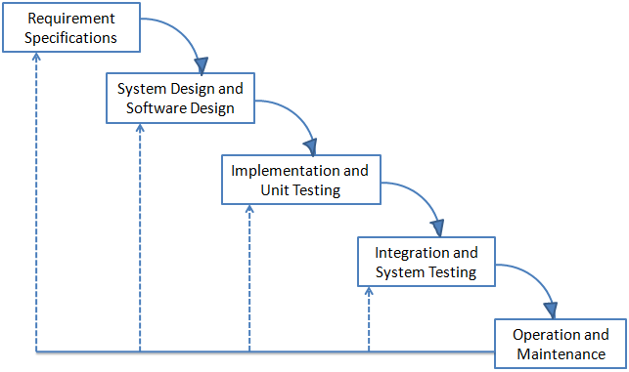

Figure 1: Waterfall Model

All of the phases in the waterfall models are included in the scope of this project and are the responsibilities of the team.

### Roles and Responsibilities

|  |  |  |  |
| --- | --- | --- | --- |
| No | Full name | Role in Group | Responsibilities |
| 1 | Kieu Trong Khanh | Project Manager | * Specify user requirement * Control the development process * Give out technique and business analysis support |
| 2 | Huynh Thanh Tam | Team Leader, BA, DEV, Tester | * Managing process * Designing database * Clarifying requirements * Prepare documents * Create test plan * Coding * Testing |
| 3 | Pham Viet Phu | BA, DEV, Tester | * Designing database * Build framework * Clarifying requirements * Support technique * Coding * Creating test cases * Testing |
| 4 | Nguyen Van Long | BA, DEV, Tester | * Coding * Clarifying requirements * GUI Design * Creating test plan and test cases * Testing |
| 5 | Huyen Ton Nu Uyen Thu | BA, DEV, Tester | * Coding * Clarifying requirements * GUI Design * Creating test plan and test cases * Testing |

Table 3: Roles and Responsibilities

### Tools and Techniques

* Front-end technologies: html, css, javascript, jQuery, AJAX
* Tools: Eclipse, NetBean, MySQL
* Apache TomCat
* Architecture and design patterns: MVC, REST, Layered, Repository

### Project management Plan



### Tasks

|  |  |  |  |  |  |  |  |
| --- | --- | --- | --- | --- | --- | --- | --- |
|  | Description | Output | Deliverables | | Resources Needed | Dependencies and Constraints | Risks |
| Develop Task List | Develop tasks, milestone, and assign task for team members | Task list | Deliver task list, project plan document before Sep 20th, 2012 | | 4 people for 1 days | N/A | Some task may be overloaded, not enough time to success in time |
| Create software project plan | Create software project plan | Software Project Management Plan (SPM) document | Deliver SPM before Sep 27th, 2012 | | 4 people for 2 days | N/A | The plan is not match with real situation because complicated technique or business. |
| Create Software Requirements Specification | Create software requirement specification | Software Requirement Specification (SRS) document | Delivery before Oct6th, 2012 | | 4 people for 3 days | N/A | Limited access to subject matter experts .  Lack of experience or bias when defining product requirements. |
| Design Database | Create conceptual, logical, physical database design | Database design and Database script | Deliver with SRS before Oc18th, 2012 | | 4 people for 5 days | Depends on the completion in SRS | Database lack some field can occur when code or change requirement! Designed Database is too complicated and can't(or hard to) query. |
| Software Design Description | Design the system in an OOP manner | Architecture design, detailed design, diagrams and design specification | SDD before Oct 18th, 2012 | 4 people for 8 days | | Depends on the completion of SRS | SDD is designed not good so that’s make functions hard to implement |
| Coding | Implement the system to reflect SDD | Source code of the project , unit test report | Executable programs and source code beforeDec10th, 2012 | 4 people for 28 days | | Depends on the completion of SRS, SDD, Database design, Coding framework | Many bugs may be hard to be fixed. |
| Testing | Perform system test for the system | System test report | Software test documentation before Dec10th, 2012 | 4 people for 12 days | | Coding is finished | Test case do not cover all real case can occur when use the software!  Not enough time to test! |
| Deployment | Deploy the system to Internet or LAN connection, create user manual | Running website with domain and hosting, user manual | Delivery user manual before Dec 12 th, 2012 | 4 people for 5 days | | Coding and system test are finished, initial data is inputted | Difference of customer's environment and developer's environment can make the software can't work or work with low performance |

Table 4: Task

### Task Sheet: Assignment and Timetable

Refer to Team12\_WBS.mpp file

### All Meeting Minutes

Refer to MeetingMinutes folder

### Coding Convention

Refer to Java coding convention at page .oracle.com/java/codingconvention.html

# Software Requirements Specifications

## User Requirement Specification

The system must satisfy the following defined requirements

### Customer Requirements

* Customer can view details of products.
* Customer can create order.
* Customer can view shopping cart.
* Customer can view details of order.
* Customer can cancel order among 05 minutes count from time customer order is created.
* Customer can view and edit personal information: First Name, Last Name, Address, Email, Phone Number.
* Customer can view and edit account information: Password, Email.

### Receipt Requirements

* The receipt can create order follow customer’s requirement.
* The receipt can view order list.
* The receipt can view order detail.
* The receipt can help customer cancel order

### Store Manager Requirements

* Store manager can view order list.
* Store manager can view order details.
* Store manager can confirm order.
* Store manager can update status of order.
* Store manager can reject order.
* Store manager can cancel order for customer.
* Store manager can assign order to delivery man.

### Delivery man Requirements

* Delivery man can view order’s list.
* Delivery man can view order’s detail.
* Delivery man can confirm order.
* Delivery man can view map.
* Delivery man can submit order to system.
* Delivery man can cancel order.

### Admin Requirements

* Admin manage Customer: create Customer account, edit Customer information, inactive Customer account.
* Admin manage Employee: create Employee, edit Employee information, inactive Employee.
* Admin keep tract on Delivery Man location.
* Admin manage Product: create Product, edit Product information, inactive Product.
* Admin manage Store: create Store, edit Store information, inactive Store.
* Admin keep track on Store location and Order location.
* Admin view Report.
* Configuration.

## System Requirement Specification

### External Interface Requirements

### User Interface

* + The interface must be design to be satisfied the following requirement:

N/A

### Hardware Interface

* + The FFDS websites can only run on the devices which support Internet connection and websites browser with javascript support ability. The system works well when the users’ computers take the configuration satisfying the following conditions:

N/A

### Software Interface

* + The product runs on the web application, on the end users’ devices, it needs a browser to run the web application.
  + Since between the end users and the system always need some data exchange, thus the database management software is required for the data storing and processing purposes.

|  |  |  |  |
| --- | --- | --- | --- |
| Software Name | Version | Cost | Source |
| Web Browser:  N/A |  | Free |  |
| My SQL | 5 | Free | Open Source |
| Apache TomCat | 6.0 | Free | Apache |
| Netbeans | 6.9 | Free | Oracle |
| Eclipse | Indigo | Free | Open Source |

Table 5: Software List

### Communication Protocols

The system using the following communication protocols:

* + HTTP protocol is used to send the request parameters from the client site to the server.
  + The processed data are responded to the client also via HTTP protocol functionality.
  + SMTP protocol is used to implement the Sending Email function which will send the order information to customer when needed.

### System Figures

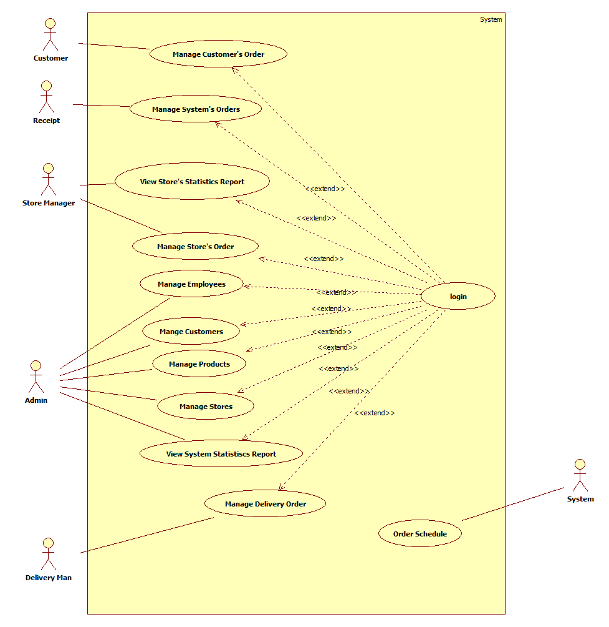

Figure 2- General Use Case Diagram

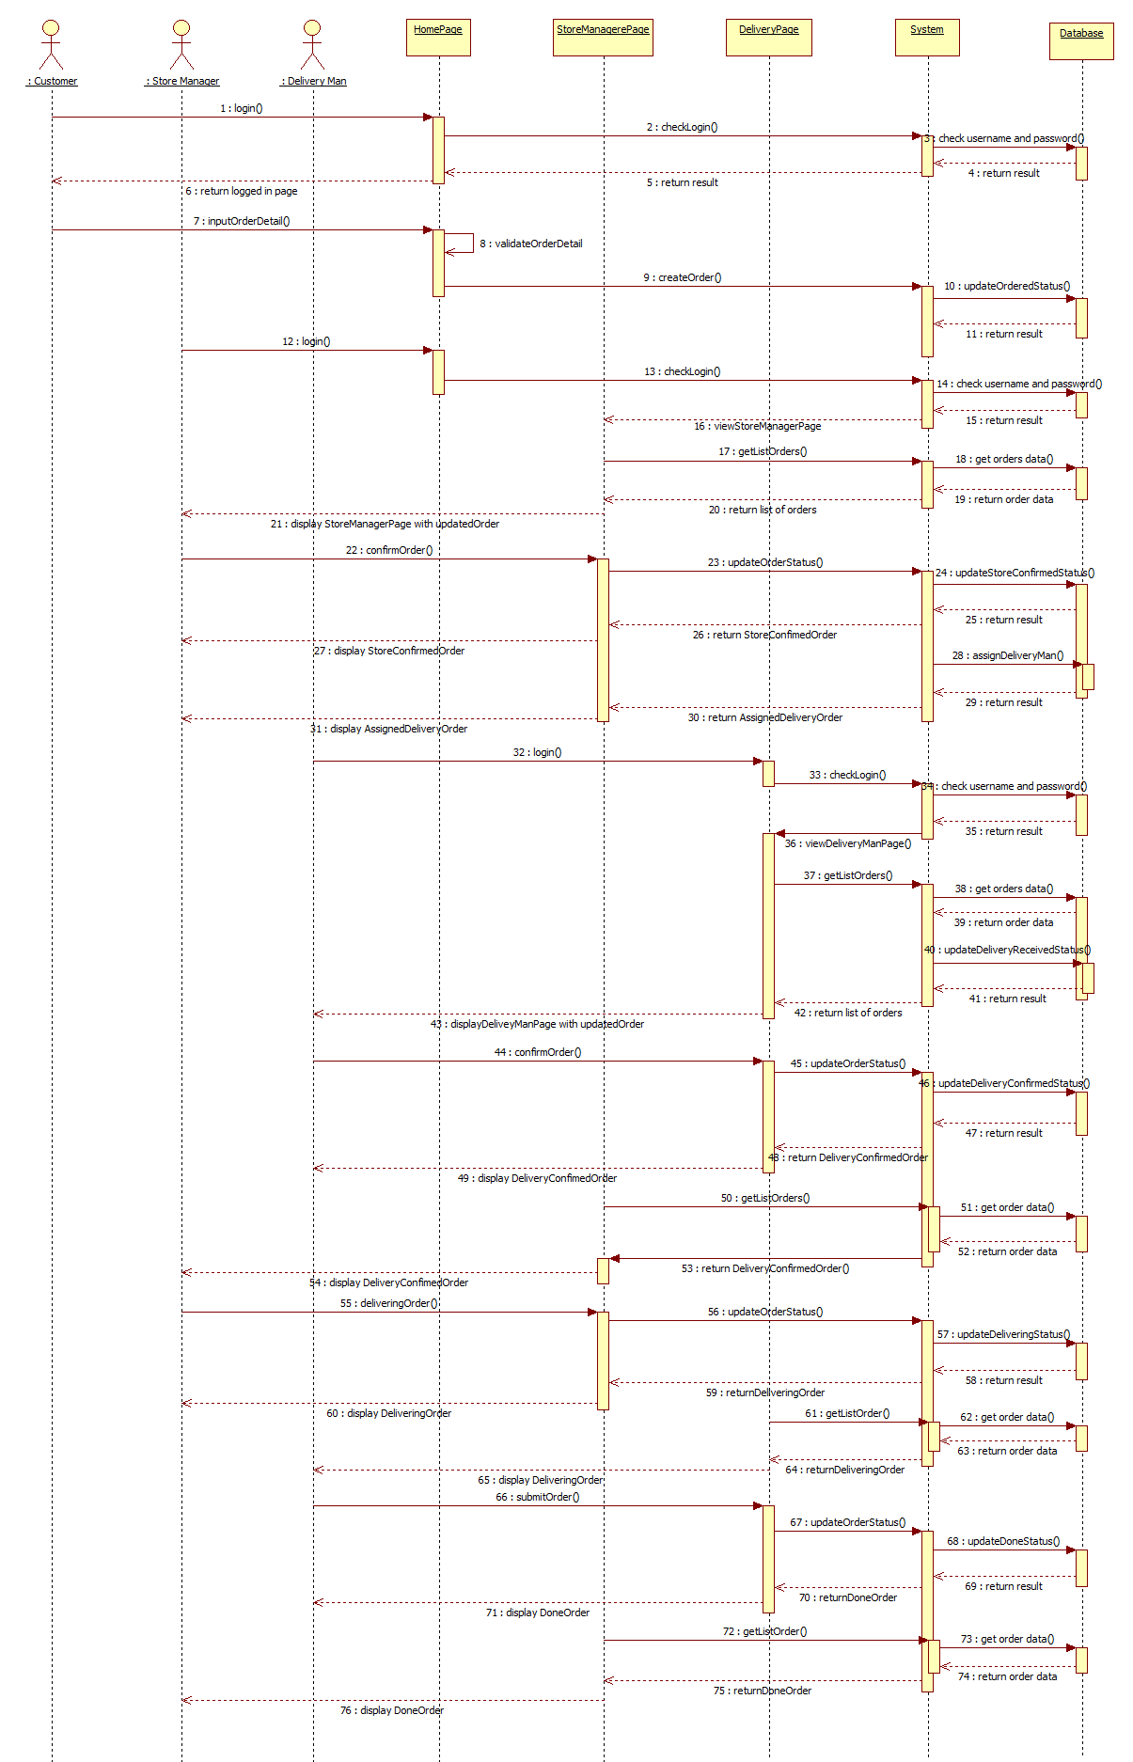

Figure 3- Customer Sequence Diagram



### <User> Log in

Optional

### <User> Log out

Optional

### <Customer> Register

Optional

### < Customer > View and Edit Personal Information

Optional

### < Customer >View and Edit Account Information

Optional

### <Customer, Visitor, Receipt >Create Order



Figure 4- Create Order use case diagram

|  |  |  |  |  |
| --- | --- | --- | --- | --- |
| **USE CASE-UC06 SPECIFICATION** | | | | |
| **Use-case No.** | UC06 | **Use-case Version** | | v1.2 |
| **Use-case Name** | Create Order | | | |
| **Author** | Nguyen Van Long | | | |
| **Date** | 19/11/2012 | **Priority** | High | |
| **Actor:**  User(Customer, Receipt, Visitor)  **Summary:**  User can view product’s details and create order.  **Goal:**  Helps user research products’ information quickly and create order.  **Triggers:**  User wants to create an order online.  (User clicks “Cho vào giỏ hàng” at the bottom of each product to add it into shopping cart)  **Preconditions:**  The page is fully loaded.  If user is customer, login with “Customer” role.  If user is receipt, login with “Receipt” role – create order follow customer requirement.  **PostConditions:**  Success:   * Add products into shopping cart successfully. * Users can view their products in shopping cart.   Failure: System displays error message. Content of error message will be specified in Exception section.  **Main Success Scenario:**   |  |  | | --- | --- | | Actor Actions | System Response | | 1. User clicks on “Cho vào giỏ hàng” button at the bottom of each product to choose product.[Exeption 1]  3. Click on shopping cart icon to see what have chosen.  5. Click “Thanh toán” button. [Alternative 2] [Alternative 3] [Alternative 4] | 2. Add product which is chosen into shopping cart.  4. Display shopping cart popup with product’s information table.[Alternative 1] [Exception 2] [Exception 3]   * Product Name [Tên SP: string, label] * Price [Giá: number, label] * Quantity [Số lượng: drop-down list (min-value: 1 – max-value: 10)] * Total [Tổng cộng: number, label] * Remove [Xóa: button] * Get more [Tiếp tục mua hàng: button] * Finish order[Thanh toán: button] * Cancel shopping cart [Thoát: button]     6. Data will be checked and display “THÔNG TIN GIAO HÀNG” popup. |   **Alternative Scenario:**   |  |  | | --- | --- | | Ator Actions | System Response | | [Alternative 1]  1. User clicks on “Số lượng” drop-down list.  [Alternative 2]  1. User clicks on”Xóa” button to remove product.  [Alternative 3]  1. User clicks on “Tiếp tục mua hàng” button to add more products into shopping cart.  [Alternative 4]  1. User clicks on “Thoát” button to close shopping cart. | 2. Change product quantity.  2. Remove product which is chosen out of shopping cart.  2. Close shopping cart and back to product list page.  2. Close shopping cart and back to product list page. |   **Exceptions:**   |  |  | | --- | --- | |  |  | | Actor Actions | System Response | | [Exception 2]  1. Click more than 10 times on “Cho vào giỏ hàng” button  [Exception 2]  1. Total amount of order is less than 100,000VND.  [Exception 3]  1. Total amount of order is greater than 2,000,000VND. | 2. Show info message: “Bạn đã chọn quá 10 sản phẩm cho + product name”  2. Show info message: “Hiện tại cửa hàng chúng tôi chỉ phục vụ cho đơn hàng trên 100,000 đ. Mong quý khách thông cảm.”  2. Show info message: “Hiện tại cửa hàng chúng tôi chỉ phục vụ cho đơn hàng dưới 2,000,000 đ.Mong quý khách thông cảm.” |   **Relationships:**  Login.  **Business Rules:**  User can only create order from 9:00AM to 21:00PM.  Total amount of order must stay from 100,000VND to 2,000,000VND. | | | | |

Table 6: Create Order Use Case Specification

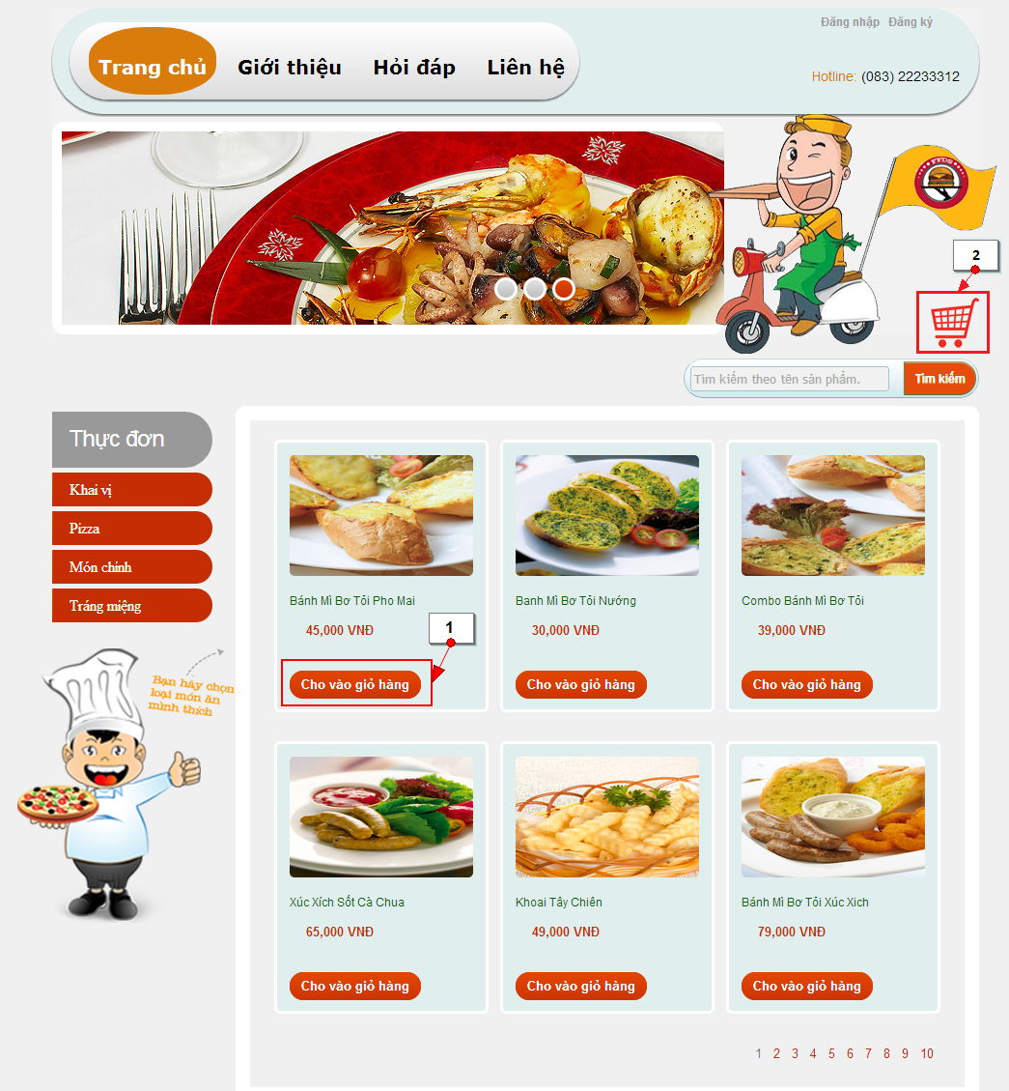

Figure 5- Add products into shopping cart screen

|  |  |  |
| --- | --- | --- |
| **No.** | **Name** | **Description** |
| **1** | “Cho vào giỏ hàng” button | Add products into shopping cart. |
| **2** | “GIỎ HÀNG” | Store all products that customer has just chosen. |

Table 7: Add products into shopping cart screen’s Controls

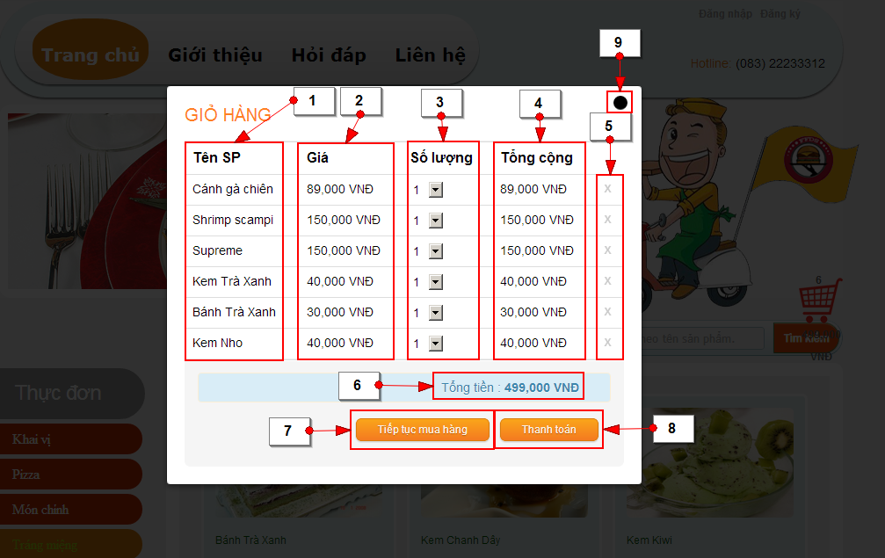

Figure 6- Shopping Cart screen

|  |  |  |
| --- | --- | --- |
| **No.** | **Name** | **Description** |
| **1** | Product Name - Read-only fields(Tên SP) | Display name of product in shopping cart |
| **2** | Price (Giá) - Read-only fields | Display price of product in shopping cart |
| **3** | Quantity (Số lượng) - Editable fields | Display quantity of product in shopping cart |
| **4** | Total amount of each kind of product (Tổng cộng) - Read-only fields | Display total amount of each kind of product in shopping cart |
| **5** | Remove button | Remove product out of shopping cart |
| **6** | Total amount of order (Tổng tiền) - Read-only fields | Display total amount of all products in shopping cart |
| **7** | Get more product button (Tiếp tục mua hàng) | Close “GIỎ HÀNG” popup and back to product list |
| **8** | Liquidation button (Thanh toán) | Close “THANH TOÁN” popup and transfer to “THÔNG TIN GIAO HÀNG” popup |
| **9** | Close button | Close “GIỎ HÀNG” popup and back to product list |

Table 8: Shopping Cart screen’s Controls

### <Customer, Visitor> Check Out Order



Figure 7- Check Out Order use case diagram

|  |  |  |  |  |
| --- | --- | --- | --- | --- |
| **USE CASE-UC07 SPECIFICATION** | | | | |
| **Use-case No.** | UC07 | **Use-case Version** | | v1.2 |
| **Use-case Name** | Check Out Order | | | |
| **Author** | Huyen Ton Nu Uyen Thu | | | |
| **Date** | 19/11/2012 | **Priority** | High | |
| **Actor:**  User(Customer, Visitor)  **Summary:**  After add products into shopping cart successfully, “THÔNG TIN GIAO HÀNG” popup will be shown to check delivery information of customer (visitor).  **Goal:**  Check out liquidation information of user is valid or not.  **Triggers:**  User wants to finish order process.  (User click “Thanh toán” button on “GIỎ HÀNG” popup to go to “THÔNG TIN GIAO HÀNG” popup).  **Preconditions:**  The page is fully loaded.  Add products into shopping cart successfully.  **PostConditions:**  Success: The new order will be added into database.  Failure: System displays error message. Content of error message will be specified in Exception section.  **Main Success Scenario:**   |  |  | | --- | --- | | Actor Actions | System Response | | 1. Click “Thanh toán” button on “GIỎ HÀNG” popup. [Alternative 1]  3. Input delivery information  Customer can change information of   * Lastname [Họ: string, text-box] * Firstname [Tên: string, text-box] * Phone [Số điện thoại: string, text-box] /[0-9]{10,11}/g * House number [Số nhà: string, text-box] * Street [Đường: string, text-box]   Visitor can fill information   * Lastname [Họ: string, text-box] * Firstname [Tên: string, text-box] * Phone [Số điện thoại: string, text-box] /[0-9]{10,11}/g * House number [Số nhà: string, text-box] * Street [Đường: string, text-box]   5. Customer (Visitor) click on “Hoàn tất mua hàng” button to submit order. [Exception 1] [Exception 2][Exception 3][Exception 4] [Exception 5][Exception 6]  7. Customer (Visitor) is waiting. | 2. Check out cutomer (visitor) information [Alternative 2][Alternative 3][Alternative 4]  - If user has logged in with “Customer” role, the system will shows “THÔNG TIN GIAO HÀNG” pop-up with basic information of customer (the information that customer has registered with website)  - If user has not logged in and creates order as “Visitor” role, the system will just shows “THÔNG TIN GIAO HÀNG” popup with empty textboxes.   * Lastname [Họ: string, text-box] * Firstname [Tên: string, text-box] * Phone [Số điện thoại: string, text-box] /[0-9]{10,11}/g * House number [Số nhà: string, text-box] * Street [Đường: string, text-box] * Ward [Phường/Xã: string, text-box, readonly] * District [Quận/Huyện: string, text-box, readonly] * City [Thành Phố: string, text-box, readonly] * Note [(Ghi chú: string, text-box] * Back [Quay lại: button] * View map [Xem bản đồ: link] * Finish order [Hoàn tất mua hàng: button] * Close [Thoát: button]   4. System will base on house number and street name that customer (visitor) has inputted to show address suggestion automationcally and fill Phường/Xã [(Ward: string, text-box, readonly] and Quận/Huyện [(District: string, text-box, readonly] by the top result of address suggestion   * Address suggestion [checkbox]   6. Display message: “Hệ thống đang xử lý, vui lòng đợi giây lát…” when system is checking all information to save into database.  8. Database will be checked and saved into database. Display “ĐẶT HÀNG THÀNH CÔNG” popup with information[Alternative 1]   * Product Name [Tên SP: string, label] * Price [Giá: string, label] * Quantity [Số lượng: int, label] * Total amount [Thành tiền: float, label] * Firstname and lastname [Họ tên: string, label] * Phone [SĐT: string, label] * Address [Địa chỉ: string, label] * Close [Thoát: button] * Print [Xuất PDF: icon]   9. Send order detail to customer’s email address |   **Alternative Scenario:**   |  |  | | --- | --- | | Actor Actions | System Response | | [Alternative 1]  1. Click “Tiếp tục mua hàng” button.  [Alternative 2]  1. Click “Quay lại” button.  [Alternative 3]  1. Click “Xem bản đồ” link. | 2. Close “GIỎ HÀNG” popup and back to product list.  2. Close “THÔNG TIN GIAO HÀNG” popup and back to “GIỎ HÀNG” popup.  2. Display map to help customer find address. |   **Exceptions:**   |  |  | | --- | --- | | Actor Actions | System Response | | [Exception 1]  1. “Họ” text-box is empty.  [Exception 2]  1. “Tên” text-box is empty.  [Exception 3]  1. “Số điện thoại” text-box is empty or invalid.  [Exception 4]  1. “Số nhà” text-box is empty.  [Exception 5]  1. “Đường” text-box is empty.  [Exception 6]  1. Customer’s address is invalid. | 2. Display message: ”Vui lòng nhập họ.”  2. Display message: ”Vui lòng nhập tên”  2. Display message: “Số điện thoại không hợp lệ. Ví dụ : 09xxx, 01xxx.”  2. Display message: “Vui lòng nhập địa chỉ.”  2. Display message: “Vui lòng nhập địa chỉ.”  2. Display message: “Địa chỉ không đúng hoặc không tồn tại trong hệ thống. Xin vui lòng nhập lại.” |   **Relationships:**  Login, Create Order.  **Business Rules:**  User can only finish check out order from 9:00AM to 21:00PM | | | | |

Table 9: Check Out Order Use Case Specification

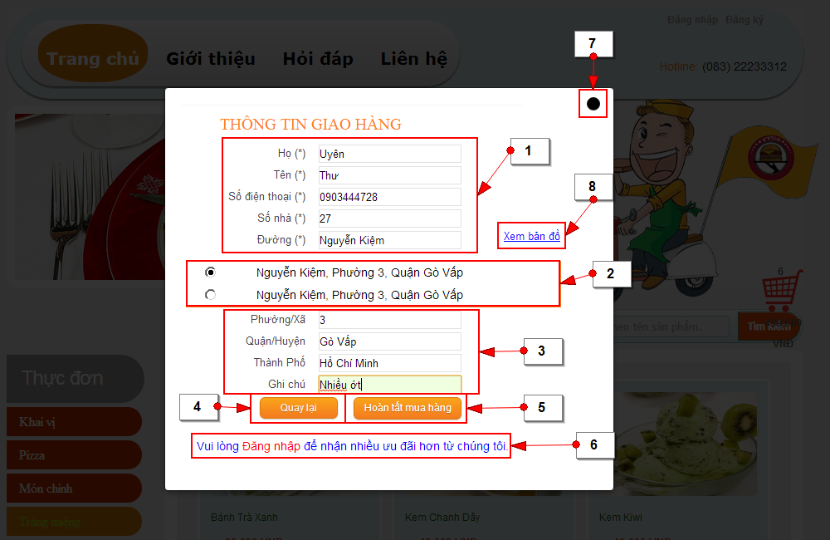

Figure 8- Check Out Order screen

|  |  |  |
| --- | --- | --- |
| **No.** | **Name** | **Description** |
| **1** | Customer’s information – Editable  Lastname (Họ: textbox)  Firstname (Tên: textbox)  Phone (Số điện thoại, texbox)  House number (Số nhà: textbox)  Street (Đường: textbox) | Get information of customer. |
| **2** | Address suggestion (checkbox) | Display addresses suggestion. |
| **3** | Customer’s information - Read-only  Ward (Phường/Xã: textbox)  District (Quận/Huyện: textbox) | Get information from address suggestion. |
| **4** | Back (Quay lại button) | Close “THÔNG TIN GIAO HÀNG” popup and back to “GIỎ HÀNG” popup. |
| **5** | Submit order (Hoàn tất mua hàng: button) | Close “THÔNG TIN GIAO HÀNG” popup and show “ĐẶT HÀNG THÀNH CÔNG” popup. |
| **6** | Login (Đăng nhập link) | Help customer login |
| **7** | Close button | Close “THÔNG TIN GIAO HÀNG” popup and back to product list |
| **8** | View map (Xem bản đồ: link) | Show map to help customer find address more exactly |

Table 10: Check Out Order screen’s Controls

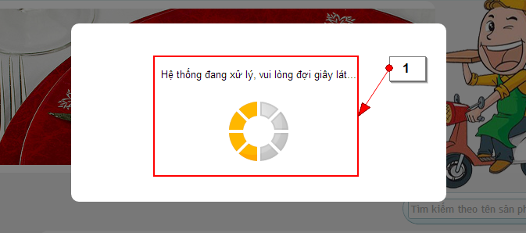

Figure 9- Checking Information Process screen

|  |  |  |
| --- | --- | --- |
| **No.** | **Name** | **Description** |
| **1** | Finish order process | Display when system is checking information to save into database. |

Table 11: Checking Information Process screen’s Controls

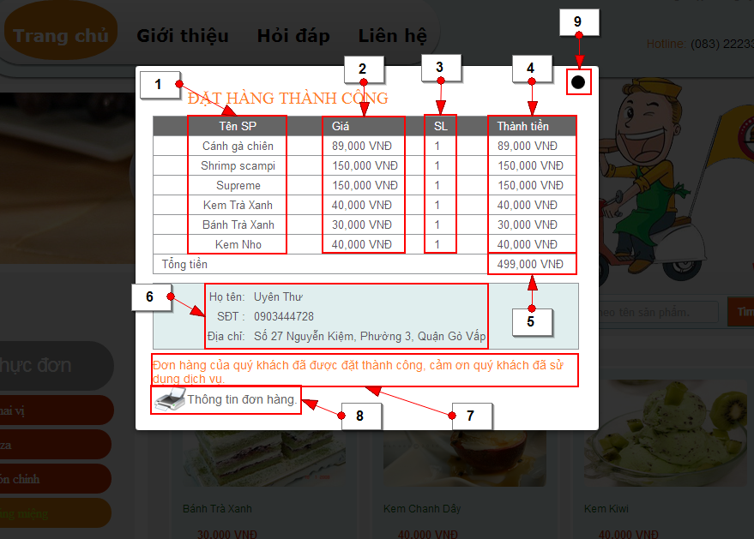

Figure 10- Finish Order screen

|  |  |  |
| --- | --- | --- |
| **No.** | **Name** | **Description** |
| **1** | Product Name (Tên SP) - Read-only | Name of product. |
| **2** | Price (Giá) - Read-only | Price of each kind of product. |
| **3** | Quantity (SL) - Read-only | Quantity of each kind of product. |
| **4** | Total amount of each kind product (Thành tiền) - Read-only | Total amount of each kind of product. |
| **5** | Total amount of order (Tồng tiền) - Read-only | Total amount of all products. |
| **6** | Customer’s information - Read-only fields | Basic information of customer. |
| **7** | Information message | Inform customer that order was created successfully |
| **8** | Print icon | Export order information to PDF for customer |
| **9** | Close button | Close “ĐẶT HÀNG THÀNH CÔNG” popup and back to product list |

Table 12: Finish Order screen’s Controls

### < Customer >Customer Cancel Order



Figure 11- Customer Cancel Order use case diagram

|  |  |  |  |
| --- | --- | --- | --- |
| **USE CASE-UC08 SPECIFICATION** | | | |
| **Use-case No.** | UC08 | **Use-case Version** | v1.2 |
| **Use-case Name** | Customer Cancel Order | | |
| **Author** | Nguyen Van Long | | |
| **Date** | 22/11/2012 | **Priority** | Normal |
| **Actor:**  Customer  **Summary:**  Customer cancel order among 05 minutes count from time customer create order.  **Goal:**  It helps customer to cancel the order.  **Triggers**  Customer wants to cancel the order.  (Customer click “Hủy đơn hàng” link at the bottom of order which has “Ordered” status)  **Preconditions:**  The page is fully loaded.  User log in with “Customer”role.  Stay at customer page.  **Post Conditions:**  Success:   * Status of order will change from “Ordered” to “Customer Cancel”.   Failure: System displays error message. Content of error message will be specified in Exception section.  **Main Success Scenario:**   |  |  | | --- | --- | | Actor Actions | System Response | | 1. Click “Thông tin đơn hàng” tab to view basic information of order  3. Click “Xem chi tiết” link to view details information of order  5. Click “Hủy đơn hàng” link to cancel order.  7. Click “OK” button to confirm[Exception 1] | 2. Display a table with basicinformation of order   * Order ID [Mã đơn hàng: string, label] * View details [Xem chi tiết: link] * Order date [Ngày đặt hàng: timestamp, label] * Total amount [Số tiền phải trả: float, label] * Cancel order [Hủy đơn hàng: link]   4. Display a table with detail information of order   * Product name [Sản phẩm: string, label] * Price [Đơn giá: float, label] * Quantity [Số lượng: int, label] * Total amount of each kind product [Thành tiền: float, label] * Total amount of order [Số tiền phải trả: float, label] * Status [Trạng thái: string, label] * Cancel order [Hủy đơn hàng: link]   6. Show confirmation message: “Bạn có muốn hủy đơn hàng không?” with “OK” button và “Cancel” button. [Alternative 1]  8. Order will be canceled and status of order will be changed from “Ordered” to “Customer Cancel”. |   **Alternative Scenario:**   |  |  | | --- | --- | | Actor Actions | System Response | | [Alternative 1]  1. Click “Cancel” button. | 2. Close info message box and back to “Danh sách đơn hàng”. |   **Exceptions:**   |  |  | | --- | --- | | Actor Actions | System Response | | [Exception 1]  1. Expiring 05 minutes count from time customer creates order. | 2. Display message: “Đơn hàng không tồn tại hoặc quá thời gian hủy” |   **Relationships:**  Login, Create Order and Check Out Order.  **Business Rules:**  The user can only change or cancel their order after order 05 minutes. | | | |

Table 13: Customer Cancel Order Use Case Specification

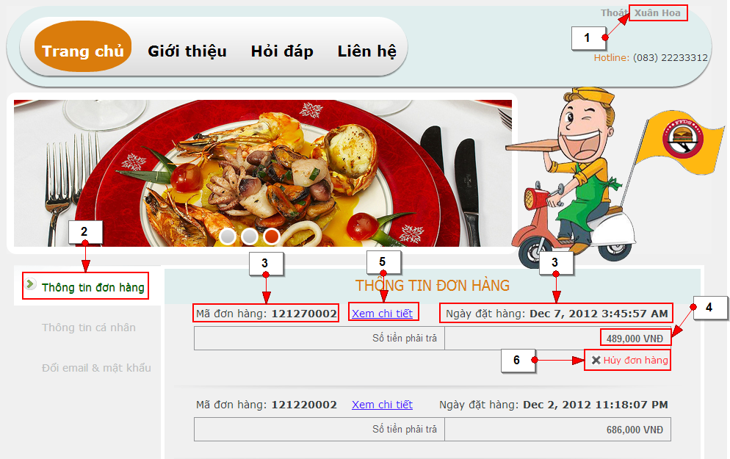

Figure 12- Customer Cancel Order screen

|  |  |  |
| --- | --- | --- |
| **No.** | **Name** | **Description** |
| **1** | Customer Name - Read-only | Name of customer who has just logged in |
| **2** | order information (Thông tin đơn hàng: tab) | Contain order information and cancel order |
| **3** | Basic information of order – Read-only | Quantity of each kind of product. |
| **4** | Total amount of order (Tồng tiền) - Read-only | Total amount of all products. |
| **5** | view order detail (Xem chi tiết : link) | Total amount of each kind of product. |
| **6** | Cancel order (Hủy đơn hàng: link) | Cancel order |

Table 14: Customer Cancel Order screen’s controls

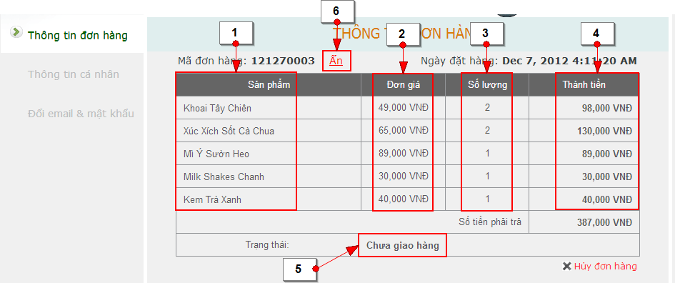

Figure 13- Order Detail screen

|  |  |  |
| --- | --- | --- |
| **No.** | **Name** | **Description** |
| **1** | Product name (Sản phẩm) - Read-only | Name of product |
| **2** | Price (Đơn giá) – Readonly | Price of each kind of product |
| **3** | Product quantity (Số lượng) - Read-only | Quantity of each kind of product. |
| **4** | Total amount of each kind of product (Thành tiền) - Read-only | Total amount of each kind of products. |
| **5** | Order status (Chưa giao hàng) - Read-only | Status of order |
| **6** | Hide (Ẩn: link) | Hide detail of order |

Table 15: Order Detail screen’s Control

### < Receipt > Check Out Order



Figure 14- Check Out Order use case diagram

|  |  |  |  |  |
| --- | --- | --- | --- | --- |
| **USE CASE-UC09 SPECIFICATION** | | | | |
| **Use-case No.** | UC09 | **Use-case Version** | | v1.2 |
| **Use-case Name** | Check Out Order | | | |
| **Author** | Huyen Ton Nu Uyen Thu | | | |
| **Date** | 19/11/2012 | **Priority** | High | |
| **Actor:**  Receipt  **Summary:**  After add products into shopping cart successfully, “THÔNG TIN GIAO HÀNG” popup will be shown to check information of customer (visitor).  **Goal:**  Check out liquidation information of user is valid or not.  **Triggers:**  Receipt wants to finish order process.  (Receipt click “Thanh toán” button on “GIỎ HÀNG” popup to go to “THÔNG TIN GIAO HÀNG” popup).  **Preconditions:**  The page is fully loaded.  Add products into shopping cart successfully.  **PostConditions:**  Success: The new order will be added into database.  Failure: System displays error message. Content of error message will be specified in Exception section.  **Main Success Scenario:**   |  |  | | --- | --- | | Actor Actions | System Response | | 1. Click “Thanh toán” button on “GIỎ HÀNG” popup. [Alternative 1]  3. Receipt can fill customer (visitor) information  ID Khách Hàng [Customer ID: String, textbox ] (this textbox will be filled if receipt create order for a customer, else if receipt create order for a visitor, customer id does not need to be filled)  5. Customer (Visitor or Receipt)click on “Hoàn tất mua hàng” button to submit order. [Exception 1] [Exception 2][Exception 3][Exception 4] [Exception 5][Exception 6]  7. Receipt is waiting. | 2. Check out cutomer (visitor) information [Alternative 2][Alternative 3][Alternative 4]  - If user has has logged in with “Receipt” role, the system will just shows “THÔNG TIN GIAO HÀNG” popup with empty textboxes.   * ID Khách Hàng [Customer ID: String, textbox ] * Họ [(Lastname: string, text-box] * Tên [(Firstname: string, text-box] * Số điện thoại [(Phone: string, text-box]/[0-9]{10,11}/g * Số nhà[(House number: string, text-box] * Đường [(Street: string, text-box] * Phường/Xã [(Ward: string, text-box, readonly] * Quận/Huyện [(District: string, text-box, readonly] * Thành Phố [(City: string, text-box, readonly] * Ghi chú [(Note: string, text-box] * Quay lại [Back: button] * Xem bản đồ [View map: link] * Hoàn tất mua hàng [Finish order: button] * Thoát [Close: button]   4. System will check customer id , if it already existed, all other customer information textboxes will be filled automatically (the information that customer has registered with website)   * Address suggestion [checkbox]   6. Display message: “Hệ thống đang xử lý, vui lòng đợi giây lát…” when system is checking all information to save into database.  8. Database will be checked and saved into database  9. Display “ĐẶT HÀNG THÀNH CÔNG” popup with information[Alternative 1]   * Tên SP [Product Name: string, label] * Giá [Price: string, label] * SL [Quantity: int, label] * Thành tiền [Total amount: float, label] * Họ tên [Firstname, lastname: string, label] * SĐT [Phone: string, label] * Địa chỉ [Address: string, label] * Thoát [Close: button] * Xuất PDF [Print: icon] |   **Alternative Scenario:**   |  |  | | --- | --- | | Actor Actions | System Response | | [Alternative 1]  1. Click “Tiếp tục mua hàng” button.  [Alternative 2]  1. Click “Quay lại” button.  [Alternative 3]  1. Click “Xem bản đồ” link. | 2. Close “GIỎ HÀNG” popup and back to product list.  2. Close “THÔNG TIN GIAO HÀNG” popup and back to “GIỎ HÀNG” popup.  2. Display map to help customer find address. |   **Exceptions:**   |  |  | | --- | --- | | Actor Actions | System Response | | [Exception 1]  1. “Họ” text-box is empty.  [Exception 2]  1. “Tên” text-box is empty.  [Exception 3]  1. “Số điện thoại” text-box is empty or invalid.  [Exception 4]  1. “Số nhà” text-box is empty.  [Exception 5]  1. “Đường” text-box is empty.  [Exception 6]  1. Customer’s address is invalid. | 2. Display message: ”Vui lòng nhập họ.”  2. Display message: ”Vui lòng nhập tên”  2. Display message: “Số điện thoại không hợp lệ. Ví dụ : 09xxx, 01xxx.”  2. Display message: “Vui lòng nhập địa chỉ.”  2. Display message: “Vui lòng nhập địa chỉ.”  2. Display message: “Địa chỉ không đúng hoặc không tồn tại trong hệ thống. Xin vui lòng nhập lại.” |   **Relationships:**  Login, Create Order.  **Business Rules:**  User can only finish check out order from 9:00AM to 21:00PM | | | | |

Table 16: Check Out Order Use Case Specification

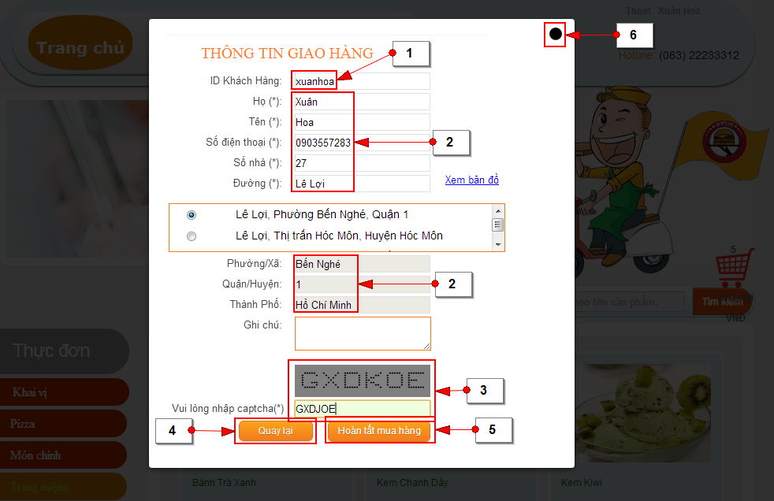

Figure 15- Check Out Order screen

|  |  |  |
| --- | --- | --- |
| **No.** | **Name** | **Description** |
| **1** | Customer ID (ID Khách Hàng) - Readonly | Username of customer |
| **2** | Customer information – Editable  Lastname (Họ: textbox)  Firstname (Tên: textbox)  Phone (Số điện thoại: texbox)  House number (Số nhà: textbox)  Street name (Đường: textbox)  Customer information – Readonly  Ward (Phường/Xã: textbox)  District (Quận/Huyện: textbox)  City (Thành ph: texbox) | Information of customer |
| **3** | Captcha | Confirm human |
| **4** | Back (Quay lại: button) | Close “THÔNG TIN GIAO HÀNG” popup and back to product list |
| **5** | Finish order (Hoàn tất giao hàng: button) | Close “THÔNG TIN GIAO HÀNG” popup and go to “ĐẶT HÀNG THÀNH CÔNG” popup |
| **6** | Close button | Close “THÔNG TIN GIAO HÀNG” popup and back to product list |

Table 17: Check Out Order screen’s Control

### < Receipt > View Order List

Optional

### < Receipt > View Order Detail

Optional

### < Receipt > Receipt Cancel Order



Figure 16- Receipt Cancel Order use case diagram

|  |  |  |  |
| --- | --- | --- | --- |
| **USE CASE-UC12 SPECIFICATION** | | | |
| **Use-case No.** | UC12 | **Use-case Version** | v1.2 |
| **Use-case Name** | Receipt Cancel Order | | |
| **Author** | Huyen Ton Nu Uyen Thu | | |
| **Date** | 07/12/2012 | **Priority** | Normal |
| **Actor:**  Receipt  **Summary:**  Receipt help customer to cancel order.  **Goal:**  It helps receipt to cancel the order.  **Triggers**  Receipt wants to help customer cancel the order.  (Receipt click “Customer cancel” link at order detail popup to cancel order)  **Preconditions:**  The page is fully loaded.  User log in with “Customer”role.  Stay at customer page.  **Post Conditions:**  Success:   * Status of order will change from “Ordered” to “Customer Cancel”.   Failure: System displays error message. Content of error message will be specified in Exception section.  **Main Success Scenario:**   |  |  | | --- | --- | | Actor Actions | System Response | | 1. Click “Thông tin đơn hàng” tab to view basic information of order  3. Click “Xem chi tiết” link to view details information of order  5. Click “Hủy đơn hàng” link to cancel order.  7. Click “OK” button to confirm[Exception 1] | 2. Display a table with basicinformation of order   * Order ID [Mã đơn hàng: string, label] * View details [Xem chi tiết: link] * Order date [Ngày đặt hàng: timestamp, label] * Total amount [Số tiền phải trả: float, label] * Cancel order [Hủy đơn hàng: link]   4. Display a table with detail information of order   * Product name [Sản phẩm: string, label] * Price [Đơn giá: float, label] * Quantity [Số lượng: int, label] * Total amount of each kind product [Thành tiền: float, label] * Total amount of order [Số tiền phải trả: float, label] * Status [Trạng thái: string, label] * Cancel order [Hủy đơn hàng: link]   6. Show confirmation message: “Bạn có muốn hủy đơn hàng không?” with “OK” button và “Cancel” button. [Alternative 1]  8. Order will be canceled and status of order will be changed from “Ordered” to “Customer Cancel”. |   **Alternative Scenario:**   |  |  | | --- | --- | | Actor Actions | System Response | | [Alternative 1]  1. Click “Cancel” button. | 2. Close info message box and back to “Danh sách đơn hàng”. |   **Exceptions:**   |  |  | | --- | --- | | Actor Actions | System Response | | [Exception 1]  1. Expiring 05 minutes count from time customer creates order. | 2. Display message: “Đơn hàng không tồn tại hoặc quá thời gian hủy” |   **Relationships:**  Login, Create Order and Check Out Order.  **Business Rules:**  The user can only change or cancel their order after order 05 minutes. | | | |

Table 18: Customer Cancel Order Use Case Specification

### < Store Manager > View Order List

Optional

### < Store Manager > View Order Detail

Optional

### <Store Manager>Receive Order

Optional

### <Store Manager>Confirm Order



Figure 17- Confirm Order use case diagram

Optional Use-case Specification

### <Store Manager>Cancel Order



Figure 18- Cancel Order use case diagram

Optional Use-case Specification

### <Store Manager>Cancel Order For Customer



Figure 19- Cancel Order For Customer use case diagram

Optional Use-case Specification

### <Delivery Man >Receive Order

Optional

### <Delivery Man >Confirm Order

****

Figure 20- Confirm order use case diagram

Optional Use-case Specification

### <Delivery Man>Finish Order

****

Figure 21- Receive delivery’s order use case diagram

Optional Use-case Specification

### <System>Draw routes in map



Figure 22- Draw routes in map use case diagram

|  |  |  |  |
| --- | --- | --- | --- |
| **USE CASE-UC21 SPECIFICATION** | | | |
| **Use-case No.** | UC22 | **Use-case Version** | v1.2 |
| **Use-case Name** | Draw routes in map | | |
| **Author** | Huynh Thanh Tam | | |
| **Date** | 29/09/2012 | **Priority** | High |
| **Actor:**  System  **Summary:**  It draw route in map from the nearest store to customer and from delivery man to the neareststore.  **Goal:**  It helps delivery man to know the shortestway to deliver order.  **Triggers**  When delivery man receive order from server.  **Preconditions:**  Orders were received from server.  **Post Conditions:**   * Success: * Routes are drawn in map. * Failure: * System displays error message. Content of error message will be specified in Exception section.   **Main Success Scenario:**   |  |  | | --- | --- | | Actor Actions | System Response | | 1. System processing. | 2. System request to Google API to get 2 Json file, to show route from nearest store to customer and from delivery man to nearest store.[Exception 1] [Exception 2]  3. System parses to Json files androidto create the routes.[Exception 1][Exception 3]  4. System show the routes in map view |   **Alternative Scenario:**   |  |  | | --- | --- | | Actor Actions | System Response | | N/A |  |   **Exceptions:**   |  |  | | --- | --- | | Actor Actions | System Response | | [Exception 1]  1. Occur problem with network connection.  [Exception 2]  1. Cannot get Json files from Google API  [Exception 3]  1. Cannot parse Json to get information. | 2. Display error message “Kết nối hệ thống bị gián đoạn!”  2. Display error message “Không thể lấy dữ liệu đường đi.”  2. Display error message “Không tìm thấy lộ trình”. |   **Relationships:**  Login, Receive delivery order.  **Business Rules:**  Returned Google API Json structure need to be known to parse and create the routes. | | | |

Table 19: Draw routes in map use case diagram

### <System> Check order of customer



Figure 23- Check order of customer

|  |  |  |  |
| --- | --- | --- | --- |
| **USE CASE-UC28 SPECIFICATION** | | | |
| **Use-case No.** | UC28 | **Use-case Version** | v1.2 |
| **Use-case Name** | Check order of customer | | |
| **Author** | Pham Viet Phu | | |
| **Date** | 29/09/2012 | **Priority** | High |
| **Actor:**  System  **Summary:**  It helps to validate customer’s order.  **Goal:**  Check order’s information is valid or not  **Triggers**  Customer click “Hoàn tất mua hàng” button.  **Preconditions:**  The page is fully loaded.  **Post Conditions:**   * Success: * All information of order will be submitted. * Failure: * System displays error message. Content of error message will be specified in Exception section.   **Main Success Scenario:**   |  |  | | --- | --- | | Actor Actions | System Response | | 1. System is checking. | 2. System will check total amount of order. [Exception 1] [Exception 2]  3. System will check distance from customer to nearest store.  [Exception 1] [Exception 3]  4. System show message for customer: “Đơn hàng của quý khách đã được đặt thành công, cảm ơn quý khách đã sử dụng dịch vụ.”  [Exception 1] [Exception 2] [Exception 3] |   **Alternative Scenario:**   |  |  | | --- | --- | | Actor Actions | System Response | | N/A |  |   **Exceptions:**   |  |  | | --- | --- | | Actor Actions | System Response | | [Exception 1]  1. Occur problem with network connection.  [Exception 2]  1. Order’s price is lower than 100,000 VND or greater than 2,000,000VND.  [Exception 3]  1. Distance between customer and appropriate store is longer than 15 kilometer. | 2. Log file: “Kết nối hệ thống bị gián đoạn!”  2. Display error message “Cửa hàng chỉ nhận giao hàng cho những đơn hàng có giá trị từ 100.000VND đến 2,000,000VND. Xin quý khách thông cảm!”  2. Display error message “Đơn hàng của quý khách nằm ngoài phạm vi giao hàng của chúng tôi. Xin quý khách thông cảm!” |   **Relationships:**  Login, Create Order, Check out order.  **Business Rules:**  Price of order must greater than 100,000VND and less than 2,000,000VND.  Distance between customer and nearest store must shorter than 15km. | | | |

Table 20: Draw routes in map use case diagram

### <Admin> Manage Employee



### Create New Employee

Optional

### Edit Employee Information

Optional

### Inactive Employee

Optional

### < Admin > Manage Customer



### Create New Customer

Optional

### Edit Customer Information

Optional

### Inactive Customer

Optional

### < Admin > Manage Product

### Create New Product

Optional

### Edit Product Information

Optional

### Inactive Product

Optional

### < Admin > Manage Delivery Man

### View Delivery Man Location

Optional

### < Admin >Manage Store

### Create New Store

Optional

### Update Store Information

Optional

### Inactive Store

Optional

### View Store Location

Optional

### View Order Location

Optional

### <Admin>Report

### Sales Income Report

Optional

### Sales Product Quantity Report

Optional

### <Admin>Configuration

Optional

### Software System Attributes



### Usability

### Graphic User Interface

* + All the text, label and image in Customer page should be in Vietnamese.
  + All the text, label and image in Admin page, Store Manger page, and Delivery Man page should be in English.
  + The interface must be similar with current process.

### Usability for end-users

* + Can access necessary information at the first time.
  + Can use some basic functions without login (add product, change product quantity, and submit order…).
  + Users have to log in to the system to use main functions (view or edit information, view or cancel order…).
  + The system should remember user’s basic information (name, role, contact information…).
  + System should let user edit basic information.

### Usability for admin and staff

* + Admin and staff can understand and use English.
  + Website admin and staff should need no more than one day of training to be productive with the system.

### Installation

* + The system must be easy to deploy. Customer can deploy successfully and learn to configure, maintain the system within one day of training.
  + The attached manual guide must be clear. User can read and do itself without developers’ help.

### Reliability

N/A

### Availability

N/A

### Security

* + Privacy: Each role of user has a specific permission to interact with system. System always checks authorization and authenticated before do anything. Only admin can grant permission to users.

### Maintainability

N/A

### Portability

* + System can run anywhere with the requirements:



#### Hardware:

N/A

#### Network:

N/A

#### Environment:

* Window 7 or above

#### Browser:

* Google Chrome 20 or above
* Firefox 10 or above

### Performance

#### Load time

N/A



#### Capacity

N/A

### Entity Relationship Diagram

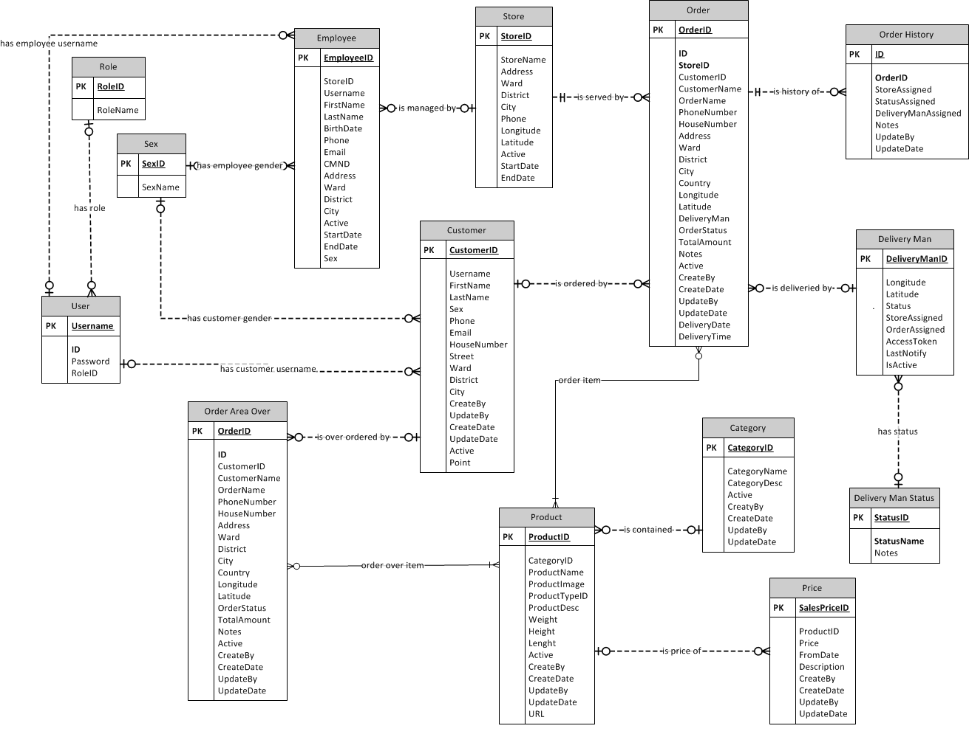

Figure 24- Entity Relationship Diagram

# Software Design Description

## Design Overview

* This document describes the technical and UI design of the FFDS system. It includes the architectural design and the detailed design of common functions and business functions. It also includes the design of database model.
* The architectural design describes the overall architecture of the system, and the architecture of each main component and subsystem. It will describe the patterns being used, the role of each component and the role of the system in the working environment.
* The detailed design describes static and dynamic structure for each component and function. It includes class diagrams, class explanations, and sequence diagrams of each use cases. The detailed design uses notations of Java (J2EE 5) as they are the framework and language for developing the system.
* The database design describes the relationship between entities, and details of each entity. It uses notations of MySQL and Navicat as it is the database server for developing the system.
  + Overview:
* Section II: gives an overall description of the system architecture design. It gives what architecture is chosen and its model that is presented in graphic
* Section III: gives component diagrams that describe the connection and integration of the system.
* Section IV: gives the detail design description include class diagram, class explanation, sequence diagram... to details the application functions in details
* Section V: describe an ERD with many entity and database design.

## System Architectural Design

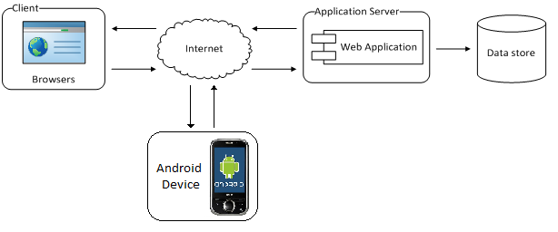

Figure 25: System Architectural Design

* The system will use the Client-Server as the main architecture. It makes use of the Internet and common web protocols to deliver its services to the users.
* The main entities of the above diagram will be described as following:
* Database store: this is the central data storage for the system. System using MySQL.
* Application Server: server Tomcat 6.0.26, Eclipse.
* Clients: these include internet browsers running on personal computers. The web browsers will interact with the web application via normal protocols (HTTP, HTTPS…).
* Android Device: will be installed an application which use to support system process.

## Component Diagram

* The architecture of FFDS system is Three Layers Architecture. Inside each layer, there are some components that handle one or some specific functions.

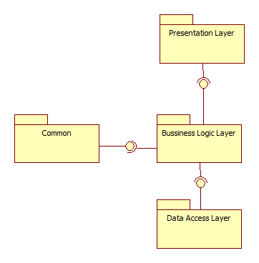

Figure 26: Component Diagram

## Presentation Layer’s Components

* This component has responsibility to deliver the front end to the users and accept their inputs. It will be developed by using JSP combines with JavaSript, jQuery and CSS.

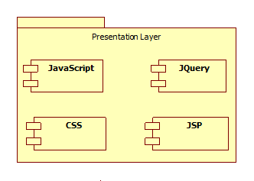

Figure 27: Presentation Layer's Components

### Business Logic Layer’s Components

* This component contains all business logic for the system. It includes business layer object classes, data transfer object classes, servlets …
* These components have responsibility to process importing data, validation, transferring data to presentation layer or data access layer.

**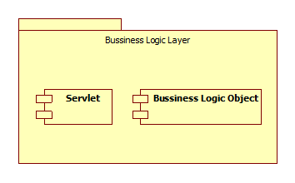**

Figure 28: Business Layer's Components

### Data Access Layer’s Components

* This component contains all data access objects which is responsible for accessing data in database system component and exchange data information with database for the system. It includes data access classes.



Figure 29: Data Access Layer's Components

### Common Component

* This component contains common logic that can be used throughout the application. It also contains library use for sending email, exporting PDF.

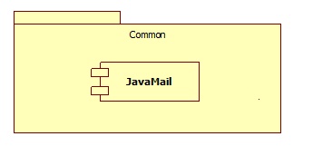

Figure 30: Common Components

## Detailed Design Description of Components

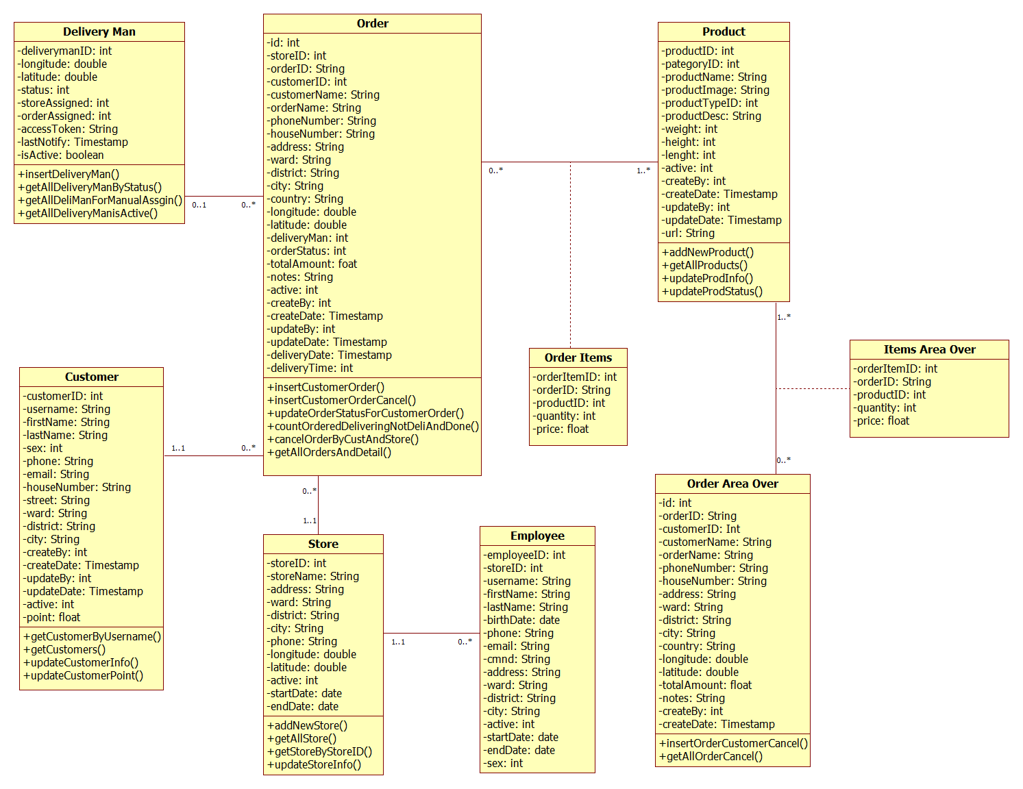

Figure 31: General Class Diagram

### <User> Log in

Optional

### <User> Log out

Optional

### <Customer> Register

Optional

### < Customer > View and Edit Personal Information

Optional

### < Customer >View and Edit Account Information

Optional

### <Customer, Receipt, Visitor>Create Order



### Class Diagram



Figure 32: Create Order Class Diagram

### Class Explanation

### Customer

**Attributes:**

|  |  |  |
| --- | --- | --- |
| **Parameter/Return** | **Type** | **Description** |
| id | int | Id |
| customer\_id | int | The identifier of customer |
| username | String | Username of customer |
| lastname | String | Lastname of customer |
| firstName | String | Firstname of customer |
| sex | int | Gender of customer |
| phone | String | Phone number of customer |
| email | String | Email address of customer |
| houseNumber | String | House number of customer |
| street | String | Street of customer’s address |
| ward | String | Ward of customer’s address |
| district | String | District of customer’s address |
| city | String | City of customer’s address |
| active | int | Status of customer |
| orderPoint | float | Point of customer |

Table 21: Customer Attributes

**Methods:**

* public Customer getCustomerByUsername(String username): this method is used to get all customer’s information base on customer’s username

|  |  |  |
| --- | --- | --- |
| **Parameter/Return** | **Type** | **Description** |
| Return | Customer | Return the information of customer |

Table 22: getCustomerByUserName’s Parameters

**Methods:**

* public boolean updateCustomerInfo(int customer\_id, String first\_name, String last\_name, int sex, String phone, String email, String house\_number, String street, String ward, String district, String city): this method is used to update customer information

|  |  |  |
| --- | --- | --- |
| **Parameter/Return** | **Type** | **Description** |
| Return | boolean | Is update or not |

Table 23: getCustomerByUserName’s Parameters

**Methods:**

* public boolean updateCustomerPoint(int customerID, float orderPoint): this method is used to update point of customer

|  |  |  |
| --- | --- | --- |
| **Parameter/Return** | **Type** | **Description** |
| Return | boolean | Is update or not |

Table 24: updateCustomerPoint’s Parameters

### Order

**Attributes:**

|  |  |  |
| --- | --- | --- |
| **Parameter/Return** | **Type** | **Description** |
| Id | Int | ID |
| orderID | String | The identifier of order |
| customerID | int | The identifier of customer |
| customerName | String | Name of customer |
| orderName | String | Name of order |
| phoneNumber | String | Phone number of customer |
| houseNumber | String | House number of order |
| address | String | House number of customer |
| ward | String | Ward of customer’s address |
| district | String | District of customer’s address |
| city | String | City of customer’s address |
| Country | String | country of customer’s address |
| longitude | double | Longitude of order |
| latitude | double | Latitude of order |
| deliveryMan | int | ID of delivery man |
| orderStatus | int | ID of order’s status |
| totalAmount | Float | Total amount of order |
| notes | String | Notes of customer about order |

Table 25: Order Attributes

**Methods:**

* public String insertOrderCustomer(Order order, int customerID): this method is used to insert order

|  |  |  |
| --- | --- | --- |
| **Parameter/Return** | **Type** | **Description** |
| order | Order | The information of order |
| Return | String | Return the list contain customer’s information |

Table 26: insertOrderCustomer’s Parameters

**Methods:**

* public ArrayList<OrderItem> getOrderItemsByOrder(String OrderID): this method is used to insert order to table

|  |  |  |
| --- | --- | --- |
| **Parameter/Return** | **Type** | **Description** |
| Return | ArrayList<OrderItem> | List items of order |

Table 27: getOrderItemsByOrder’s Parameters

**Methods:**

* public int checkValidOrderCustomer(String house\_number, String address, String ward, String district, String city, float total\_amount): this method is used to check order of customer is valid or not

|  |  |  |
| --- | --- | --- |
| **Parameter/Return** | **Type** | **Description** |
| Return | int | Result of checking |

Table 28: checkValidOrderCustomer’s Parameters

### Store

**Attributes:**

|  |  |  |
| --- | --- | --- |
| **Parameter/Return** | **Type** | **Description** |
| storeID | int | The identifier of store |
| employeeID | int | The identifier of employee |
| storeName | int | Name of store |
| address | String | Address of store |
| ward | String | Ward of store’s address |
| district | String | District of store’s address |
| city | String | City of store’s address |
| phone | String | Phone number of store |
| longitude | double | Longitude of store’s location |
| latitude | double | Latitude of store’s location |
| active | int | Status of store |

Table 29: Store Attributes

**Methods:** N/A

### Sequence Diagram



Figure 33: Create Order Sequence Diagram

### < Customer > Customer Cancel Order

Optional

### < Receipt > View Order List

Optional

### < Receipt > View Order Detail

Optional

### < Receipt > View Customer List

Optional

### < Store Manager > View Order List

Optional

### < Store Manager > View Order Detail

Optional

### <Store Manager>Receive Order

Optional

### <Store Manager>Confirm Order

Optional

### <Store Manager>Cancel Order



### Class Diagram



Figure 34: Create Order Class Diagram

### Class Explanation

### Order

**Attributes:**

|  |  |  |
| --- | --- | --- |
| **Parameter/Return** | **Type** | **Description** |
| Id | Int | ID |
| orderID | String | The identifier of order |
| customerID | int | The identifier of customer |
| customerName | String | Name of customer |
| orderName | String | Name of order |
| phoneNumber | String | Phone number of customer |
| houseNumber | String | House number of order |
| address | String | House number of customer |
| ward | String | Ward of customer’s address |
| district | String | District of customer’s address |
| city | String | City of customer’s address |
| Country | String | country of customer’s address |
| longitude | double | Longitude of order |
| latitude | double | Latitude of order |
| deliveryMan | int | ID of delivery man |
| orderStatus | int | ID of order’s status |
| totalAmount | Float | Total amount of order |
| notes | String | Notes of customer about order |

Table 30: Order Attributes

**Methods:**

* public String insertOrderCustomer(Order order, int customerID): this method is used to insert of customer

|  |  |  |
| --- | --- | --- |
| **Parameter/Return** | **Type** | **Description** |
| order | Order | The information of order |
| Return | String | Return the list contain customer’s information |

Table 31: insertOrderCustomer’s Parameters

**Methods:**

* public ArrayList<Order> searchNewOrdersByStore(int storeID): this method is used to search all new orders of store

|  |  |  |
| --- | --- | --- |
| **Parameter/Return** | **Type** | **Description** |
| Return | ArrayList<Order> | List orders of store |

Table 32: searchNewOrdersByStore’s Parameters

**Methods:**

* public ArrayList<OrderItem> getOrderItemsByOrder(String orderID): this method is used to all items of order

|  |  |  |
| --- | --- | --- |
| **Parameter/Return** | **Type** | **Description** |
| Return | ArrayList<OrderItem> | List all items of order |

Table 33: getOrderItemsByOrder’s Parameters

### Store

**Attributes:**

|  |  |  |
| --- | --- | --- |
| **Parameter/Return** | **Type** | **Description** |
| storeID | int | The identifier of store |
| employeeID | int | The identifier of employee |
| storeName | int | Name of store |
| address | String | Address of store |
| ward | String | Ward of store’s address |
| district | String | District of store’s address |
| city | String | City of store’s address |
| phone | String | Phone number of store |
| longitude | double | Longitude of store’s location |
| latitude | double | Latitude of store’s location |
| active | int | Status of store |

Table 34: Store Attributes

**Methods:**

* public Store getStoreByStoreID(int storeID): this method is used to get all store’s information base on the identifier of store

|  |  |  |
| --- | --- | --- |
| **Parameter/Return** | **Type** | **Description** |
| Return | Store | Information of store |

Table 35: getStoreByStoreID’s Parameters

**Methods:**

* public ArrayList<String> getStoreLatLong(int StoreID): this method is used to get longitude and latitude of store

|  |  |  |
| --- | --- | --- |
| **Parameter/Return** | **Type** | **Description** |
| Return | ArrayList<String> | List orders of store |

Table 36: searchNewOrdersByStore’s Parameters

**Methods:**

* public boolean cancelOrderByCustAndStore(String order\_id, boolean isCustomer): this method is used to cancel order

|  |  |  |
| --- | --- | --- |
| **Parameter/Return** | **Type** | **Description** |
| Return | boolean | Is cancel or not |

Table 37: searchNewOrdersByStore’s Parameters

### Sequence Diagram

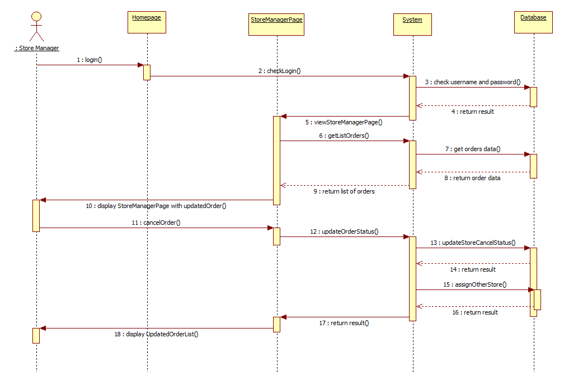

Figure 35: Store Reject Order Sequence Diagram

### <Store Manager>Cancel Order for Customer

Optional

### <Delivery Man >Receive Order

Optional

### <Delivery Man >Confirm Order

Optional

### <Delivery Man >Finish Order

Optional

### < Delivery Man >Does not confirm order



### Class Diagram

Optional

### Class Explaination

Optional

### Sequence Diagram

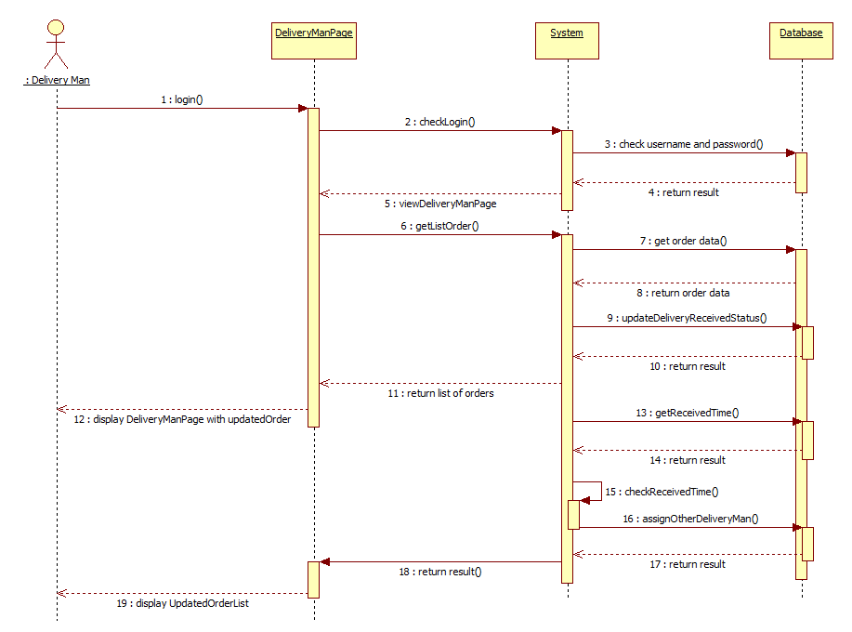

Figure 36: Delivery Man Does Not Confirm Order Sequence Diagram

### <System>Draw routes in map

Optional

### <System> Check order of customer

Optional

### <Admin> Manage Employee



### Create New Employee

Optional

### Edit Employee Information

Optional

### Inactive Employee

Optional

### < Admin > Manage Customer



### Create New Customer

Optional

### Edit Customer Information

Optional

### Inactive Customer

Optional

### < Admin > Manage Product



### Create New Product

Optional

### Edit Product Information

Optional

### Inactive Product

Optional

### < Admin > Manage Delivery Man



### View Delivery Man Location

Optional

### < Admin >Manage Store



### Create New Store

Optional

### Update Store Information

Optional

### Inactive Store

Optional

### View Store Location

Optional

### View Order Location

Optional

### <Admin>Report



### Sales Income Report

Optional

### Sales Product Quantity Report

Optional

## Algorithm

### Create Order

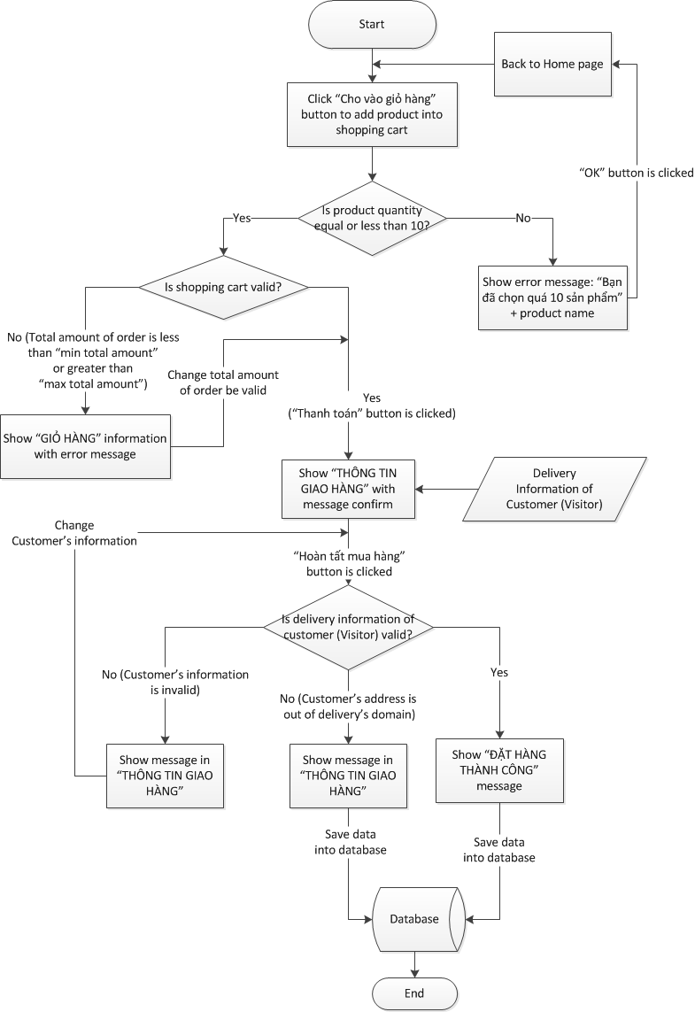

Figure 37: Create Order Algorithm

### Assign Order To Store

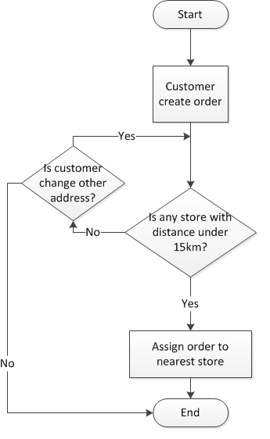

Figure 38: Assign Order To Store Algorithm

### Store Manager Cancel Order

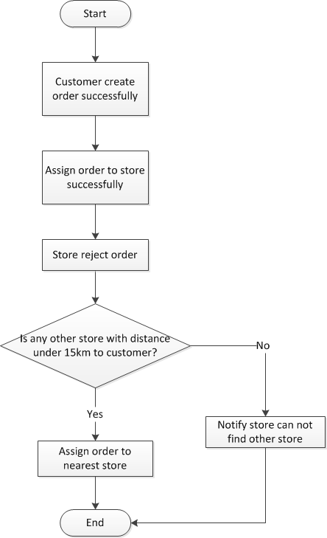

Figure 39: Store Manager Cancel Order Algorithm

### Suggest Address To Customer

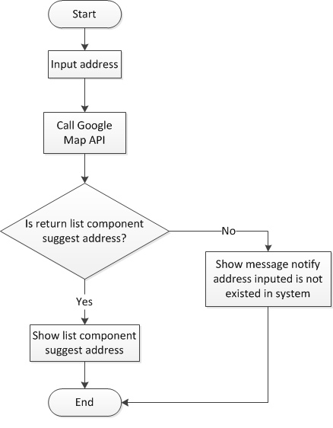

Figure 40: Suggest Address To Customer Algorithm

## Database Design

### Entity Relation Diagram

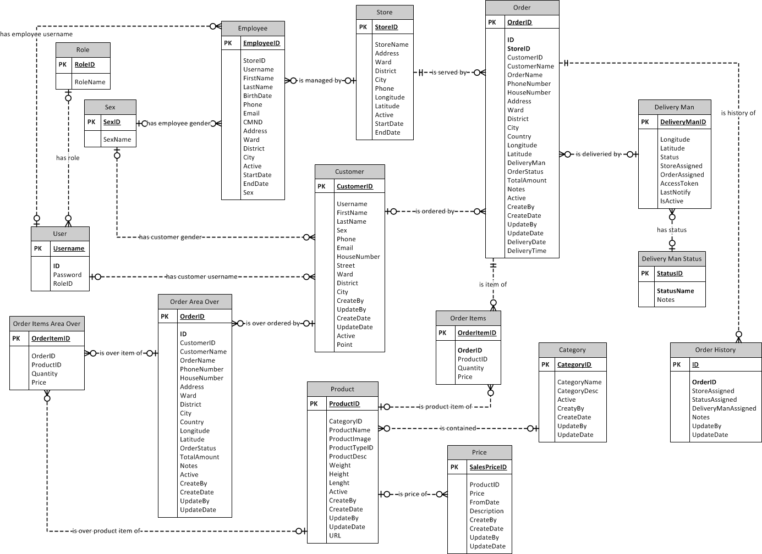

Figure 41: Entity Relation Diagram

### Tables

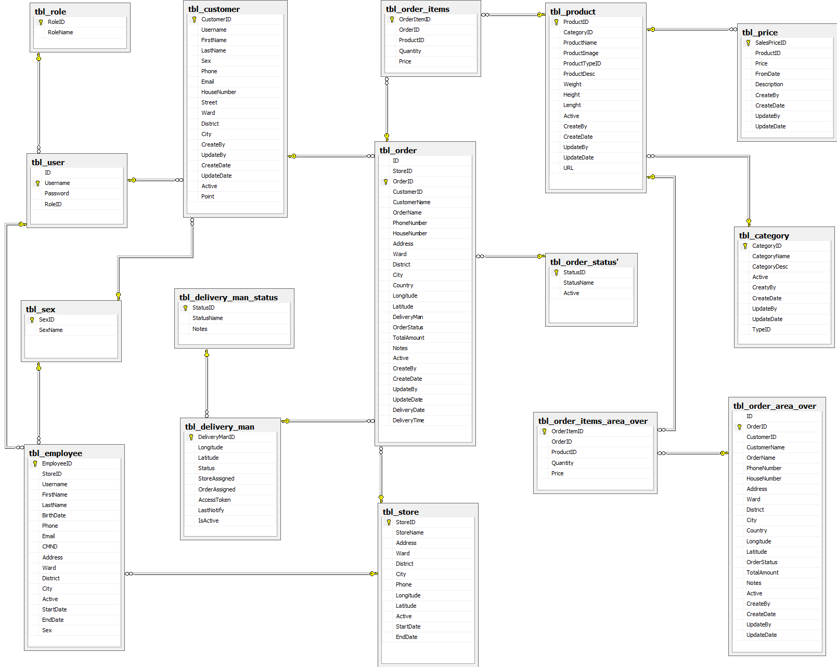

Figure 42: Database Diagram

|  |  |  |
| --- | --- | --- |
| **No.** | **Table Name** | **Description** |
| 1 | Tbl\_role | Storing information about all roles in system |
| 2 | Tbl\_sex | Storing information about all gender in system |
| 3 | Tbl\_user | Storing information about account (username, password, role) of all users in system |
| 4 | Tbl\_emloyee | Storing information (username, phone, email, address, …) about all employees (admin, store manager, receipt, delivery man) in system |
| 5 | Tbl\_customer | Storing information (username, phone, email, address, …) about all customers in system |
| 6 | Tbl\_delivery\_man\_status | Storing all status of delivery man in system |
| 7 | Tbl\_delivery\_man | Storing delivery information (location, number of order…) of delivery man |
| 8 | Tbl\_order\_items | Storing information (quantity, price…) of all products in each order |
| 9 | Tbl\_order | Storing information (order id, customer name, address, total amount…) about all order |
| 10 | Tbl\_product | Storing information (product id, product name, category…) about all products in system |
| 11 | Tbl\_order\_status | Storing all status of order |
| 12 | Tbl\_store | Storing information (store name, address, phone…) about all stores in system |
| 13 | Tbl\_price | Storing price information of all products |
| 14 | Tbl\_order\_items\_area\_over | Storing information (quantity, price…) about all products of each order which over 05 kilometers |
| 15 | Tbl\_category | Storing information about all category in system |
| 16 | Tbl\_order\_area\_over | Storing information (order id, customer name, address, total amount…) about all order which over 05 kilometers |
| 17 | Tbl\_product\_type | Storing all types of product |

Table 38: Tables List

### Table Dictionary



#### Tbl\_role

|  |  |  |  |  |  |  |
| --- | --- | --- | --- | --- | --- | --- |
| Field Name | Type | Null | Unique | P/F Key | Default | Description |
| RoleID | int |  |  | PK |  | The ID of the role |
| RoleName | varchar(30) |  |  |  |  | The name of role |

Table 39: tbl\_role table dictionary

#### Tbl\_sex

|  |  |  |  |  |  |  |
| --- | --- | --- | --- | --- | --- | --- |
| Field Name | Type | Null | Unique | P/F Key | Default | Description |
| SexID | int |  |  | PK |  | The ID of the sex |
| SexName | varchar(15) |  |  |  |  | The name of sex |

Table 40: tbl\_sex table dictionary

#### Tbl\_user

|  |  |  |  |  |  |  |
| --- | --- | --- | --- | --- | --- | --- |
| Field Name | Type | Null | Unique | P/F Key | Default | Description |
| ID | int |  |  | PK |  | The ID of user |
| Username | varchar(30) |  |  | PK |  | The username of user |
| Password | varchar(30) |  |  |  |  | The password of user |
| RoleID | int |  |  | FK |  | The role of user |

Table 41: tbl\_user table dictionary

#### Tbl\_employee

|  |  |  |  |  |  |  |
| --- | --- | --- | --- | --- | --- | --- |
| Field Name | Type | Null | Unique | P/F Key | Default | Description |
| EmployeeID | int |  |  | PK |  | The ID of employee |
| StoreID | int |  |  | FK |  | The Id of store |
| RoleID | int |  |  | FK |  | The ID of role |
| Username | varchar (50) |  |  | FK |  | The username of employee |
| FirstName | varchar (50) |  |  |  |  | The first name of employee |
| LastName | varchar (50) |  |  |  |  | The last name of employee |
| BirthDate | date |  |  |  |  | The birth date of employee |
| Phone | varchar (15) |  |  |  |  | The phone of employee |
| Email | varchar (50) |  |  |  |  | The email of employee |
| CMND | varchar (15) |  |  |  |  | The identify card of employee |
| Address | varchar (100) |  |  |  |  | The address of employee |
| Ward | varchar (50) |  |  |  |  | The ward of employee’s address |
| District | varchar (50) |  |  |  |  | The district of employee’s address |
| City | varchar (50) |  |  |  |  | The city of employee’s address |
| Active | Binary (255) |  |  |  | True | Whether an employee is available for system or not |
| StartDate | date |  |  |  |  | The start date work of employee |
| EndDate | date |  |  |  |  | The end date work of employee |
| Sex | int |  |  |  |  | The gender of employee |

Table 42: tbl\_user table dictionary

#### Tbl\_customer

|  |  |  |  |  |  |  |
| --- | --- | --- | --- | --- | --- | --- |
| Field Name | Type | Null | Unique | P/F Key | Default | Description |
| CustomerID | int |  |  | PK |  | The ID of the customer |
| Username | varchar(50) |  |  | FK |  | The username of customer |
| FirstName | varchar(30) |  |  |  |  | The first name of customer |
| LastName | varchar(30) |  |  |  |  | The last name of customer |
| Sex | int |  |  |  |  | The gender of customer |
| Phone | varchar(15) |  |  |  |  | The phone number of customer |
| Email | varchar(50) |  |  |  |  | The email address of customer |
| HouseNumber | varchar(15) |  |  |  |  | The house number of customer’s address |
| Street | varchar(50) |  |  |  |  | The street name of customer’s address |
| Ward | varchar(50) |  |  |  |  | The ward of customer’s address |
| District | varchar(50) |  |  |  |  | The district of customer’s address |
| City | varchar(50) |  |  |  |  | The city of customer’s address |
| CreateBy | varchar(100) |  |  |  |  | The username of person (admin or customer) who create the customer account |
| UpdateBy | varchar(100) |  |  |  |  | The username of person (admin or customer) who update the customer account |
| CreateDate | timestamp |  |  |  |  | The date create customer account |
| UpdateDate | timestamp |  |  |  |  | The date update customer account |
| Active | binary (255) |  |  |  | True | Whether an customer is available for system or not |
| Point | float (10) |  |  |  |  | The points that user will get after they create an order successfully |

Table 43: tbl\_customer Table Dictionary

#### Tbl\_delivery\_man\_status

|  |  |  |  |  |  |  |
| --- | --- | --- | --- | --- | --- | --- |
| Field Name | Type | Null | Unique | P/F Key | Default | Description |
| StatusID | int |  |  | PK |  | The ID of the holiday |
| StatusName | varchar (15) |  |  |  |  | The date when the holiday begins |
| Notes | varchar (100) | True |  |  |  | The date when the holiday ends |

Table 44: tbl\_delivery\_man Table Dictionary

#### Tbl\_delivery\_man

|  |  |  |  |  |  |  |
| --- | --- | --- | --- | --- | --- | --- |
| Field Name | Type | Null | Unique | P/F Key | Default | Description |
| DeliveryManID | int |  |  | PK |  | The ID of the room |
| Longitude | double (20) |  |  |  |  | The building that the room belongs to |
| Latitude | double (20) |  |  |  |  | Whether a room is available for system or not |
| Status | int |  |  |  |  | The status of delivery man |
| StoreAssigned | int |  |  |  |  | The number of store that assign order for delivery man |
| OrderAssigned | int |  |  |  |  | The number of order that was assigned for delivery man |
| AccessToken | varchar (255) |  |  |  |  | Contains the security information for a login session and identifies the delivery man |
| LastNotify | timestamp |  |  |  |  | Save the last update |
| IsActive | binary |  |  |  | True | Whether a delivery man is available for system or not |

Table 45: tbl\_delivery\_man Table Dictionary

#### Tbl\_order\_items

|  |  |  |  |  |  |  |
| --- | --- | --- | --- | --- | --- | --- |
| Field Name | Type | Null | Unique | P/F Key | Default | Description |
| OrderItemID | int |  |  | PK |  | The ID of order item |
| OrderID | varchar (30) |  |  | FK |  | The ID of order |
| ProductID | int |  |  | FK |  | The ID of product |
| Quantity | int |  |  |  |  | The quantity of each kind of product in order |
| Price | float |  |  |  |  | The price of each kind of product in order |

Table 46: tbl\_order\_items Table Dictionary

#### Tbl\_order

|  |  |  |  |  |  |  |
| --- | --- | --- | --- | --- | --- | --- |
| Field Name | Type | Null | Unique | P/F Key | Default | Description |
| ID | int |  |  | PK |  | The table’s ID which will increase automatically |
| StoreID | int |  |  | FK |  | The ID of store |
| OrderID | varchar (30) |  |  | FK |  | The ID of order |
| CustomerID | int |  |  | FK |  | The ID of customer |
| CustomerName | varchar (50) |  |  |  |  | The name of customer |
| OrderName | varchar (100) |  |  |  |  | The name of order |
| PhoneNumber | varchar (13) |  |  |  |  | The phone number of customer |
| HouseNumber | varchar (15) |  |  |  |  | The house number of customer |
| Address | varchar (100) |  |  |  |  | The address of customer |
| Ward | varchar (30) |  |  |  |  | The ward of customer’ address |
| District | varchar (30) |  |  |  |  | The district of customer’s address |
| City | varchar (30) |  |  |  |  | The city of customer’s address |
| Country | varchar (30) |  |  |  |  | The country of customer |
| Longitude | double |  |  |  |  | The longitude of customer’s address |
| Latitude | double |  |  |  |  | The latitude of customer’s address |
| DeliveryMan | int |  |  | FK |  | The ID of delivery man who deliver the order |
| OrderStatus | int |  |  |  |  | The status’s ID of order at current time |
| TotalAmount | float |  |  |  |  | The total amount of order |
| Notes | text | True |  |  |  | The note of customer about order |
| Active | binary |  |  |  | True | The order is valid or not |
| CreateBy | varchar (30) |  |  |  |  | The ID of person who create order |
| CreateDate | timestamp |  |  |  |  | The create date of order |
| UpdateBy | varchar (30) |  |  |  |  | The ID of person who update order |
| UpdateDate | timestamp |  |  |  |  | The update date of order |
| DeliveryDate | timestamp |  |  |  |  | The date that delivery ma deliver order to customer |
| DeliveryTime | float |  |  |  |  | The period of time count from the time that delivery man receive order to deliver to the time customer receive order |

Table 47: tbl\_order Table Dictionary

#### Tbl\_product

|  |  |  |  |  |  |  |
| --- | --- | --- | --- | --- | --- | --- |
| Field Name | Type | Null | Unique | P/F Key | Default | Description |
| ProductID | int |  |  | PK |  | The ID of product |
| CategoryID | int |  |  | FK |  | The ID of category |
| ProductName | varchar (50) |  |  |  |  | The name of product |
| ProductImage | varchar (50) |  |  |  |  | The image’s url of product |
| ProductTypeID | int |  |  | FK |  | The ID of product type |
| ProductDesc | text |  |  |  |  | The description of product |
| Weight | int |  |  |  |  | The weight of product |
| Height | int |  |  |  |  | The height of product |
| Lenght | int |  |  |  |  | The length of product |
| Active | binary |  |  |  | True | Whether a product is available or not |
| CreateBy | varchar(30) |  |  |  |  | The id of person who create product’s information |
| CreateDate | date |  |  |  |  | The create date of product |
| UpdateBy | varchar(30) |  |  |  |  | The id of person who update product’s information |
| UpdateDate | date |  |  |  |  | The update date of product |
| URL | varchar(200) |  |  |  |  | Link to product detail |

Table 48: tbl\_product Table Dictionary

#### Tbl\_order\_status

|  |  |  |  |  |  |  |
| --- | --- | --- | --- | --- | --- | --- |
| Field Name | Type | Null | Unique | P/F Key | Default | Description |
| StatusID | int |  |  | PK |  | The ID of order’s status |
| StatusName | varchar(30) |  |  |  |  | The name of status |
| Active | binary |  |  |  |  | Whether a status is available or not |

Table 49: tbl\_order\_status Table Dictionary

#### Tbl\_store

|  |  |  |  |  |  |  |
| --- | --- | --- | --- | --- | --- | --- |
| Field Name | Type | Null | Unique | P/F Key | Default | Description |
| StoreID | int |  |  | PK |  | The ID of store |
| StoreName | varchar(50) |  |  |  |  | The name of store |
| ManagerID | int |  |  | FK |  | The Manager ID of store |
| Address | varchar(100) |  |  |  |  | The address of store |
| Ward | varchar(50) |  |  |  |  | The war of store’s address |
| District | varchar(50) |  |  |  |  | The district of store’s address |
| City | varchar(30) |  |  |  |  | The city of store’s city |
| Phone | varchar(15) |  |  |  |  | The phone number |
| Longitude | double |  |  |  |  | The date when the course begins |
| Latitude | double |  |  |  |  | The ID of the slot which the course will be hold on |
| Active | binary |  |  |  | True | Whether a store is available for system or not |
| StartDate | date |  |  |  |  | The start date of store |
| EndDate | date |  |  |  |  | The end date of store |

Table 50: tbl\_store Table Dictionary

#### Tbl\_price

|  |  |  |  |  |  |  |
| --- | --- | --- | --- | --- | --- | --- |
| Field Name | Type | Null | Unique | P/F Key | Default | Description |
| SalesPriceID | int |  |  | PK |  | The sales price ID of product |
| ProductID | int |  |  | FK |  | The ID of product |
| Price | float |  |  |  |  | The price of product |
| FromDate | date |  |  |  |  | The start date selling of product |
| ToDate | date |  |  |  |  | The end date selling of product |
| Description | text | True |  |  |  | The description of product |
| CreateBy | varchar (30) |  |  |  |  | The ID of person who create price for product |
| CreateDate | date |  |  |  |  | The create date of product’s price |
| UpdateBy | varchar (30) |  |  |  |  | The ID of person who update price for product |
| UpdateDate | date |  |  |  |  | The update date of product’s price |

Table 51: tbl\_price Table Dictionary

#### Tbl\_order\_items\_area\_over

|  |  |  |  |  |  |  |
| --- | --- | --- | --- | --- | --- | --- |
| Field Name | Type | Null | Unique | P/F Key | Default | Description |
| OrderItemID | int |  |  | PK |  | The ID of order item which is canceled |
| OrderID | varchar (30) |  |  | FK |  | The ID of order which is canceled |
| ProductID | int |  |  | FK |  | The ID of product which is canceled |
| Quantity | int |  |  |  |  | The quantity of each kind of product in order which is canceled |
| Price | float |  |  |  |  | The price of each kind of product in order which is canceled |

Table 52: tbl\_order\_items\_cancel Table Dictionary

#### Tbl\_category

|  |  |  |  |  |  |  |
| --- | --- | --- | --- | --- | --- | --- |
| Field Name | Type | Null | Unique | P/F Key | Default | Description |
| CategoryID | int |  |  | PK |  | The ID of category |
| CategoryName | varchar (50) |  |  |  |  | The name of category |
| CategoryDesc | varchar (100) |  |  |  |  | The description of category |
| Active | binary |  |  |  |  | Whether a category is available for system or not |
| CreatyBy | varchar (30) |  |  |  |  | The ID of person who create category |
| CreateDate | date |  |  |  |  | The create date of category |
| UpdateBy | varchar (50) |  |  |  |  | The ID of person who create category |
| UpdateDate | date |  |  |  |  | The update date of category |
| TypeID | binary |  |  |  |  | The type ID |

Table 53: tbl\_category Table Dictionary

#### Tbl\_order\_area\_over

|  |  |  |  |  |  |  |
| --- | --- | --- | --- | --- | --- | --- |
| Field Name | Type | Null | Unique | P/F Key | Default | Description |
| ID | int |  |  | PK |  | The table’s ID which will increase automatically |
| OrderID | varchar (30) |  |  | FK |  | The ID of order which is canceled |
| CustomerID | int |  |  | FK |  | The ID of customer |
| CustomerName | varchar (50) |  |  |  |  | The name of customer |
| OrderName | varchar (100) |  |  |  |  | The name of order which is canceled |
| PhoneNumber | varchar (13) |  |  |  |  | The phone number of customer |
| HouseNumber | varchar (15) |  |  |  |  | The house number of customer |
| Address | varchar (100) |  |  |  |  | The address of customer |
| Ward | varchar (30) |  |  |  |  | The ward of customer’ address |
| District | varchar (30) |  |  |  |  | The district of customer’s address |
| City | varchar (30) |  |  |  |  | The city of customer’s address |
| Country | varchar (30) |  |  |  |  | The country of customer |
| Longitude | double |  |  |  |  | The longitude of customer’s address |
| Latitude | double |  |  |  |  | The latitude of customer’s address |
| OrderStatus | int |  |  |  |  | The status’s ID of order at current time |
| TotalAmount | float |  |  |  |  | The total amount of order |
| Notes | text | True |  |  |  | The note of customer about order |
| Active | binary |  |  |  | True | The order is valid or not |
| CreateBy | varchar (30) |  |  |  |  | The ID of person who create order |
| CreateDate | timestamp |  |  |  |  | The create date of order |
| UpdateBy | varchar (30) |  |  |  |  | The ID of person who update order |
| UpdateDate | timestamp |  |  |  |  | The update date of order |

Table 54: tbl\_order \_cancel Table Dictionary

#### Tbl\_product\_type

|  |  |  |  |  |  |  |
| --- | --- | --- | --- | --- | --- | --- |
| Field Name | Type | Null | Unique | P/F Key | Default | Description |
| TypeID | int |  |  | PK |  | The ID of product type |
| TypeName | varchar (30) |  |  |  |  | The name of product type |

Table 55: tbl\_product\_type Table Dictionary

## References

# Software Test Documentation

## Introduction

### System Overview

This document describes the approach and methodologies used by the testing group to plan, organize and manage the testing of this system. It describes implementation details of test cases or technical details of how the product features should work.

The FFDS system allows users to perform the following actions:

* Create order: add product, submit order.
* Export order information and liquidation information to PDF file.
* View orders list and orders detail.
* Cancel order.
* Update order status: Ordered, Store Confirmed, Delivering, Store Cancel, Customer Cancel.
* Manage master data: add, edit or inactive Employee, Product, Customer, Store.
* Keep track on location of store, order, delivery man.
* Keep track on report.

### Test Approach

* The testing for this project will consist of Unit, System and Acceptance test levels. It is hoped that there will be as less problem as possible in project.
* Unit Testing will be done by the developers and will be approved by the implementing team leader. All unit test information will be managed by developers and it must be showed when team required.
* System Testing will be performed by tester with assistance from the individual developers as required.
* Acceptance Testing will be performed by all the member of team. The acceptance test will be done for a period of 2 weeks after completion of the System test process. Programs will enter into Acceptance test after all critical and major defects have been corrected. A program may have one major defect as long as it does not obstruct testing of the program. Prior to final completion of acceptance testing all open critical and major defects must be corrected.

## Test Plan

### Features to be tested

The following is the list of features that will be focused on the test phase of the program:

#### <Customer, Visitor, Receipt>Add Product into Shopping Cart

* Test all functions in “Add Product into Shopping Cart” include: add product, change product quantity.

#### <Customer, Visitor, Receipt>Check out Delivery Information

* Test all functions in “Check out Delivery Information” includes: input personal information of customer, show address suggestion, view map, and submit order, show all information of order

#### <Customer, Visitor, Receipt>Export Order Detail to PDF

* Test function in “Export Order Detail to PDF” includes: export order detail to pdf

#### <Customer>Cancel Order

* Test all functions in “Cancel Order” includes: view order list, view order detail, and cancel order.

#### <Store Manager>Confirm Order

* Test all function in “Confirm Order” includes: view order list, view order detail, and confirm order.

#### <Store Manager>Cancel Order

* Test all function in “Confirm Order” includes: view order list, view order detail, and cancel order.

#### <Store Manager>Confirm Order for Customer

* Test all functions in “Cancel Order for Customer” include: view order list, view order detail, and cancel order for customer.

#### <Store Manager>Assign Order to Delivery Man

* Test all functions in “Assign Order to Delivery Man” include: view order list, view order detail, and assign order to delivery man.

#### <Admin>Keep track on location of Delivery Man

* Test function in “Keep track on location of Delivery Man” include: view location of all delivery man who has logged in system.

#### <Admin>Keep track on location of Store

* Test function in “Keep track on location of Store” include: view location of all stores in system on map.

#### <Admin>Keep track on location of Order

* Test all functions in “Keep track on location of Order” include: view location of all orders which has delivered successfully on map, view location of all orders which has delivered unsuccessfully on map.

#### <Admin>View Statistics Report

* Test all functions in “View Statistics Report” include: view Sales Income Report, view Sales Product Quantity Report.

### Features not to be tested

The following features will not be focused on the test phase. They are just got the unit test of the developers:



#### <Customer> View and Edit Personal Information

* Test all function in “View and Edit Personal Information” includes: view personal information (first name, last name, address, and phone); edit personal information (first name, last name, address, and phone).

#### <Customer>View and Edit Account Information

* Test all function in “View and Edit Account Information” includes: view account information (email, password), edit account information (email, password).

#### <Store Manager> Receive Order

* Test function in “Receive Order” include: receive new order with “Ordered” status.

#### <Admin> View, add, edit and active (inactive) Employee

* Test all functions in “View, add, edit and active (inactive) Employee” include: view Employee information, add new Employee, edit Employee information, active (inactive) Employee.

#### <Admin> View, add, edit and active (inactive) Customer

* Test all functions in “View, add, edit and active (inactive) Customer” include: view Customer information, add new Customer, edit Customer information, active (inactive) Customer.

#### <Admin> View, add, edit and active (inactive) Product

* Test all functions in “View, add, edit and active (inactive) Product” include: view Product information, add new Product, edit Product information, active (inactive) Product.

#### <Admin> View, add, edit and active (inactive) Store

* Test all functions in “View, add, edit and active (inactive) Store” include: view Store information, add new Store, edit Store information, active (inactive) Store.

## Test Cases

### <Visitor>Register (R)

Optional

### <Customer, Visitor>Create Order (CO)



#### Customer (Visitor) add product to shopping cart (AP)

|  |  |  |  |  |  |  |  |
| --- | --- | --- | --- | --- | --- | --- | --- |
| **ID** | **Test Case Description** | **Test Case Procedure** | **Expected Output** | **Inter-test case Dependence** | **Result** | **Test Date** | **Note** |
|  | List roles |  |  |  |  |  |  |
|  | Steps 1. Stay at Home page | | | | | | |
| AP1 | Total quantity of one product greater than 10 | At Home page, clicks 11 times on “Cho vào giỏ hàng” button at the bottom of “Khoai Tây Chiên” product | Display information message: “Bạn đã chọn quá 10 sản phẩm cho Khoai Tây Chiên” |  | Passed | 28/11/2012 |  |
| AP2 | Total amount of order equal or greater than 100,000VNĐ and less than or equal 2,000,000VNDD | At Home page, clicks “Cho vào giỏ hàng” button to add some product into shopping cart:  Bánh mì bơ tỏi pho mai: 45,000VNĐ (SL: 1)  Khoai Tây Chiên: 49,000VNĐ (SL: 1)  Chicken Cury: 150VNĐ (SL: 1)  Mì Ý Thịt Thập Cẩm: 89,000VNĐ (SL: 1)  Kem Trà Xanh: 40,000VNĐ (SL: 1)  Click shopping cart icon to review products  Click “Thanh toán” button on “GIỎ HÀNG” popup | Display “THÔNG TIN GIAO HÀNG” popup with contents:  Họ (\*) (textbox)  Tên (\*) (textbox)  Số điện thoại (\*)(textbox)  Số nhà (\*)(textbox)  Đường (\*)(textbox)  Quận/Huyện (dropdown list)  Phường/Xã (textbox)  Thành Phố (\*) (dropdownlist)  Ghi chú (textbox) | AP1 | Passed | 14/11/2012 |  |
| AP3 | Total amount of order less than 100,000VNĐ | - At Home page, clicks “Cho vào giỏ hàng” button to add some product into shopping cart:  Khoai Tây Chiên: 49,000VNĐ (SL: 1)  Click shopping cart icon to review products | At “GIỎ HÀNG” popup, display information message: “Hiện tại hệ thống chúng tôi chỉ phục vụ cho đơn hàng trên 100,000 đ.  Xin thông cảm.” |  | Passed | 14/11/2012 |  |
| AP4 | Total amount of order greater than 2,000,000VNĐ | At Home page, clicks “Cho vào giỏ hàng” button to add some product into shopping cart:  Bánh mì bơ tỏi pho mai: 45,000VNĐ (SL: 10)  Khoai Tây Chiên: 49,000VNĐ (SL: 6)  Chicken Cury: 150VNĐ (SL: 8)  Mì Ý Thịt Thập Cẩm: 89,000VNĐ (SL: 3)  Kem Trà Xanh: 40,000VNĐ (SL: 5)  Click “Giỏ hàng” to review products | At “GIỎ HÀNG” popup, display information message: “Hiện tại hệ thống chúng tôi chỉ phục vụ cho đơn hàng dưới 2,000,000 đ.  Vui lòng bỏ bớt sản phẩm trong giỏ hàng.” |  | Passed | 14/11/2012 |  |

Table 56: Create Order Test Case

#### Customer (Visitor) input check-out information at “THÔNG TIN MUA HÀNG” popup (COI)

|  |  |  |  |  |  |  |  |
| --- | --- | --- | --- | --- | --- | --- | --- |
| **ID** | **Test Case Description** | **Test Case Procedure** | **Expected Output** | **Inter-test case Dependence** | **Result** | **Test Date** | **Note** |
|  | List roles |  |  |  |  |  |  |
|  | Steps 1. Add product into shopping cart successfully  2. Click shopping cart icon  3. Click “Thanh toán” button on “GIỎ HÀNG” popup | | | | | | |
| COI1 | Input valid customer’s delivery information (visitor) | At “THÔNG TIN GIAO HÀNG” pop-up, input valid liquidation information:  Họ (\*) (textbox): Huỳnh  Tên (\*) (textbox): Thành Tâm  Số điện thoại (\*)(textbox): 0907333777  Số nhà (\*)(textbox): 27  Đường (\*)(textbox): Nguyễn Kiệm  System shows address suggestion, customer (visitor) choose appropriate address  Address suggestion will be filled into “Quận/Huyện” textbox (readonly), “Phường/Xã” textbox (readonly) automatically  Thành Phố (\*) (textbox, readonly): Hồ Chí Minh  Ghi chú (textbox): Nhiều ớt  Click “Hoàn tất mua hàng” button | Show “ĐẶT HÀNG THÀNH CÔNG” popup with contents:   |  |  |  |  | | --- | --- | --- | --- | | Tên SP | Giá | SL | Thành tiền | |  |  |  |  | | Bánh mì bơ tỏi pho mai | 45,000 VNĐ | 1 | 45,000 VNĐ | |  |  |  |  | | Khoai Tây Chiên | 49,000 VNĐ | 1 | 49,000 VNĐ | |  |  |  |  | | Chicken Cury | 150,000 VNĐ | 1 | 150,000 VNĐ | |  |  |  |  | | Mì Ý Thịt Thập Cẩm | 89,000 VNĐ | 1 | 89,000 VNĐ | |  |  |  |  | | Kem Trà Xanh | 40,000 VNĐ | 1 | 40,000 VNĐ | |  |  |  |  | | Tổng tiền | | | 373,000 VNĐ |   Họ tên: Huỳnh Thành Tâm  SĐT: 0907333777  Địa chỉ: Nguyễn Kiệm, phường 3, quận Gò Vấp, Hồ Chí Minh  Đơn hàng của quý khách đã được đặt thành công, cảm ơn quý khách đã sử dụng dịch vụ.  Print icon: Thông tin đơn hàng  System will find and assign order to appropriate store automatically. | [AP2](#_Customer_(Visitor)_add) | Passed | 14/11/2012 |  |
| COI2 | (Visitor) Customer’s delivery information is empty | At “THÔNG TIN GIAO HÀNG” pop-up, input valid liquidation information:  Họ (\*) (textbox):  Tên (\*) (textbox):  Số điện thoại (\*)(textbox):  Số nhà (\*)(textbox):  Đường (\*)(textbox):  Quận/Huyện (textbox, readonly):  Phường/Xã (textbox, readonly):  Thành Phố (\*) (textbox, readonly): Hồ Chí Minh  Ghi chú (textbox): Nhiều ớt  Click “Hoàn tất mua hàng” button | Keep staying at “THÔNG TIN GIAO HÀNG” popup  Display error messages:  “Vui lòng nhập họ!!!”  “Vui lòng nhập tên !!!”  “Số điện thoại không hợp lệ. Ví dụ : 09xxx, 01xxx”  “Vui lòng nhập địa chỉ !!!” | [AP1](#_Customer_(Visitor)_add) | Passed | 14/11/2012 |  |
| COI3 | Input invalid customer’s address information (visitor) but system also display address suggestion | At “THÔNG TIN GIAO HÀNG” pop-up, input valid liquidation information:  Họ (\*) (textbox): Huỳnh  Tên (\*) (textbox): Thành Tâm  Số điện thoại (\*)(textbox): 0907888444  Số nhà (\*)(textbox): **45543**  Đường (\*)(textbox): **abcxyz**  System shows address suggestion and fill into “Quận/Huyện” textbox (readonly), “Phường/Xã” textbox (readonly) automatically  (**BUT WRONG**)  Thành Phố (\*) (textbox, readonly): Hồ Chí Minh  Ghi chú (textbox): Nhiều ớt  Click “Hoàn tất mua hàng” button | Show “ĐẶT HÀNG THÀNH CÔNG” popup with contents:   |  |  |  |  | | --- | --- | --- | --- | | Tên SP | Giá | SL | Thành tiền | |  |  |  |  | | Bánh mì bơ tỏi pho mai | 45,000 VNĐ | 1 | 45,000 VNĐ | |  |  |  |  | | Khoai Tây Chiên | 49,000 VNĐ | 1 | 49,000 VNĐ | |  |  |  |  | | Chicken Cury | 150,000 VNĐ | 1 | 150,000 VNĐ | |  |  |  |  | | Mì Ý Thịt Thập Cẩm | 89,000 VNĐ | 1 | 89,000 VNĐ | |  |  |  |  | | Kem Trà Xanh | 40,000 VNĐ | 1 | 40,000 VNĐ | |  |  |  |  | | Tổng tiền | | | 373,000 VNĐ |   Họ tên: Huỳnh Thành Tâm  SĐT: 0907333777  Địa chỉ: Nguyễn Kiệm, phường 3, quận Gò Vấp, Hồ Chí Minh  Đơn hàng của quý khách đã được đặt thành công, cảm ơn quý khách đã sử dụng dịch vụ.  Print icon: Thông tin đơn hàng  System will find and assign order to appropriate store automatically. | [AP1](#_Customer_(Visitor)_add) | Passed | 14/11/2012 |  |
| COI4 | Input invalid customer’s address information (visitor), system cannot show address suggestion | At “THÔNG TIN GIAO HÀNG” pop-up, input valid liquidation information:  Họ (\*) (textbox): Huỳnh  Tên (\*) (textbox): Thành Tâm  Số điện thoại (\*)(textbox): 0907888444  Số nhà (\*)(textbox): **45543**  Đường (\*)(textbox): **abcxyz** | System show information message: “Địa chỉ bạn vừa nhập không có trong hệ thống của chúng tôi.” | [AP1](#_Customer_(Visitor)_add) | Passed | 28/11/2012 |  |
| COI5 | Customer does not remember address clearly  (EX: exact address of customer is 27 Nguyễn Kiệm but customer fill into textbox is 27 Nguyễn Oanh) | At “THÔNG TIN GIAO HÀNG” pop-up, input valid liquidation information:  Họ (\*) (textbox): Huỳnh  Tên (\*) (textbox): Thành Tâm  Số điện thoại (\*)(textbox): 0907888444  Số nhà (\*)(textbox): 27  Đường (\*)(textbox): Nguyễn Oanh  System shows address suggestion and fill into “Quận/Huyện” textbox (readonly), “Phường/Xã” textbox (readonly) automatically  (**BUT WRONG**)  Thành Phố (\*) (textbox, readonly): Hồ Chí Minh  Ghi chú (textbox): Nhiều ớt  Click on “Xem bản đồ” link to view and search exact address  Click “Hoàn tất mua hàng” button | System get order’s address information from map  Show “ĐẶT HÀNG THÀNH CÔNG” popup with contents:   |  |  |  |  | | --- | --- | --- | --- | | Tên SP | Giá | SL | Thành tiền | |  |  |  |  | | Bánh mì bơ tỏi pho mai | 45,000 VNĐ | 1 | 45,000 VNĐ | |  |  |  |  | | Khoai Tây Chiên | 49,000 VNĐ | 1 | 49,000 VNĐ | |  |  |  |  | | Chicken Cury | 150,000 VNĐ | 1 | 150,000 VNĐ | |  |  |  |  | | Mì Ý Thịt Thập Cẩm | 89,000 VNĐ | 1 | 89,000 VNĐ | |  |  |  |  | | Kem Trà Xanh | 40,000 VNĐ | 1 | 40,000 VNĐ | |  |  |  |  | | Tổng tiền | | | 373,000 VNĐ |   Họ tên: Huỳnh Thành Tâm  SĐT: 0907333777  Địa chỉ: Nguyễn Kiệm, phường 3, quận Gò Vấp, Hồ Chí Minh  Đơn hàng của quý khách đã được đặt thành công, cảm ơn quý khách đã sử dụng dịch vụ.  Print icon: Thông tin đơn hàng  System will find and assign order to appropriate store automatically. |  |  |  |  |

Table 57: Check Out Order Test Case

### <Customer>Cancel Order (CC)

|  |  |  |  |  |  |  |  |
| --- | --- | --- | --- | --- | --- | --- | --- |
| **ID** | **Test Case Description** | **Test Case Procedure** | **Expected Output** | **Inter-test case Dependence** | **Result** | **Test Date** | **Note** |
|  | List roles |  |  |  |  |  |  |
|  | Steps   * Login the system with Customer role. | | | | | | |
| CC1 | Customer cancel order after create order 05 minutes | Click “Username” at the top right of the website  Customer’s page will be shown, click “Hủy đơn hàng” below order’s detail table | * Show confirmation message: “Bạn có chắc muốn hủy đơn hàng này không?” * After click “Có”, order will be canceled | [CO](#_<Customer,_Visitor>Create_Order) | Passed | 15/11/2012 |  |
| CC2 | Customer cancel order after create order greater than 05 minutes | Click “Username” at the top right of the website | Customer’s page will be shown  “Hủy đơn hàng” will be disabled | [CO](#_<Customer,_Visitor>Create_Order) | Passed | 15/11/2012 |  |



Table 58: Cancel Order Test Case

### <Store Manager>Receive Order (SRO)

|  |  |  |  |  |  |  |  |
| --- | --- | --- | --- | --- | --- | --- | --- |
| **ID** | **Test Case Description** | **Test Case Procedure** | **Expected Output** | **Inter-test case Dependence** | **Result** | **Test Date** | **Note** |
|  | List roles |  |  |  |  |  |  |
|  | Steps 1. Login the system with Store Manager role. 2. Click "Order” tab in the left menu. | | | | | | |
| SRO1 | Store Manager confirm order | At order list, click on “Ordered” status  Order detail will be show with three other statuses:  Store confirmed  Cancel  Cust\_Cancel  Store Manager click “Store confirmed” status | Popup will be close automatically  Order’s status will be changed from “Ordered” to “Store Confirmed”  System will find and assign order to appropriate delivery man automatically.  Order’s status will be changed from “Store Confirmed” to “Assigned Delivery” (if appropriate Delivery Man were found out, but he/she has not yet logged in) | [CO1 or CO3](#_Customer_(Visitor)_input) | Passed | 14/11/2012 |  |
| SRO2 | Store Manager cancel order | At order list, click on “Ordered” status  Order detail will be show with two other statuses:  Store confirmed  Cancel  Cust\_Cancel  Click “Cancel” status | Popup will be close automatically  Order’s status will be changed from “Ordered” to “Cancel”  System will find other store automatically | [CO1 or CO3](#_Customer_(Visitor)_input) | Passed | 14/11/2012 |  |
| SRO3 | All Store Manager of system cancel the order which is assigned | Store Manager 1 click “Cancel” to cancel order which is assigned  Store Manager 2 click “Cancel” to cancel order which were canceled by Store Manager 1  Store Manager 3 clcik “Canccel” to cancel order which were canceled by Store Manager 2 | Order’s status will be changed from “Ordered” to “Store Cancel”  System will stop finding process | [SRO2](#_<Store_Manager>_Receive) | Pass | 14/11/2012 |  |
| SRO4 | Among 05 minutes count from time order is created, Store Manager confirm order, then Customer cancel order |  |  |  |  |  |  |

Table 59: Receive Order Test Case

### <Store Manager>Cancel Order for Customer (SCO)

|  |  |  |  |  |  |  |  |
| --- | --- | --- | --- | --- | --- | --- | --- |
| **ID** | **Test Case Description** | **Test Case Procedure** | **Expected Output** | **Inter-test case Dependence** | **Result** | **Test Date** | **Note** |
|  | List roles |  |  |  |  |  |  |
|  | Steps 1. Login the system with Store Manager role. 2. Click "Order” tab in the left menu. | | | | | | |
| SCO | Store Manager cancel order for customer (if customer want to cancel order after create order greater than 05 minutes) | At order list, click on “Ordered” status  Order detail will be show with three other statuses:  Store confirmed  Cancel  Cust\_Cancel  Store Manager click “Cust\_Cancel” status | Popup will be close automatically  Order’s status will be changed from “Ordered” to “Customer Cancel”  System will stop finding process | [CO](#_<Customer,_Visitor>Create_Order) | Passed | 15/11/2012 |  |

Table 60: Cancel Order For Customer Test Case

### <Delivery Man> Receive Order (DRO)

|  |  |  |  |  |  |  |  |
| --- | --- | --- | --- | --- | --- | --- | --- |
| **ID** | **Test Case Description** | **Test Case Procedure** | **Expected Output** | **Inter-test case Dependence** | **Result** | **Test Date** | **Note** |
|  | List roles |  |  |  |  |  |  |
|  | Steps 1. Login the system with Delivery Man role. | | | | | | |
| DRO1 | Delivery Man has just loggedin system | Delivery Man has just logged in system | Order’s status will be changed from “Assigned Delivery” to “Delivery Received” | [SRO1](#_<Store_Manager>_Receive) | Passed | 14/11/2012 |  |
| DRO2 | Delivery Man confirm order | Delivery Man click check symbol | Order’s status will be changed from “Delivery Received” to “Delivery Confirmed” | [DRO1](#_<Delivery_Man>_Receive) | Passed | 14/11/2012 |  |
| DRO3 | Delivery Man receive products at store | Delivery Man receive product at store  Store Manager click “Delivery Confirmed” status  Order detail will be show with “Delivering” status, Store Manager click “Delivering” status | Order’s status will be changed from “Delivery Confirmed” to “Delivering” | [DRO2](#_<Delivery_Man>_Receive) | Passed | 14/11/2012 |  |
| DRO4 | Delivery Man does not confirm order after 05 minutes | Delivery Man does not confirm order after 05 minutes | System will find other Delivery Man automatically | [DRO1](#_<Delivery_Man>_Receive) | Passed | 14/11/2012 |  |
| DRO5 | All Delivery Man do not confirm order after 05 minutes | Delivery Man 1 does not confirm order which is assigned after 05 minutes  Delivery Man 2 does not confirm order which were not be confirmed by Delivery Man 1 after 05 minutes  Delivery Man 3 does not confirm order which were not be confirmed by Delivery Man 2 after 05 minutes | Order’s status will be changed from “Delivery Received” to “Cancel”  System will stop finding process | [DRO4](#_<Delivery_Man>_Receive) | Fail | 14/11/2012 |  |
| DRO6 | Delivery Man has confirmed order but does not go to store to get products after 10 minutes | Delivery Man confirm order which has just assigned  Delivery Man did not go to store to get products after 10 minutes count from time delivery man comfirm the order | “Delivery Confirmed” status will change color to pink |  | Passed | 04/12/2012 |  |

Table 61: Delivery Man Receive Order Test Case

### <Admin>Manage Customer



#### Input Customer Data (ICD)

|  |  |  |  |  |  |
| --- | --- | --- | --- | --- | --- |
| **Username** | **Last Name** | **First Name** | **Phone** | **Email** | **Status** |
| Phupham | Phạm Viết | Phú | 0903556764 | [phupham@yahoo.com.vn](mailto:phupham@yahoo.com.vn) | Active |
| Tamhuynh | Huỳnh Thành | Tâm | 0905666777 | [tamhuynh@yahoo.com.vn](mailto:tamhuynh@yahoo.com.vn) | Active |
| Longnguyen | Nguyễn Văn | Long | 0906777333 | [longnguyen@yahoo.com.vn](mailto:longnguyen@yahoo.com.vn) | Active |
| Thuhuyen | Huyền Kim | Thư | 0907555333 | [thuhuyen@yahoo.com.vn](mailto:thuhuyen@yahoo.com.vn) | Active |
| Baotam | Nguyễn Bảo | Tâm | 0974772825 | [tambao@yahoo.com.vn](mailto:tambao@yahoo.com.vn) | Active |
| Kimanh | Thái Thị Kim | Anh | 0123567482 | [kimanh@yahoo.com.vn](mailto:kimanh@yahoo.com.vn) | Active |
| Vinhhoang | Vĩnh | Hoàng | 01205738448 | [vinhhoang@yahoo.com.vn](mailto:vinhhoang@yahoo.com.vn) | Active |

Table 62: Customer Data

#### Manage Customer (MC)

|  |  |  |  |  |  |  |  |
| --- | --- | --- | --- | --- | --- | --- | --- |
| **ID** | **Test Case Description** | **Test Case Procedure** | **Expected Output** | **Inter-test case Dependence** | **Result** | **Test Date** | **Note** |
|  | List roles |  |  |  |  |  |  |
|  | Steps 1. Login the system withAdmin role.  2. Click “Customers” tab in the left menu | | | | | | |
| MC1 | View Customers list | Click “Customers” tab in the left menu | Data table will be shown with customer’s information ([ICD](#_Input_Customer_data)) | [(R)](#_<Visitor>_Register_(R)) | Passed | 15/11/2012 |  |
| MC2 | Edit Customer’s information | Click Phupham username at [ICD](#_Input_Customer_data)  “THÔNG TIN KHÁCH HÀNG” popup will be shown will detail information:  Mã khách hàng (textbox, readonly): 1  Tên đăng nhập (textbox, readonly): Phupham  Họ khách hàng (textbox): Phạm Viết  Tên khách hàng (textbox): Phú  Giới tính (dropdown list): Nam  Số điện thoại (textbox): 0903556764  Địa chỉ email (textbox): phupham@yahoo.com.vn  Số nhà (textbox): 27  Tên đường (textbox): Nguyễn Kiệm  Phường (textbox): 3  Quận (dropdown list): Gò Vấp  Thành phố (dropdown list, readonly): Hồ Chí Minh  Ngày đăng ký (textbox readonly): 1-11-2012  Change some information in above popup:  Họ khách hàng (textbox): **PhạmGiết**  Tên khách hàng (textbox): Phú  Giới tính (dropdown list): **Nữ**  Số điện thoại (textbox): **01234562783**  Địa chỉ email (textbox): **phupham@gmail.com**  Click “Hoàn tất” button | Popup will be closed  Customer’s information will be changed and updated into database  Mã khách hàng (textbox, readonly): 1  Tên đăng nhập (textbox, readonly): Phupham  Họ khách hàng (textbox): **PhạmThị**  Tên khách hàng (textbox): Phú  Giới tính (dropdown list): **Nữ**  Số điện thoại (textbox): **01234562783**  Địa chỉ email (textbox): [**phupham@gmail.com**](mailto:phupham@gmail.com)  Số nhà (textbox): 27  Tên đường (textbox): Nguyễn Kiệm  Phường (textbox): 3  Quận (dropdown list): Gò Vấp  Thành phố (dropdown list, readonly): Hồ Chí Minh  Ngày đăng ký (textbox readonly): 1-11-2012 | [MC1](#_Manage_Customer_(MC)) | Passed | 15/11/2012 |  |
| MC3 | Change customer’s status from active to inactive | Click on “Active” status of Phupham customer  Click “Yes” button | A confirmation message will be show with content: “Are you sure want to lock Phupham’s account?”  After click “Yes” button, status field of Phupham customer will be changed from “Active” to “Inactive” | [MC1](#_Manage_Customer_(MC)) | Passed | 15/11/2012 |  |
| MC4 | Change customer’s status from inactive to active | Click on “Inactive” status of Phupham customer  Click “Yes” button | A confirmation message will be show with content: “Are you sure want to unlock Phupham’s account?”  After click “Yes” button, status field of Phupham customer will be changed from “Inactive” to “Active” | [MC1](#_Manage_Customer_(MC)) | Passed | 15/11/2012 |  |
| MC5 | Add Customer | Click “Add customer” button  Input information of new customer into “THÔNG TIN KHÁCH HÀNG” popup:  Tên đăng nhập (textbox, readonly): Thuyenvinh  Họ khách hàng (textbox): Vĩnh Thuyên  Tên khách hàng (textbox): Kim  Giới tính (dropdown list): Nữ  Số điện thoại (textbox): 0906843764  Địa chỉ email (textbox): thuyenvinh@yahoo.com.vn  Số nhà (textbox): 24  Tên đường (textbox): Lê Duẩn  Phường (textbox): Bến Nghé  Quận (dropdown list): 1  Thành phố (dropdown list, readonly): Hồ Chí Minh  Click “Hoàn tất” button | Popup will be closed  Customer’s information will be added into database  Tên đăng nhập (textbox, readonly): Thuyenvinh  Họ khách hàng (textbox): Vĩnh Thuyên  Tên khách hàng (textbox): Kim  Giới tính (dropdown list): Nữ  Số điện thoại (textbox): 0906843764  Địa chỉ email (textbox): [thuyenvinh@yahoo.com.vn](mailto:thuyenvinh@yahoo.com.vn)  Số nhà (textbox): 24  Tên đường (textbox): Lê Duẩn  Phường (textbox): Bến Nghé  Quận (dropdown list): 1  Thành phố (dropdown list, readonly): Hồ Chí Minh | [MC1](#_Manage_Customer_(MC)) | Passed | 15/11/2012 |  |
| MC6 | Edit or add exist “Userame” | Edit or add customer with existed Username “Phupham” | Show error message: “This Username is already existed.” | [MC2or MC5](#_Manage_Customer_(MC)) | Passed | 15/11/2012 |  |
| MC7 | Edit or add exist “Email” | Edit or add customer with existed Email “phupham@yahoo.com.vn” | Show error message: “This Email is already existed.” | [MC2 or MC5](#_Manage_Customer_(MC)) | Passed | 15/11/2012 |  |

Table 63: Manager Customer Test Case

### <Admin>Manage Product



#### Input Product Data (IPD)

|  |  |  |  |  |
| --- | --- | --- | --- | --- |
| **Product Name** | **Product Image** | **Price** | **Category** | **Status** |
| Cánh gà rán | images/Products/page3-img1.jpg | 50,000 | Món chính | Active |
| Bánh pizza táo | images/Products/page3-img2.jpg | 120,000 | Món chính | Active |
| Gà ri nướng | images/Products/page3-img3.jpg | 36,000 | Món chính | Active |
| Nước ngọt | images/Products/page3-img4.jpg | 80,000 | Tráng miệng | Active |
| Bánh táo | images/Products/page3-img5.jpg | 150,000 | Tráng miệng | Active |
| Mì xào trứng | images/Products/page3-img6.jpg | 40,000 | Món phụ | Active |
| Nui xào bò | images/Products/page3-img7.jpg | 60,000 | Món phụ | Active |

Table 64: Product Data

#### Manage Product (MP)

|  |  |  |  |  |  |  |  |
| --- | --- | --- | --- | --- | --- | --- | --- |
| **ID** | **Test Case Description** | **Test Case Procedure** | **Expected Output** | **Inter-test case Dependence** | **Result** | **Test Date** | **Note** |
|  | List roles |  |  |  |  |  |  |
|  | Steps 1. Login the system with Admin role.  2. Click “Products” tab in the left menu | | | | | | |
| MP1 | View Products list | Click “Products” tab in the left menu | Data table will be shown with product’s information ([IPD](#_Input_Product_Data)) |  | Passed | 15/11/2012 |  |
| MP2 | Edit Product’s information | Click “Cánh gà rán” at [IPD](#_Input_Product_Data)  “THÔNG TIN SẢN PHẨM” popup will be shown will detail information:  Mã sản phẩm (textbox, readonly): 1  Tên sản phẩm (textbox): Cánh gà rán  Hình ảnh (image): images/Products/page3-img12.jpg  Mô tả (textbox): Món mặn  Loại sản phẩm (dropdown list): Món chính  Giá sản phẩm (textbox): 50,000  Từ ngày (datetime picker): 1-11-2012  Đến ngày datetime picker): 30-11-2012  Change some information in above popup:  Tên sản phẩm (textbox): **Cánh gà chiên**  Hình ảnh (image): **images/Products/page3-img12.jpg**  Mô tả (textbox): **Món chay**  Click “Hoàn tất” button | Popup will be closed  Product’s information will be changed and updated into data table  Mã sản phẩm (textbox, readonly): 1  Tên sản phẩm (textbox): **Cánh gà chiên**  Hình ảnh (image): **images/Products/page3-img12.jpg**  Mô tả (textbox): **Món chay**  Loại sản phẩm (dropdown list): Món chính  Giá sản phẩm (textbox): 50,000  Từ ngày (datetime picker): 1-11-2012  Đến ngày datetime picker): 30-11-2012 | [MP1](#_Manage_Product_(MP)) | Passed | 15/11/2012 |  |
| MP3 | Change product’s status from active to inactive | Click on “Active” status of “Cánh gà chiên” customer  Click “Yes” button | A confirmation message will be show with content: “Are you sure want to stop selling Cánh gà chiên?”  After click “Yes” button, status field of “Cánh gà chiên” will be changed from “Active” to “Inactive” | [MC1](#_Manage_Customer_(MC)) | Passed | 15/11/2012 |  |
| MP4 | Change product’s status from inactive to active | Click on “Inactive” status of “Cánh gà chiên” customer  Click “Yes” button | A confirmation message will be show with content: “Are you sure want to sell Cánh gà chiên again?”  After click “Yes” button, status field of “Cánh gà chiên” will be changed from “Inactive” to “Active” | [MC1](#_Manage_Customer_(MC)) | Passed | 15/11/2012 |  |
| MP5 | Add Product | Click “Add product” button  Input information of new product into “THÔNG TIN SẢN PHẨM” popup:  Tên sản phẩm (textbox): Gà chiên mắm  Hình ảnh (image): images/Products/page3-img13.jpg  Mô tả (textbox): Món mặn  Loại sản phẩm (dropdown list): Món chính  Giá sản phẩm (textbox): 150,000  Từ ngày (datetime picker): 1-12-2012  Đến ngày datetime picker): 30-12-2012  Click “Hoàn tất” button | Popup will be closed  Product’s information will be added into data table  Tên sản phẩm (textbox): Gà chiên mắm  Hình ảnh (image): images/Products/page3-img13.jpg  Mô tả (textbox): Món mặn  Loại sản phẩm (dropdown list): Món chính  Giá sản phẩm (textbox): 150,000  Từ ngày (datetime picker): 1-12-2012  Đến ngày datetime picker): 30-12-2012 | [MC1](#_Manage_Customer_(MC)) | Passed | 15/11/2012 |  |

Table 65: Manage Product Test Case

### <Admin> Manage Store



#### Input Store Data (ISD)

|  |  |  |  |  |  |  |  |  |
| --- | --- | --- | --- | --- | --- | --- | --- | --- |
| **Store Name** | **Manager ID** | **Address** | **Ward** | **District** |  | **City** | **Phone** | **Active** |
| Cửa Hàng Quận 11 | 3 | 300 Lạc Long Quân | 5 | 11 |  | Hồ Chí Minh | 0973986702 | Active |
| Cửa hàng Quận 1 | 3 | 1 Bùi Thị Xuân | 1 | 1 |  | Hồ Chí Minh | 0973986702 | Active |
| Cửa hàng Quận Bình Thạnh | 3 | 1 Bình Quới | 1 | Bình Thạnh |  | Hồ Chí Minh | 0973986702 | Active |

Table 66: Store Data

#### Manage Store (MS)

|  |  |  |  |  |  |  |  |
| --- | --- | --- | --- | --- | --- | --- | --- |
| **ID** | **Test Case Description** | **Test Case Procedure** | **Expected Output** | **Inter-test case Dependence** | **Result** | **Test Date** | **Note** |
|  | List roles |  |  |  |  |  |  |
|  | Steps 1. Login the system with Admin role.  2. Click “Stores” tab in the left menu | | | | | | |
| MS1 | View Stores list | Click “Stores” tab in the left menu | Data table will be shown with Store’s information ([ISD](#_Input_Store_Data)) |  | Passed | 15/11/2012 |  |
| MS2 | Edit Store’s information | Click “Cửa Hàng Quận 11” at [ISD](#_Input_Store_Data)  “THÔNG TIN CỬA HÀNG” popup will be shown will detail information:  Mã cửa hàng (textbox, readonly): 1  Tên cửa hàng (textbox): Cửa Hàng Quận 11  Mã quản lý (textbox, readonly): 1  Địa chỉ (textbox): 300 Lạc Long Quân  Phường (textbox): 5  Quận (dropdown list): 11  Thành phố (dropdown list, readonly): Hồ Chí Minh  Số điện thoại (textbox): 0927444773  Change some information in above popup:  Địa chỉ (textbox): 08 Quang Trung  Click “Hoàn tất” button | Popup will be closed  Store’s information will be changed and updated into data table  Mã cửa hàng (textbox, readonly): 1  Tên cửa hàng (textbox): Cửa Hàng Quận 11  Mã quản lý (textbox, readonly): 1  Địa chỉ (textbox): **08 Quang Trung**  Phường: 5  Quận: 11  Thành phố (dropdown list, readonly): Hồ Chí Minh  Số điện thoại (textbox): 0927444773 | [MS1](#_Manage_Store_(MS)) | Passed | 15/11/2012 |  |
| MS3 | Change store’s status from active to inactive | Click on “Active” status of “Cửa Hàng Quận 11” store  Click “Yes” button | A confirmation message will be show with content: “Are you sure want to close Cửa Hàng Quận 11 store?”  After click “Yes” button, status field of “Cửa Hàng Quận 11” store will be changed from “Active” to “Inactive” | [MS1](#_Manage_Store_(MS)) | Passed | 15/11/2012 |  |
| MS4 | Change store’s status from inactive to active | Click on “Inactive” status of “Cửa Hàng Quận 11” store  Click “Yes” button | A confirmation message will be show with content: “Are you sure want to open Cửa Hàng Quận 11store again?”  After click “Yes” button, status field of “Cửa Hàng Quận 11” store will be changed from “Inactive” to “Active” | [MS1](#_Manage_Store_(MS)) | Passed | 15/11/2012 |  |
| MS5 | Add Store | Click “Add store” button  Input information of new product into “THÔNG TIN CỬA HÀNG” popup:  Tên cửa hàng (textbox): Thuyền Viên  Địa chỉ (textbox): 122 Nguyễn Kiệm  Phường (textbox): 3  Quận (dropdown list): Gò Vấp  Thành phố (dropdown list, readonly): Hồ Chí Minh  Số điện thoại (textbox): 0927444773  Click “Hoàn tất” button | Popup will be closed  Store’s information will be added into data table  Tên cửa hàng (textbox): Thuyền Viên  Địa chỉ (textbox): 122 Nguyễn Kiệm  Phường (textbox): 3  Quận (dropdown list): Gò Vấp  Thành phố (dropdown list, readonly): Hồ Chí Minh  Số điện thoại (textbox): 0927444773 | [MS1](#_Manage_Store_(MS)) | Passed | 15/11/2012 |  |

Table 67: Manage Store Test Case

## Checklists

### Checklist of Validation

|  |  |  |  |  |
| --- | --- | --- | --- | --- |
| Question | | Yes | No | N/A |
| 1 | Does a failure of validation on every field cause a sensible user error symbol? | x |  |  |
| 2 | Is the user required to fix entries which have failed validation tests? |  |  | X |
| 3 | Have any fields got multiple validation rules and if so are all rules being applied? | x |  |  |
| 4 | If the user enters an invalid value and clicks on the insert button is the invalid entry identified and highlighted correctly with an error symbol? | x |  |  |
| 5 | Is validation consistently applied at screen level unless specifically required at field level? | x |  |  |
| 6 | For all numeric fields check whether negative numbers can and should be able to be entered. |  | x |  |
| 7 | For all numeric fields check the minimum and maximum values and also some mid-range values allowable? |  | x |  |
| 8 | For all character/alphanumeric fields check the field to ensure that there is a character limit specified and that this limit is exactly correct for the specified database size? | X |  |  |
| 9 | Do all mandatory fields require user input? | x |  |  |
| 10 | If any of the database columns do not allow null values then the corresponding screen fields must be mandatory. (If any field which initially was mandatory has become optional then check whether null values are allowed in this field.) | x |  |  |

Table 68: Checklist of Validation

### Submission Checklist

|  |  |  |  |  |
| --- | --- | --- | --- | --- |
| Question | | Yes | No | N/A |
| TABLES AND FIGURES | | | | |
| 1 | Does every table column, including the stub column, have a heading? | x |  |  |
| 2 | Are all tables referred to in text? | x |  |  |
| 3 | Are the elements in the figures large enough to remain legible after the figure has been reduced to the width of a journal column or page? |  |  | X |
| 4 | Is lettering in a figure no smaller than 8 points and no larger than 14 points? |  | x |  |
| 5 | Are the figures being submitted in a file format acceptable to the publisher? |  |  | X |
| 6 | Has the figure been prepared at a resolution sufficient to produce a high-quality image? |  |  | X |
| 7 | Are all figures numbered consecutively with Arabic numerals? |  | x |  |
| 8 | Are all figures and tables mentioned in the text and numbered in the order in which they are mentioned? | x |  |  |
| REFERENCES | | | | |
| 1 | Are references cited both in text and in the reference list? |  |  | X |
| 2 | Do the text citations and reference list entries agree both in spelling and in date? |  |  | X |
| 3 | Are journal titles in the reference list spelled out fully? |  | x |  |
| 4 | Are the references (both in the parenthetical text citations and in the reference list) ordered alphabetically by the authors’ surnames? |  | x |  |
| 5 | Are inclusive page numbers for all articles or chapters in books provided in the reference list? |  | x |  |
| 6 | Are references to studies included in your meta-analysis preceded by an asterisk? |  | x |  |
| FORMAT | | | | |
| 1 | Have you checked the journal’s website for instructions to authors regarding specific formatting requirements for submission? |  | x |  |
| 2 | Is the entire manuscript—including quotations, references, author note, content footnotes, and figure captions—double-spaced? Is the manuscript neatly prepared? |  | x |  |
| 3 | Are the margins at least 1 in. (2.54 cm)? |  |  | X |
| 4 | Are the title pages, abstracts, references, appendices, content footnotes, tables, and figures on separate pages (with only one table or figure per page)? Are the figure captions on the same page as the figures? Are manuscript elements ordered in sequence, with the text pages between the abstract and the references? |  |  | X |
| 5 | Are all pages numbered in sequence, starting with the title page? | x |  |  |
| PARAGRAPHS AND HEADINGS | | | | |
| 1 | Is each paragraph longer than a single sentence but not longer than one manuscript page? |  |  | X |
| 2 | Do the levels of headings accurately reflect the organization of the paper? | x |  |  |
| 3 | Do all headings of the same level appear in the same format? | x |  |  |

Table 69: Submission Checklist

# Software User’s Manual

## Installation Guide

### Setting up environment at server side

The following software must be installed into the server machine:

* Microsoft Windows 7 or a higher version
* Apache Tom Cat version 6 or higher (can download from <http://tomcat.apache.org/>)
* Microsoft .Net framework version 3.5 or higher (can download from <http://www.microsoft.com/en-us/download/details.aspx?id=21>)
* mysql-5.1.65-win32 or higher (can download at <http://www.mysql.com/downloads/> )

After all necessary software is installed into the server; the deployed device needs to get the path to the Tom Cat server’s folder by setting CATALINA\_HOME environment variable to Tom Cat server’s folder

### Deployment at server sites

* Open MySQL and run fast\_food\_system.sql to create new database which is named fast\_food\_system
* Copy FastFoodDeliverySystem.war file to [Tomcat server folder]/webapps
* After Tomcat unzips the war file to FastFoodDeliverySystem folder in [Tomcat server folder]/webapps folder, the following files need to be modified:
  + Open [Tomcat server folder]\webapps\FastFoodDeliverySystem\src\java\ db.properties and change the following rows:

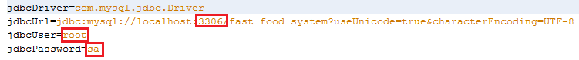

Change the rounded number at the first row to the set port of the installed MySQL

Change the rounded string at the second row to the MySQL login account

Change the rounded string at the third row to the MySQL login password

* Start Tomcat server



Figure 43: Start Tomcat Server

### Setting up environment at client side

The client devices need to have one of the following browsers to launch the FastFoodDeliverySystem websites:

* Google Chrome version 20 or higher (can download at <https://www.google.com/intl/en/chrome/browser/>)
* Firefox version 10 or higher (can download at <http://www.mozilla.org/en-US/firefox/new/>)

## Main Process

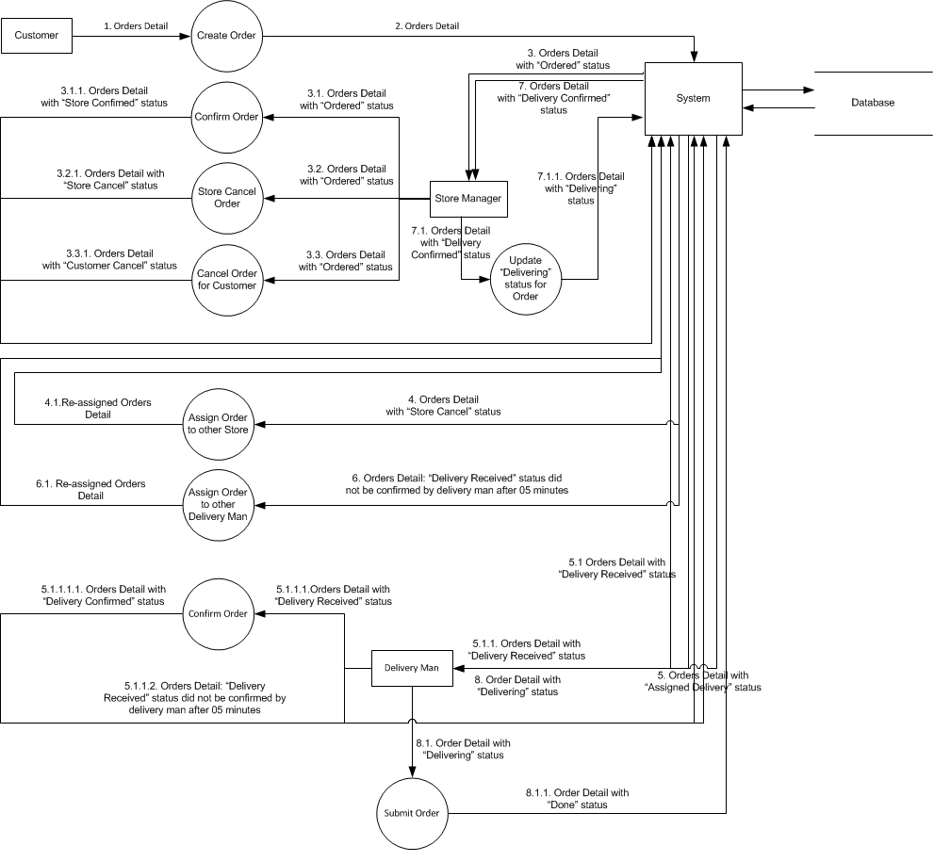

Figure 44: Main Data Flow

## User’s Guide

### Visitor Guide

#### Register

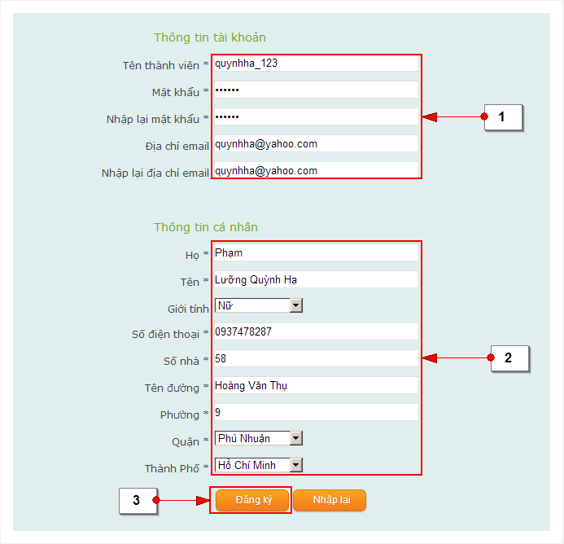

Figure 45: Register screen

|  |  |
| --- | --- |
| **STEP** | **DESCRIPTION** |
| **1** | Fill account information of customer to textbox  Username of customer  Password of customer  Confirm password of customer  Email of customer  Confirm email of customer |
| **2** | Fill personal information of customer to textbox  Last name of customer  First name of customer  Gender of customer  Phone number of customer  House number of customer  Street name of customer’s address  Ward of customer’s address  District of customer’s address  City of customer’s address |
| **3** | Click “Đăng ký” button to confirm all above information and create account  (Click “Nhập lại” button if customer want to re-fill all information) |

Table 70: Register step

### Customer (Visitor) Guide



#### Login

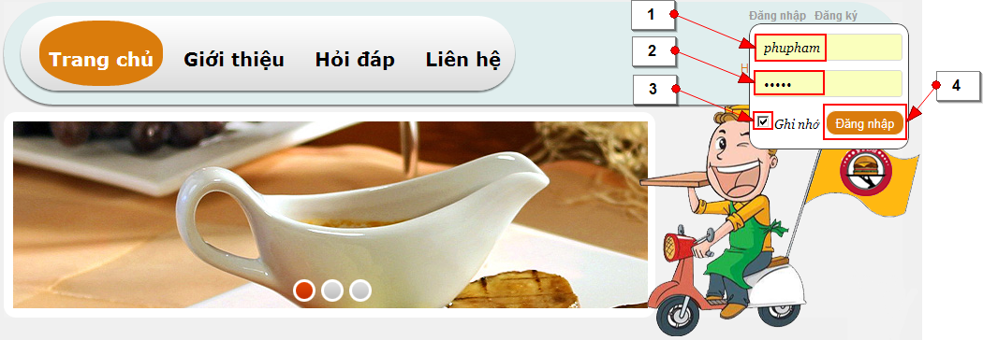

Figure 46: Login screen

Click “Đăng nhập” to show login popup

|  |  |
| --- | --- |
| **STEP** | **DESCRIPTION** |
| **1** | Fill the account to the password textbox |
| **2** | Fill the password to the password textbox |
| **3** | Check it if customer want to remember username and password when login next time |
| **4** | Click on “Đăng nhập” button to login to website |

Table 71: Login step

#### Logout

Optional

#### Add product into shopping cart



Figure 47: Add Product screen

|  |  |
| --- | --- |
| **STEP** | **DESCRIPTION** |
| **1** | Click “Cho vào giỏ hàng” button to add product into shopping cart. |
| **2** | Click on shopping cart icon to view all the products which has chosen |

Table 72: Add Product step

#### Change product quantity or remove product

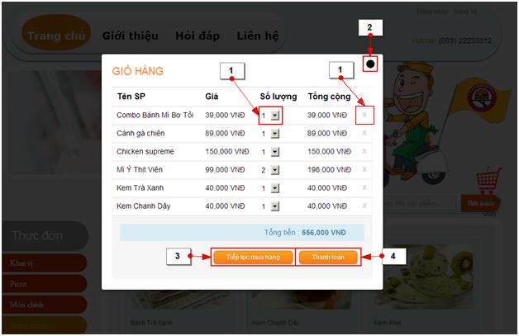

Figure 48: Change Product Quantity screen

After shopping cart is shown up

|  |  |
| --- | --- |
| **STEP** | **DESCRIPTION** |
| **1** | Click on product quantity dropdown list to change product’s quantity (or click on remove symbol to remove product out of shopping cart) |
| **4** | Click on “Thanh toán” button to close shopping cart popup and go to “THÔNG TIN GIAO HÀNG” popup  (Click on close button to close “GIỎ HÀNG” popup and back to product list)  (Click on “Tiếp tục mua hàng” button to close “GIỎ HÀNG” popup and back to product list to add more products) |

Table : Change Product Quantity step

#### Check out

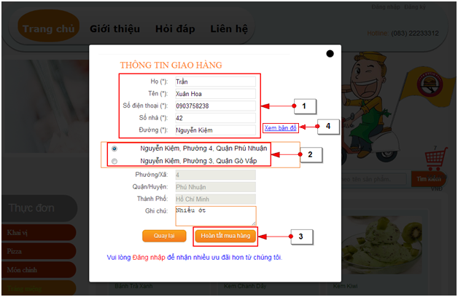

Figure 49: Check Out screen

After customer make sure about all products in shopping cart, “Thanh toán” button will be clicked to close “GIỎ HÀNG” popup and go to “THÔNG TIN GIAO HÀNG” popup

|  |  |
| --- | --- |
| **STEP** | **DESCRIPTION** |
| **1** | Fill customer information |
| **2** | Customer check on correct address in address suggestion check box |
| **3** | Click on “Thanh toán” button to finish order process |

Table : Check Out step



#### View and cancel order

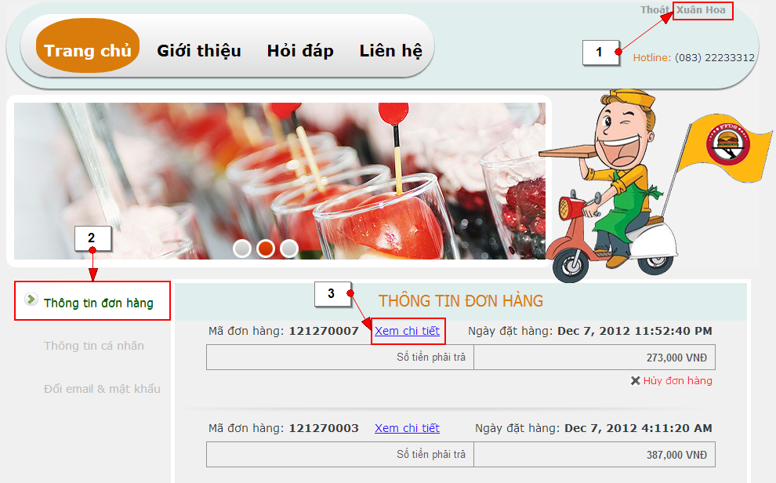Figure 50: View Order screen

|  |  |
| --- | --- |
| **STEP** | **DESCRIPTION** |
| **1** | Login with “Customer” role |
| **2** | Click on “Thông tin đơn hàng” tab to view orders |
| **3** | Click “Xem chi tiết ” link to view order’s details |

Table : View Order step

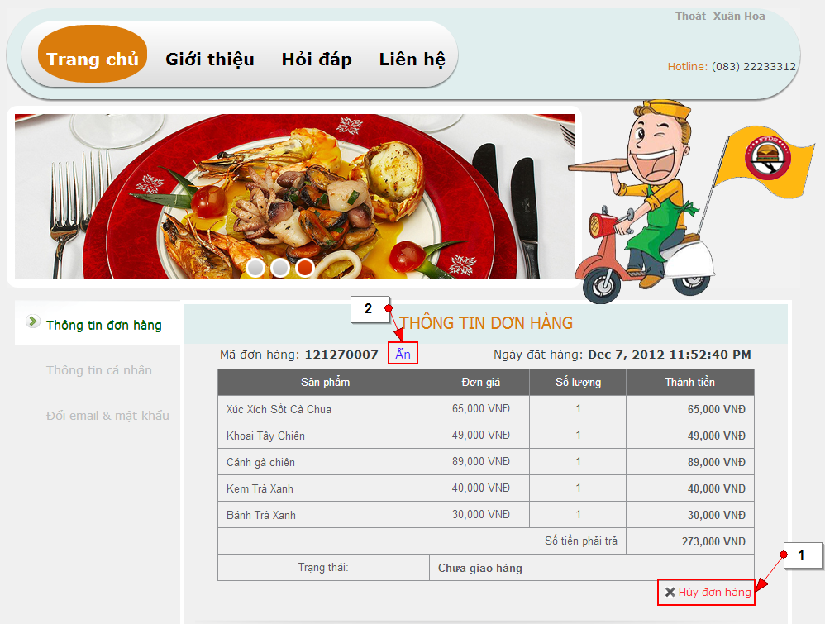

Figure 51: View Order Detail screen

|  |  |
| --- | --- |
| **STEP** | **DESCRIPTION** |
| **1** | Click on “Hủy đơn hàng” link to cancel order |
| **2** | Click on “Ẩn” link to hide order detail |

Table : Cancel Order step

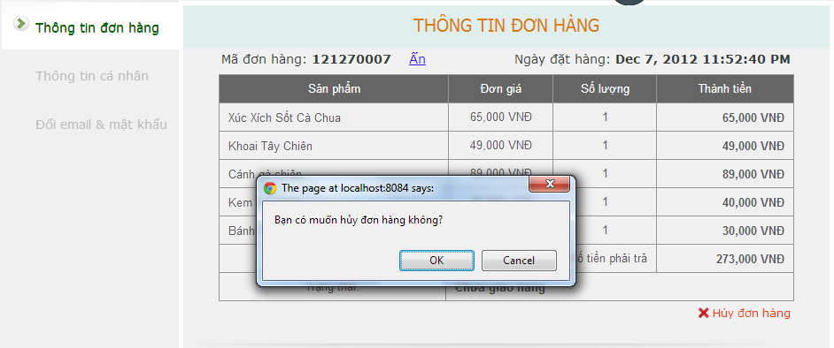

Figure 52: Confirm Cancel Order screen

|  |  |
| --- | --- |
| **STEP** | **DESCRIPTION** |
| **1** | Click “OK” button to confirm |

Table : Confirm Cancel Order step

#### View and edit personal information

Optional

#### View and edit account information

Optional

### Store Manager Guide



#### View order list

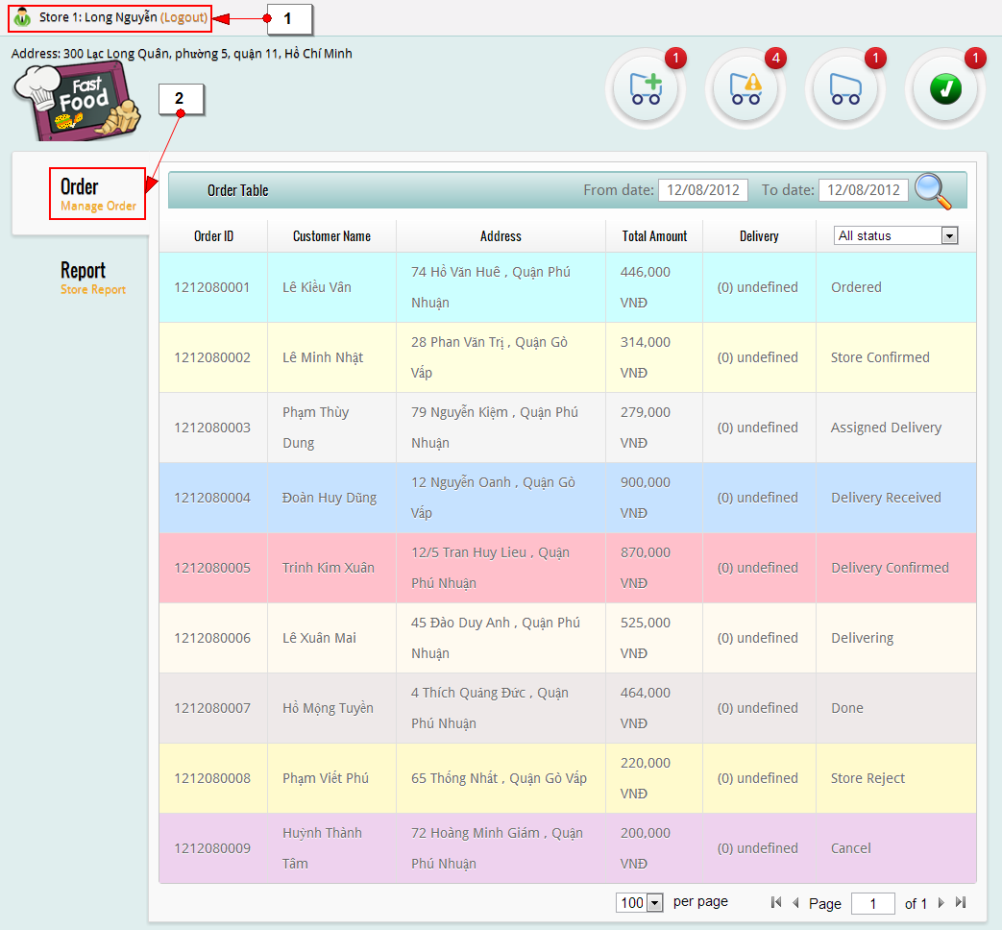

Figure 53: Order List screen

|  |  |
| --- | --- |
| **STEP** | **DESCRIPTION** |
| **1** | Login with “Store Manager” role |
| **2** | View all orders at “Order” tab |

Table : Order List step

#### View order detail

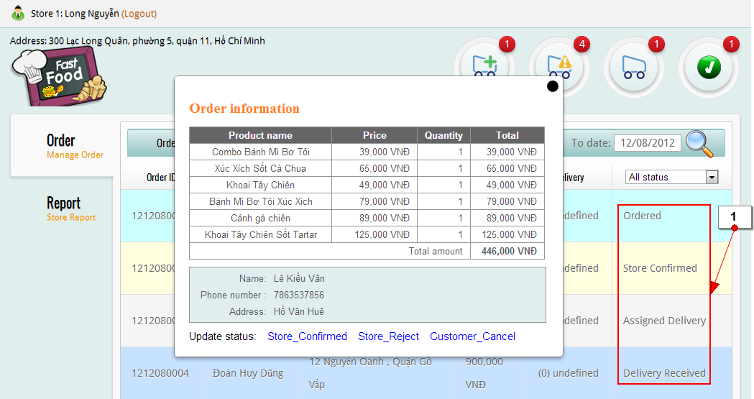

Figure 54: View Order Detail screen

|  |  |
| --- | --- |
| **STEP** | **DESCRIPTION** |
| **1** | Click on one of order’s status to view order detail   * Ordered (Order that customer has created) * Store Confirmed (Order that store manager has confirmed) * Assigned Delivery (Order that was assigned to delivery man) * Delivery Received (Order that delivery man has received) * Delivery Confirmed (Order that was confirmed by delivery man) * Delivering (Order that is delivering) * Store Reject (Order that was rejected by store manager) * Done (Order that delivery man has delivered to customer) * Cancel (Order that was canceled by customer) |

Table : View Order Detail step

#### Confirm order

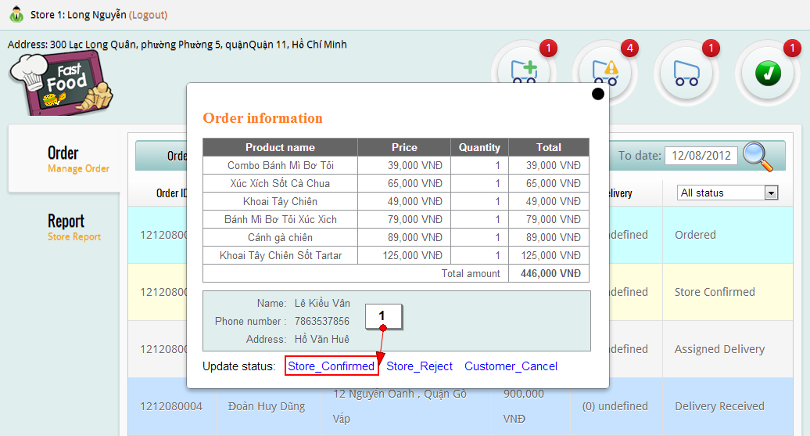

Figure 55: View Order Detail screen

|  |  |
| --- | --- |
| **STEP** | **DESCRIPTION** |
| **1** | Click on Store\_Confirm link to confirm order  (Click on Store\_Reject to reject order- system will assign that orderto other store automatically)  (Click on Customer\_Cancel to cancel order for customer) |

Table : View Order Detail step

#### Reject order

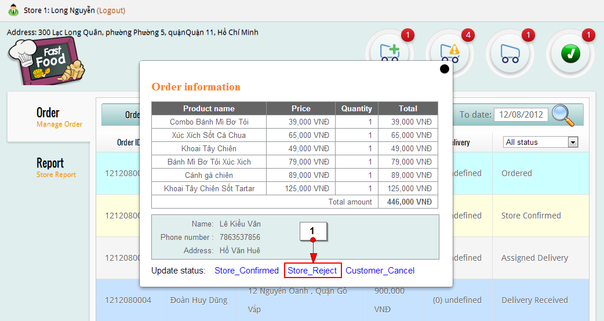

Figure 56: Reject Orderl screen

|  |  |
| --- | --- |
| **STEP** | **DESCRIPTION** |
| **1** | Click on Store\_Reject to reject order- system will assign that orderto other store automatically |

Table : Reject Order step

#### Cancel order for customer

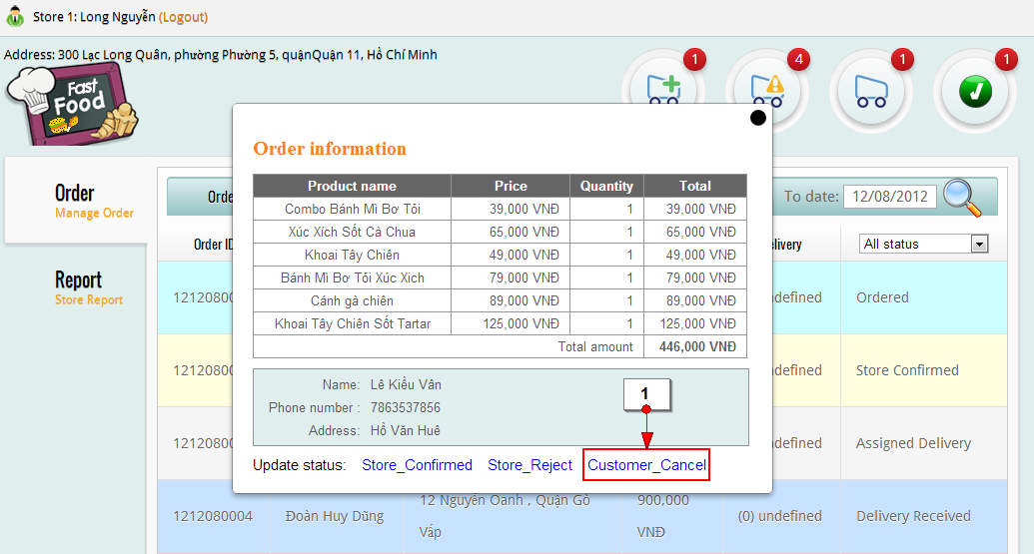

Figure 57: Cancel Order screen

|  |  |
| --- | --- |
| **STEP** | **DESCRIPTION** |
| **1** | Click on Customer\_Cancel to cancel order for customer |

Table : Cancel Order step

### Delivery Man Guide



#### View Order List

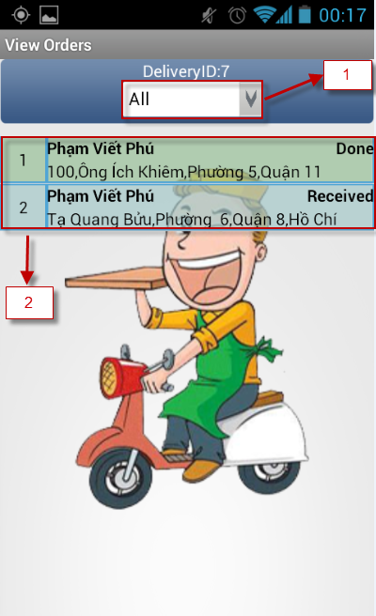

Figure 58: View Order List screen

|  |  |
| --- | --- |
| **STEP** | **DESCRIPTION** |
| **1** | Click on status dropdown list to choose status |
| **2** | View list of order |

Table : View Order List step

#### View Order Detail

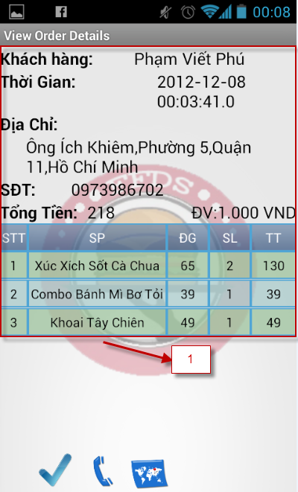

Figure 59: View Order Detail screen

|  |  |
| --- | --- |
| **STEP** | **DESCRIPTION** |
| **1** | Click on order at order list to view order detail |

Table : View Order Detail step

#### Confirm Order

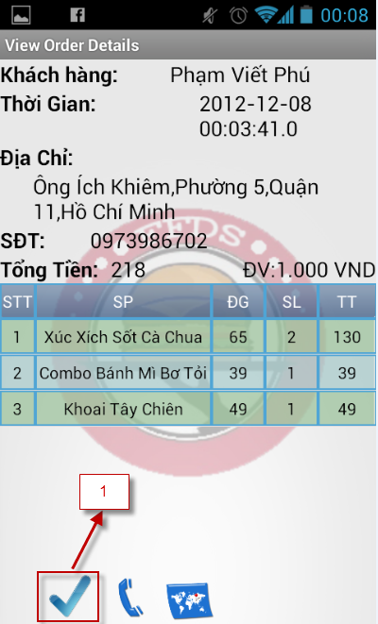

Figure 60: Confirm Order screen

|  |  |
| --- | --- |
| **STEP** | **DESCRIPTION** |
| **1** | Click on check symbol to confirm the order |

Table : Confirm Order step

#### View Map

#### View map from delivery man to store

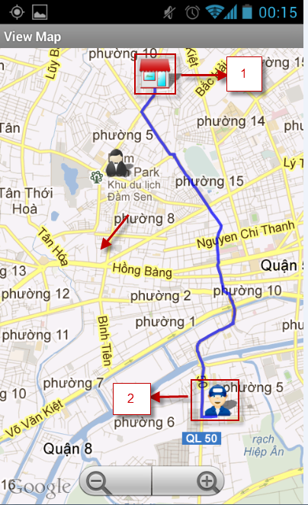

Figure 61: View Map From Delivery Man To Store screen

|  |  |
| --- | --- |
| **STEP** | **DESCRIPTION** |
| **1** | Click on map icon at above screen to view map, then click on store icon |
| **2** | Click on delivery man icon |

Table : View Map From Delivery Man To Store step

#### View map from delivery man to customer

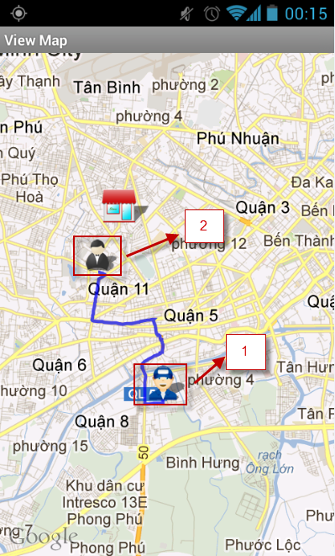

Figure 62: View Map From Delivery Man To Customer screen

|  |  |
| --- | --- |
| **STEP** | **DESCRIPTION** |
| **1** | Click on map icon at above screen to view map, then click on delivery man icon |
| **2** | Click on customer icon |

Table : View Map From Delivery Man To Customer step

#### Submit Order

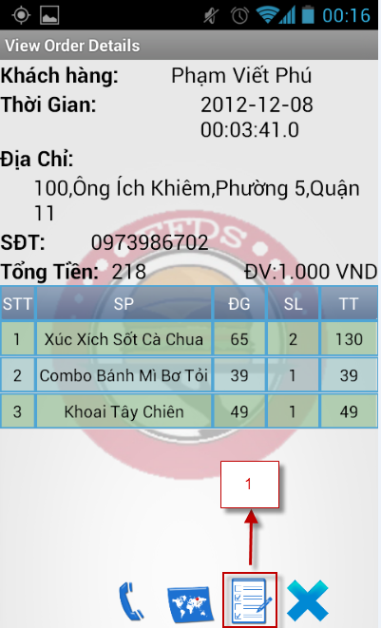

Figure 63: Submit Order screen

|  |  |
| --- | --- |
| **STEP** | **DESCRIPTION** |
| **1** | Click on check order icon to change order status to “Done” |

Table : Submit Order step

#### Customer does not receive order

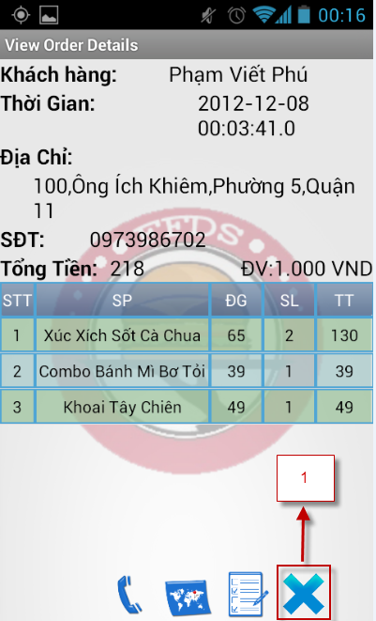

Figure 64: Customer Cancel Order screen

|  |  |
| --- | --- |
| **STEP** | **DESCRIPTION** |
| **1** | Click on cancel symbol to cancel order |

Table : Customer Cnacel Order step

### Admin Guide



#### Manage Employee

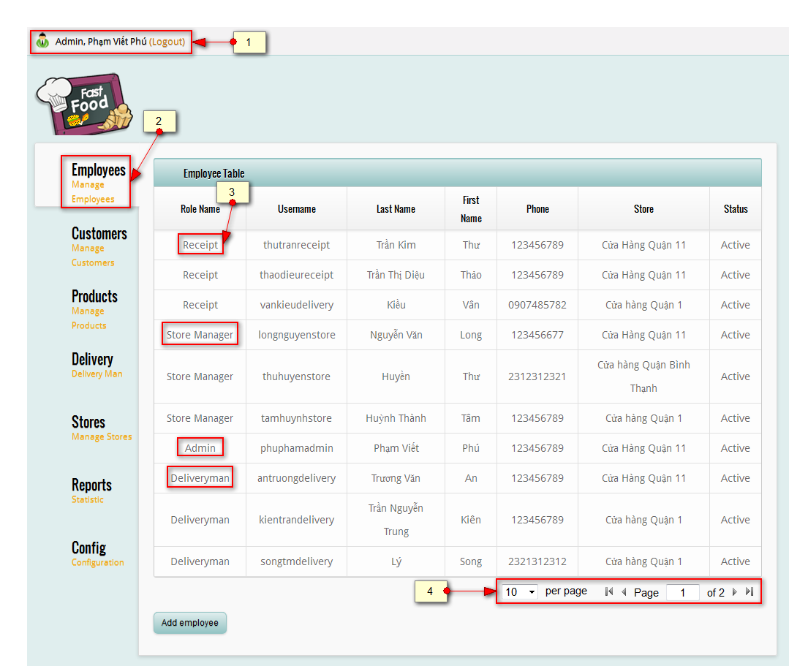

Figure 65: View List Of Employee screen

|  |  |
| --- | --- |
| **STEP** | **DESCRIPTION** |
| **1** | Login with “Admin” role |
| **2** | View list of employee at “Employees” tab |
| **3** | Click on one of role to view or edit detail of employee |
| **4** | Click on per page dropdown list to choose number of employee will be shown in per page |

Table : View List Of Employee step

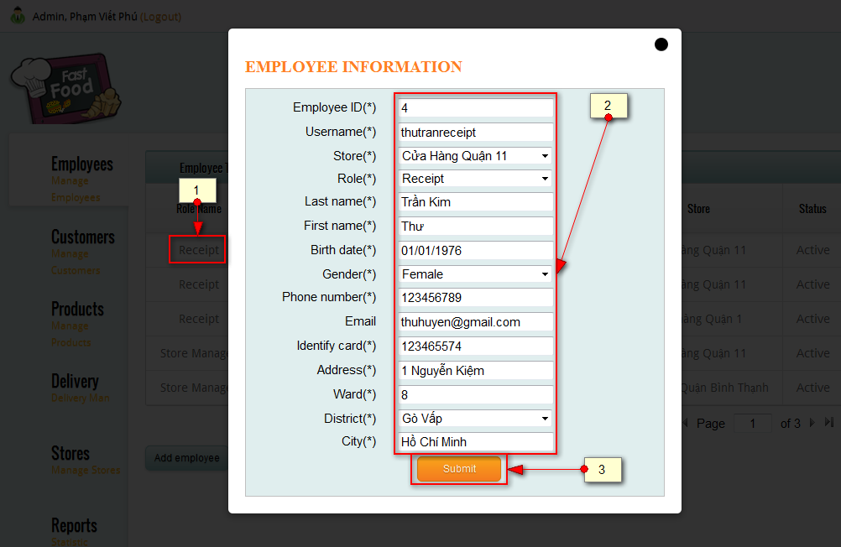

Figure 66: View And Edit Detail Of Employee screen

|  |  |
| --- | --- |
| **STEP** | **DESCRIPTION** |
| **1** | Click on one of role to view or edit detail of employee |
| **2** | Change information in textbox or choose other item in dropdown list |
| **3** | Click on “Submit” button to submit information |

Table : View And Edit Detail Of Employee step

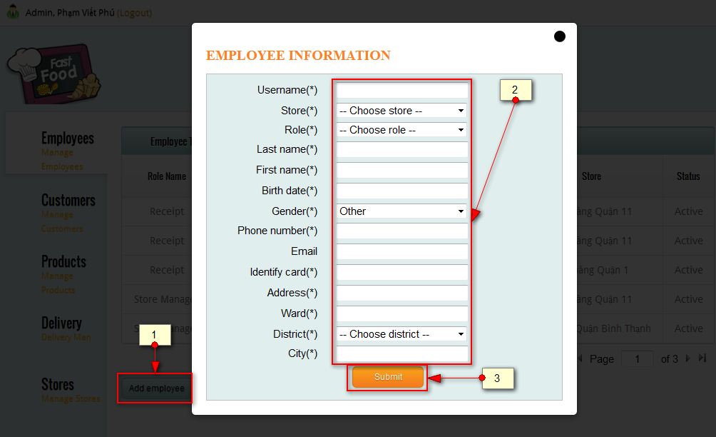

Figure 67: Add New Employee screen

|  |  |
| --- | --- |
| **STEP** | **DESCRIPTION** |
| **1** | Click on “Add employee” button |
| **2** | Fill information into textbox or choose item in dropdown list |
| **3** | Click on “Submit” button to submit information |

Table : Add New Employee step

#### Manage Customer

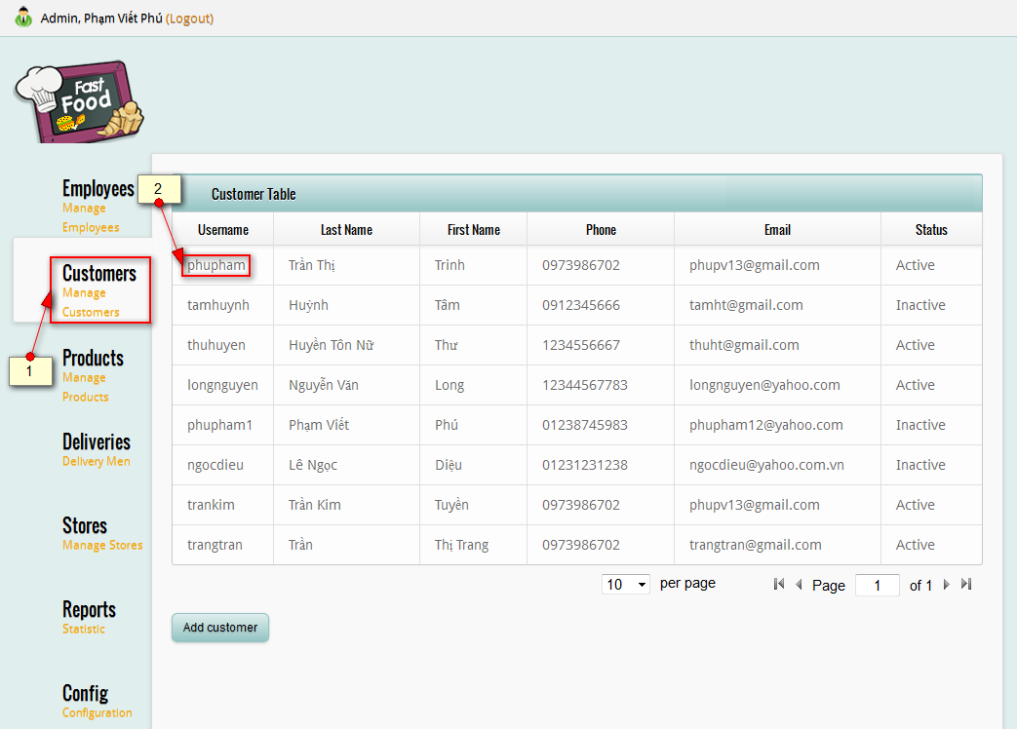

Figure 68: View Customer List screen

|  |  |
| --- | --- |
| **STEP** | **DESCRIPTION** |
| **2** | View list of customer at “Customers” tab |
| **3** | Click on one of username to view or edit detail of customer |

Table : View Customer List step

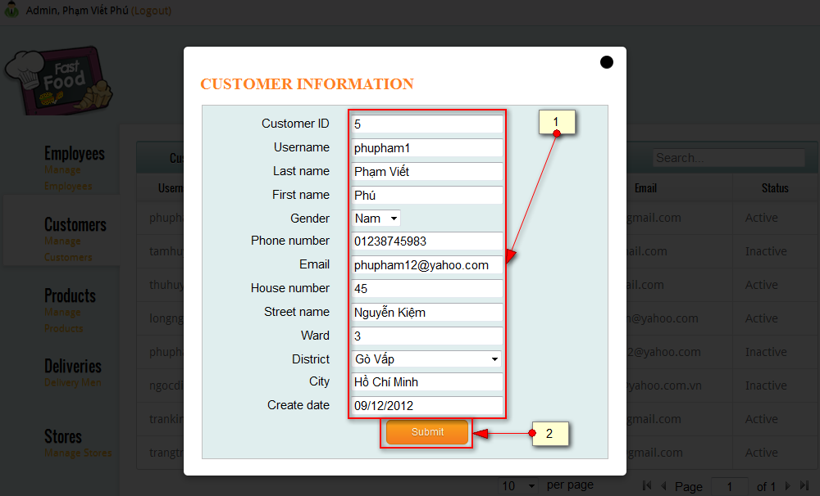

Figure 69: View And Edit Detail Of Customer screen

|  |  |
| --- | --- |
| **STEP** | **DESCRIPTION** |
| **2** | Change information in textbox or choose other item in dropdown list |
| **3** | Click on “Submit” button to submit information |

Table : View And Edit Detail Of Customer step

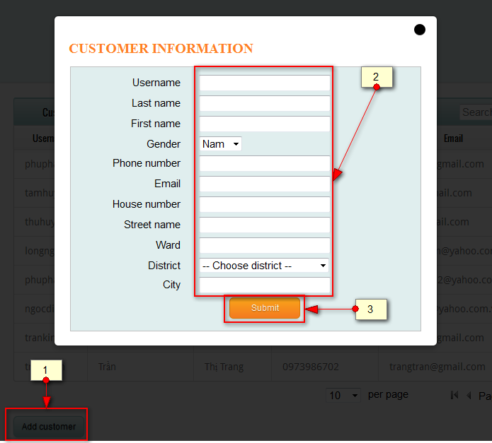

Figure 70: Add New Customer screen

|  |  |
| --- | --- |
| **STEP** | **DESCRIPTION** |
| **1** | Click on “Add customer” button |
| **2** | Fill information into textbox or choose item in dropdown list |
| **3** | Click on “Submit” button to submit information |

Table : Add New Customer step

#### Manage Product

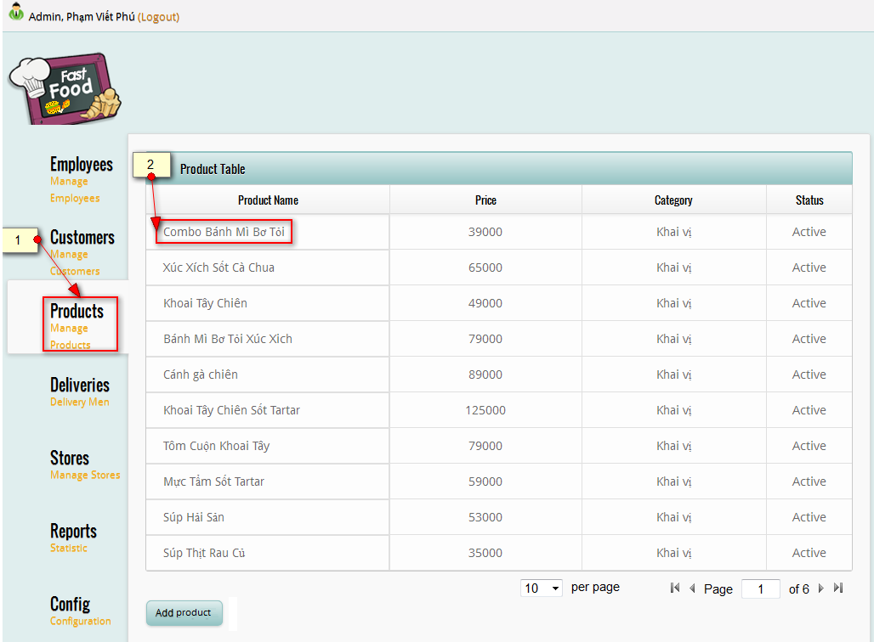

Figure 71: View Product List screen

|  |  |
| --- | --- |
| **STEP** | **DESCRIPTION** |
| **2** | View list of employee at “Products” tab |
| **3** | Click on one of product to view or edit detail of product |

Table : View Product List step

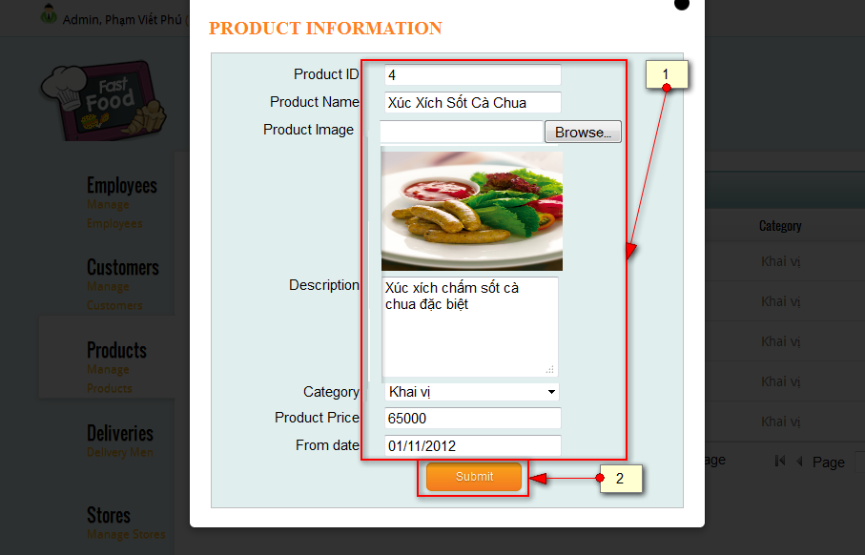

Figure 72: View And Edit Detail Of Product screen

|  |  |
| --- | --- |
| **STEP** | **DESCRIPTION** |
| **2** | Change information in textbox or choose other item in dropdown list |
| **3** | Click on “Submit” button to submit information |

Table : View And Edit Detail Of Product step

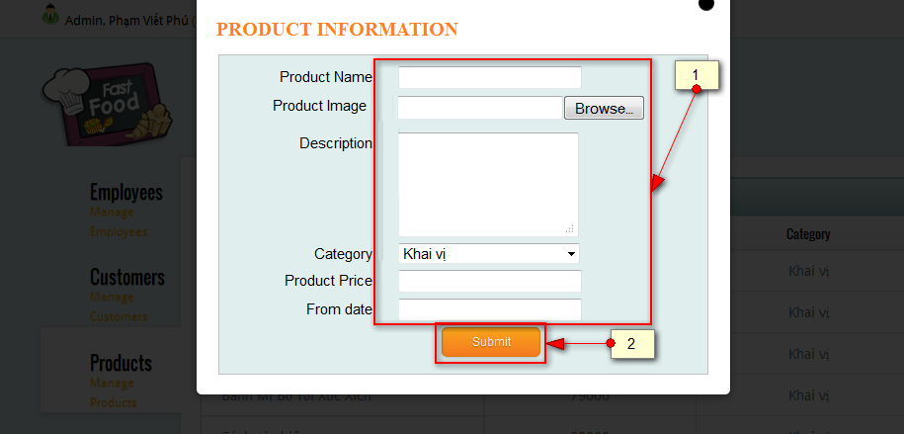

Figure 73: Add New Product screen

|  |  |
| --- | --- |
| **STEP** | **DESCRIPTION** |
| **1** | Fill information into textbox or choose item in dropdown list |
| **2** | Click on “Submit” button to submit information |

Table : Add New Product step

**Error notification: information textbox and dropdown list is invalid**

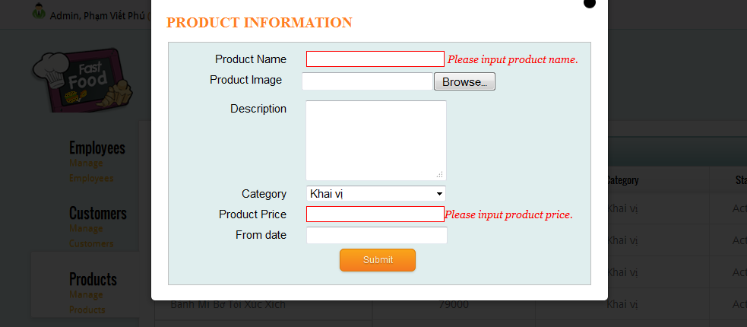

#### Manage Store

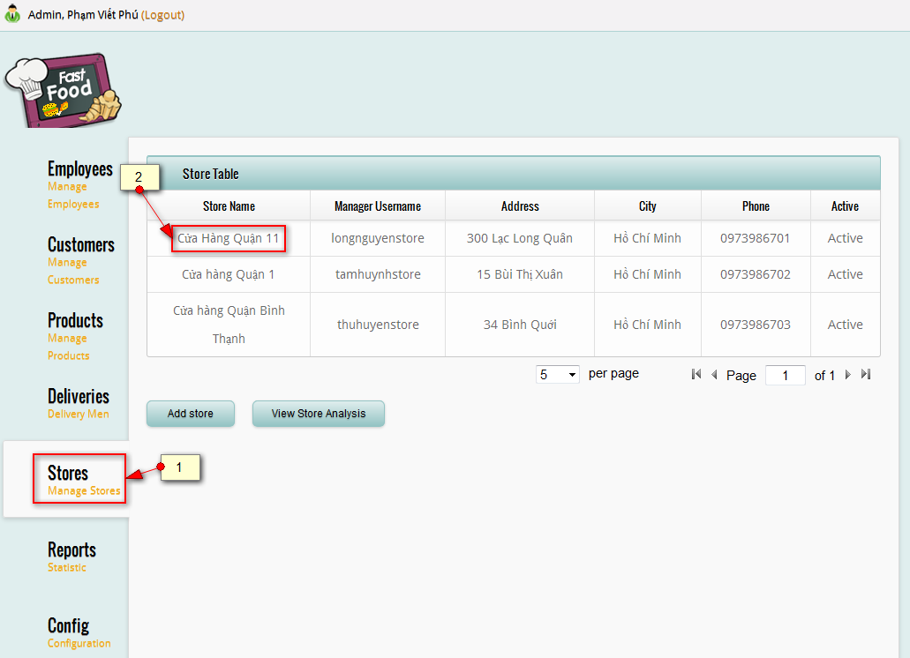

Figure 74: View Store List screen

|  |  |
| --- | --- |
| **STEP** | **DESCRIPTION** |
| **1** | View list of store at “Stores” tab |
| **2** | Click on one of store name to view or edit detail of store |

Table : View Store List step

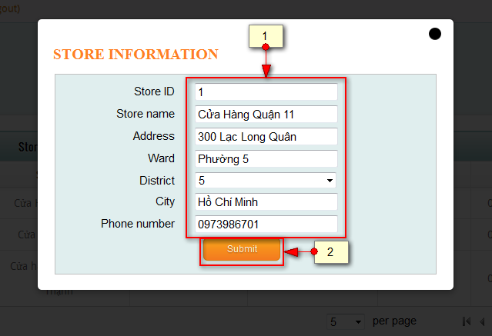

Figure 75: View And Edit Store Detail screen

|  |  |
| --- | --- |
| **STEP** | **DESCRIPTION** |
| **1** | Edit information of textbox or choose item |
| **2** | Click on “Submit” to submit information |

Table : View And Edit Store Detail step

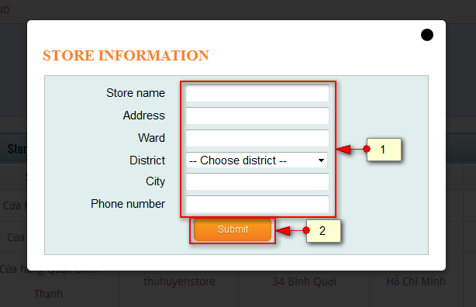

Figure 76: Add New Store screen

|  |  |
| --- | --- |
| **STEP** | **DESCRIPTION** |
| **1** | Fill information textbox and choose item |
| **2** | Click on “Submit” to submit information |

Table : Add New Store step

#### Keep track on Deliver Man’s location

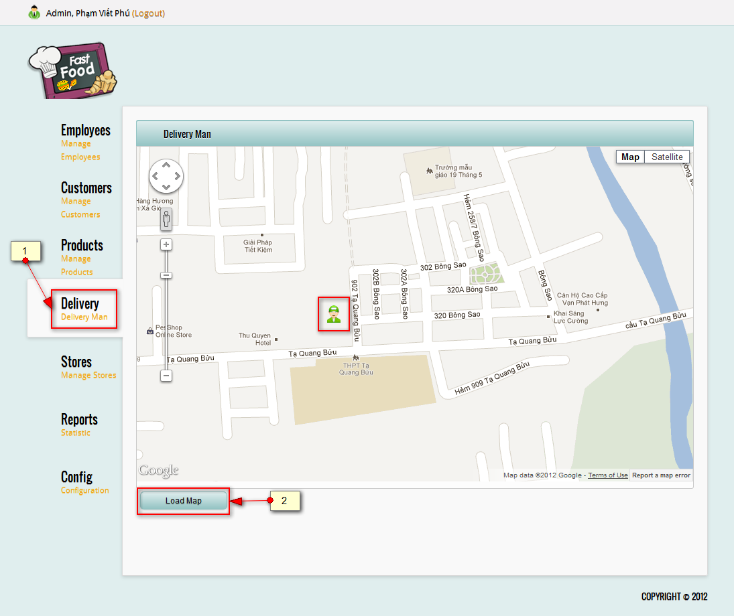

Figure 77: Keep track on delivery man’s location screen

|  |  |
| --- | --- |
| **STEP** | **DESCRIPTION** |
| **1** | Click on “Delivery” tab to view delivery man’s location |
| **2** | Click on “Load Map” to reload map |

Table : Keep track on delivery man’s location step

#### View report

#### Configuration

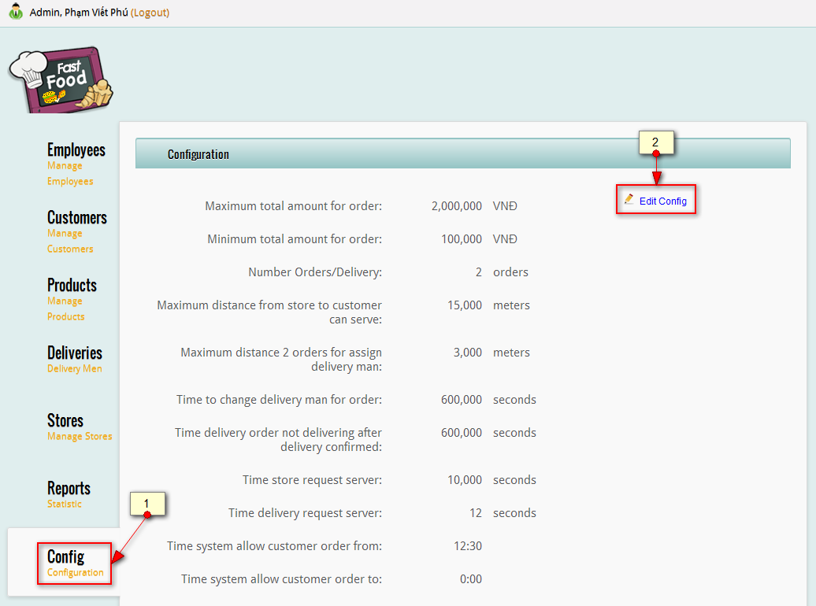

Figure 78: View Configuration List screen

|  |  |
| --- | --- |
| **STEP** | **DESCRIPTION** |
| **1** | Click on “Config” tab to view list of configuation |
| **2** | Click on “Edit Config” link to edit |

Table : View Configuration List step

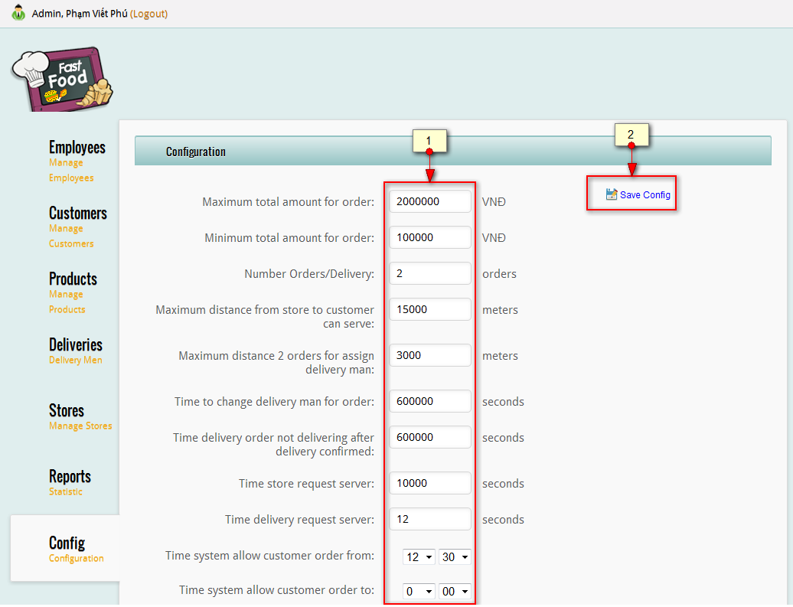

Figure 79: Edit Configuration screen

|  |  |
| --- | --- |
| **STEP** | **DESCRIPTION** |
| **1** | Change value of configuration in textbox |
| **2** | Click on “Save Config” to save change |

Table : Edit Configuration step

## Constraints

N/A

# Appendix

**Tables**

[Table 1: Abbreviation& AcronymList 3](#_Toc342935758)

[Table 2: Introduction 20](#_Toc342935759)

[Table 3: Roles and Responsibilities 23](#_Toc342935760)

[Table 4: Task 26](#_Toc342935761)

[Table 5: Software List 29](#_Toc342935762)

[Table 6: Create Order Use Case Specification 35](#_Toc342935763)

[Table 7: Add products into shopping cart screen’s Controls 36](#_Toc342935764)

[Table 8: Shopping Cart screen’s Controls 37](#_Toc342935765)

[Table 9: Check Out Order Use Case Specification 43](#_Toc342935766)

[Table 10: Check Out Order screen’s Controls 44](#_Toc342935767)

[Table 11: Checking Information Process screen’s Controls 44](#_Toc342935768)

[Table 12: Finish Order screen’s Controls 45](#_Toc342935769)

[Table 13: Customer Cancel Order Use Case Specification 48](#_Toc342935770)

[Table 14: Customer Cancel Order screen’s controls 48](#_Toc342935771)

[Table 15: Order Detail screen’s Control 49](#_Toc342935772)

[Table 16: Check Out Order Use Case Specification 53](#_Toc342935773)

[Table 17: Check Out Order screen’s Control 54](#_Toc342935774)

[Table 18: Customer Cancel Order Use Case Specification 57](#_Toc342935775)

[Table 19: Draw routes in map use case diagram 61](#_Toc342935776)

[Table 20: Draw routes in map use case diagram 63](#_Toc342935777)

[Table 21: Customer Attributes 73](#_Toc342935778)

[Table 22: getCustomerByUserName’s Parameters 73](#_Toc342935779)

[Table 23: getCustomerByUserName’s Parameters 73](#_Toc342935780)

[Table 24: updateCustomerPoint’s Parameters 73](#_Toc342935781)

[Table 25: Order Attributes 74](#_Toc342935782)

[Table 26: insertOrderCustomer’s Parameters 74](#_Toc342935783)

[Table 27: getOrderItemsByOrder’s Parameters 74](#_Toc342935784)

[Table 28: checkValidOrderCustomer’s Parameters 74](#_Toc342935785)

[Table 29: Store Attributes 75](#_Toc342935786)

[Table 30: Order Attributes 80](#_Toc342935787)

[Table 31: insertOrderCustomer’s Parameters 80](#_Toc342935788)

[Table 32: searchNewOrdersByStore’s Parameters 80](#_Toc342935789)

[Table 33: getOrderItemsByOrder’s Parameters 80](#_Toc342935790)

[Table 34: Store Attributes 81](#_Toc342935791)

[Table 35: getStoreByStoreID’s Parameters 81](#_Toc342935792)

[Table 36: searchNewOrdersByStore’s Parameters 81](#_Toc342935793)

[Table 37: searchNewOrdersByStore’s Parameters 81](#_Toc342935794)

[Table 38: Tables List 92](#_Toc342935795)

[Table 39: tbl\_role table dictionary 92](#_Toc342935796)

[Table 40: tbl\_sex table dictionary 92](#_Toc342935797)

[Table 41: tbl\_user table dictionary 92](#_Toc342935798)

[Table 42: tbl\_user table dictionary 93](#_Toc342935799)

[Table 43: tbl\_customer Table Dictionary 94](#_Toc342935800)

[Table 44: tbl\_delivery\_man Table Dictionary 94](#_Toc342935801)

[Table 45: tbl\_delivery\_man Table Dictionary 95](#_Toc342935802)

[Table 46: tbl\_order\_items Table Dictionary 95](#_Toc342935803)

[Table 47: tbl\_order Table Dictionary 96](#_Toc342935804)

[Table 48: tbl\_product Table Dictionary 97](#_Toc342935805)

[Table 49: tbl\_order\_status Table Dictionary 97](#_Toc342935806)

[Table 50: tbl\_store Table Dictionary 97](#_Toc342935807)

[Table 51: tbl\_price Table Dictionary 98](#_Toc342935808)

[Table 52: tbl\_order\_items\_cancel Table Dictionary 98](#_Toc342935809)

[Table 53: tbl\_category Table Dictionary 98](#_Toc342935810)

[Table 54: tbl\_order \_cancel Table Dictionary 99](#_Toc342935811)

[Table 55: tbl\_product\_type Table Dictionary 100](#_Toc342935812)

[Table 56: Create Order Test Case 105](#_Toc342935813)

[Table 57: Check Out Order Test Case 109](#_Toc342935814)

[Table 58: Cancel Order Test Case 109](#_Toc342935815)

[Table 59: Receive Order Test Case 111](#_Toc342935816)

[Table 60: Cancel Order For Customer Test Case 112](#_Toc342935817)

[Table 61: Delivery Man Receive Order Test Case 113](#_Toc342935818)

[Table 62: Customer Data 114](#_Toc342935819)

[Table 63: Manager Customer Test Case 117](#_Toc342935820)

[Table 64: Product Data 117](#_Toc342935821)

[Table 65: Manage Product Test Case 120](#_Toc342935822)

[Table 66: Store Data 120](#_Toc342935823)

[Table 67: Manage Store Test Case 122](#_Toc342935824)

[Table 68: Checklist of Validation 123](#_Toc342935825)

[Table 69: Submission Checklist 124](#_Toc342935826)

[Table 70: Register step 128](#_Toc342935827)

[Table 71: Login step 128](#_Toc342935828)

[Table 72: Add Product step 129](#_Toc342935829)

[Table 73: Change Product Quantity step 130](#_Toc342935830)

[Table 74: Check Out step 131](#_Toc342935831)

[Table 75: View Order step 132](#_Toc342935832)

[Table 76: Cancel Order step 133](#_Toc342935833)

[Table 77: Confirm Cancel Order step 134](#_Toc342935834)

[Table 78: Order List step 135](#_Toc342935835)

[Table 79: View Order Detail step 135](#_Toc342935836)

[Table 80: View Order Detail step 136](#_Toc342935837)

[Table 81: Reject Order step 137](#_Toc342935838)

[Table 82: Cancel Order step 138](#_Toc342935839)

[Table 83: View Order List step 139](#_Toc342935840)

[Table 84: View Order Detail step 140](#_Toc342935841)

[Table 85: Confirm Order step 140](#_Toc342935842)

[Table 86: View Map From Delivery Man To Store step 141](#_Toc342935843)

[Table 87: View Map From Delivery Man To Customer step 142](#_Toc342935844)

[Table 88: Submit Order step 143](#_Toc342935845)

[Table 89: Customer Cnacel Order step 144](#_Toc342935846)

[Table 90: View List Of Employee step 145](#_Toc342935847)

[Table 91: View And Edit Detail Of Employee step 146](#_Toc342935848)

[Table 92: Add New Employee step 147](#_Toc342935849)

[Table 93: View Customer List step 148](#_Toc342935850)

[Table 94: View And Edit Detail Of Customer step 149](#_Toc342935851)

[Table 95: Add New Customer step 150](#_Toc342935852)

[Table 96: View Product List step 151](#_Toc342935853)

[Table 97: View And Edit Detail Of Product step 152](#_Toc342935854)

[Table 98: Add New Product step 153](#_Toc342935855)

[Table 99: View Store List step 154](#_Toc342935856)

[Table 100: View And Edit Store Detail step 155](#_Toc342935857)

[Table 101: Add New Store step 156](#_Toc342935858)

[Table 102: Keep track on delivery man’s location step 157](#_Toc342935859)

[Table 103: View Configuration List step 158](#_Toc342935860)

[Table 104: Edit Configuration step 159](#_Toc342935861)

**Figures**

[Figure 1: Waterfall Model 22](#_Toc342936101)

[Figure 2- General Use Case Diagram 29](#_Toc342936102)

[Figure 3- Customer Sequence Diagram 32](#_Toc342936103)

[Figure 4- Create Order use case diagram 32](#_Toc342936104)

[Figure 5- Add products into shopping cart screen 36](#_Toc342936105)

[Figure 6- Shopping Cart screen 37](#_Toc342936106)

[Figure 7- Check Out Order use case diagram 38](#_Toc342936107)

[Figure 8- Check Out Order screen 43](#_Toc342936108)

[Figure 9- Checking Information Process screen 44](#_Toc342936109)

[Figure 10- Finish Order screen 45](#_Toc342936110)

[Figure 11- Customer Cancel Order use case diagram 45](#_Toc342936111)

[Figure 12- Customer Cancel Order screen 48](#_Toc342936112)

[Figure 13- Order Detail screen 49](#_Toc342936113)

[Figure 14- Check Out Order use case diagram 49](#_Toc342936114)

[Figure 15- Check Out Order screen 54](#_Toc342936115)

[Figure 16- Receipt Cancel Order use case diagram 55](#_Toc342936116)

[Figure 17- Confirm Order use case diagram 58](#_Toc342936117)

[Figure 18- Cancel Order use case diagram 58](#_Toc342936118)

[Figure 19- Cancel Order For Customer use case diagram 58](#_Toc342936119)

[Figure 20- Confirm order use case diagram 59](#_Toc342936120)

[Figure 21- Receive delivery’s order use case diagram 59](#_Toc342936121)

[Figure 22- Draw routes in map use case diagram 59](#_Toc342936122)

[Figure 23- Check order of customer 61](#_Toc342936123)

[Figure 24- Entity Relationship Diagram 67](#_Toc342936124)

[Figure 25: System Architectural Design 68](#_Toc342936125)

[Figure 26: Component Diagram 69](#_Toc342936126)

[Figure 27: Presentation Layer's Components 69](#_Toc342936127)

[Figure 28: Business Layer's Components 70](#_Toc342936128)

[Figure 29: Data Access Layer's Components 70](#_Toc342936129)

[Figure 30: Common Components 70](#_Toc342936130)

[Figure 31: General Class Diagram 71](#_Toc342936131)

[Figure 32: Create Order Class Diagram 72](#_Toc342936132)

[Figure 33: Create Order Sequence Diagram 78](#_Toc342936133)

[Figure 34: Create Order Class Diagram 79](#_Toc342936134)

[Figure 35: Store Reject Order Sequence Diagram 82](#_Toc342936135)

[Figure 36: Delivery Man Does Not Confirm Order Sequence Diagram 83](#_Toc342936136)

[Figure 37: Create Order Algorithm 86](#_Toc342936137)

[Figure 38: Assign Order To Store Algorithm 87](#_Toc342936138)

[Figure 39: Store Manager Cancel Order Algorithm 88](#_Toc342936139)

[Figure 40: Suggest Address To Customer Algorithm 89](#_Toc342936140)

[Figure 41: Entity Relation Diagram 90](#_Toc342936141)

[Figure 42: Database Diagram 91](#_Toc342936142)

[Figure 43: Start Tomcat Server 125](#_Toc342936143)

[Figure 44: Main Data Flow 126](#_Toc342936144)

[Figure 45: Register screen 127](#_Toc342936145)

[Figure 46: Login screen 128](#_Toc342936146)

[Figure 47: Add Product screen 129](#_Toc342936147)

[Figure 48: Change Product Quantity screen 130](#_Toc342936148)

[Figure 49: Check Out screen 131](#_Toc342936149)

[Figure 50: View Order screen 132](#_Toc342936150)

[Figure 51: View Order Detail screen 133](#_Toc342936151)

[Figure 52: Confirm Cancel Order screen 134](#_Toc342936152)

[Figure 53: Order List screen 135](#_Toc342936153)

[Figure 54: View Order Detail screen 135](#_Toc342936154)

[Figure 55: View Order Detail screen 136](#_Toc342936155)

[Figure 56: Reject Orderl screen 137](#_Toc342936156)

[Figure 57: Cancel Order screen 138](#_Toc342936157)

[Figure 58: View Order List screen 138](#_Toc342936158)

[Figure 59: View Order Detail screen 139](#_Toc342936159)

[Figure 60: Confirm Order screen 140](#_Toc342936160)

[Figure 61: View Map From Delivery Man To Store screen 141](#_Toc342936161)

[Figure 62: View Map From Delivery Man To Customer screen 142](#_Toc342936162)

[Figure 63: Submit Order screen 143](#_Toc342936163)

[Figure 64: Customer Cancel Order screen 144](#_Toc342936164)

[Figure 65: View List Of Employee screen 145](#_Toc342936165)

[Figure 66: View And Edit Detail Of Employee screen 146](#_Toc342936166)

[Figure 67: Add New Employee screen 147](#_Toc342936167)

[Figure 68: View Customer List screen 148](#_Toc342936168)

[Figure 69: View And Edit Detail Of Customer screen 149](#_Toc342936169)

[Figure 70: Add New Customer screen 150](#_Toc342936170)

[Figure 71: View Product List screen 151](#_Toc342936171)

[Figure 72: View And Edit Detail Of Product screen 152](#_Toc342936172)

[Figure 73: Add New Product screen 152](#_Toc342936173)

[Figure 74: View Store List screen 154](#_Toc342936174)

[Figure 75: View And Edit Store Detail screen 155](#_Toc342936175)

[Figure 76: Add New Store screen 156](#_Toc342936176)

[Figure 77: Keep track on delivery man’s location screen 157](#_Toc342936177)

[Figure 78: View Configuration List screen 158](#_Toc342936178)

[Figure 79: Edit Configuration screen 159](#_Toc342936179)